Name Date Period
Lesson 4-3 · Session 1 · Guided Notes
Estimate with Benchmarks
Learning target — I can estimate a percent by comparing an amount to benchmark percents. · 6.RP.A.3c
WORDS TO KNOW fill in the missing words
WORD | WHAT IT MEANS | EXAMPLE
estimate  estimar | A close answer that is not . | about 50% done
benchmark percent  porcentaje de referencia | An percent to use, like 10%, 25%, 50%, or 75%. | 50% = one half
the whole  el todo | The full amount. It counts as . | all 80 MB of a download
KEY IDEA complete each sentence
• First name the . That amount is 100%.
• Find benchmark amounts: 50% is of the whole, 25% is one fourth, and 10% is the whole ÷ 10.
• Pick the benchmark amount that is to the part.
WORKED EXAMPLE fill in the blanks as we solve
A game download is 80 MB. 41 MB are done. About what percent is done?
Step 1 The whole is MB.
Step 2 50% of 80 MB is MB.
Step 3 41 MB is just a little more than 40 MB.
Answer About of the download is done.
YOU TRY use the example as a model

1. About what percent? Name the closest benchmark.
a. 12 out of 50 ≈ % | b. 59 out of 80 ≈ % | c. 8 out of 75 ≈ %

2. A tablet holds 64 GB. 47 GB are used. Fill in the GB line, then estimate the percent used.
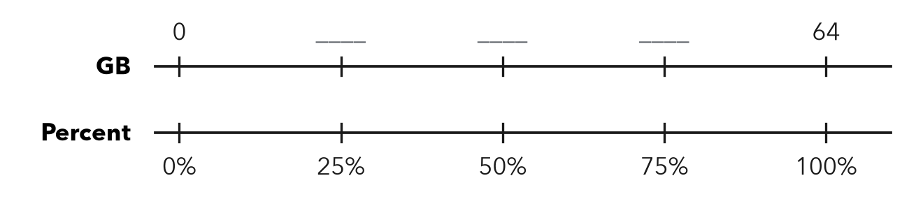
About %

SUM IT UP in your own words
To estimate a percent, I first name the because .
Name Date Period
Lesson 4-3 · Session 2 · Guided Notes
Estimate a Percent of a Number
Learning target — I can estimate a percent of a number using friendly percents and rounded amounts. · 6.RP.A.3c
WORDS TO KNOW fill in the missing words
WORD | WHAT IT MEANS | EXAMPLE
estimate  estimación | An answer that is to the exact amount. | about 60 bottles
compatible numbers  números compatibles | Numbers that are to compute with in your head. | 19% of 312 ≈ 20% of 300
ten percent  diez por ciento | One tenth of the whole: divide by . | 10% of 300 = 30
KEY IDEA complete each sentence
• Round the percent and the whole to numbers.
• Find first, then build: 20% is double, 5% is half of 10%.
• Write “about” because the answer is an .
WORKED EXAMPLE fill in the blanks as we solve
Estimate 20% of 312 bottles.
Step 1 312 is about .
Step 2 10% of 300 is .
Step 3 20% is two 10% parts: 30 + 30 = 60.
Answer About bottles
YOU TRY use the example as a model

1. Estimate. Round first.
a. 21% of 198 ≈ | b. 52% of 60 ≈ | c. 11% of 703 ≈

2. A bill is $38.40. Estimate a 15% tip.

Show your work.
About

SUM IT UP in your own words
To estimate a percent of a number, I round to because .

