Name Date Period
Lesson 4-5 · Session 1 · Practice · Form A
Find the Whole
Learning target — I can find the whole when I know a part and the percent it represents. · 6.RP.A.3c

REMEMBER  • The whole is 100%. If the percent is less than 100%, the whole is greater than the part.  • Step down to a friendly percent (10%, 5%, or 25%), then build up to 100%.  • Check: the percent of your whole should give back the part. | WORKED EXAMPLE  24 stickers are 40% of a pack. How many stickers are in the pack?  Step 1 40% ÷ 4 = 10%, so 24 ÷ 4 = 6.  Step 2 10% × 10 = 100%, so 6 × 10 = 60.  Step 3 Check: 0.40 × 60 = 24.  Answer 60 stickers
WORDS part (parte) · whole (entero) · double number line (doble recta numérica)
PRACTICE show your work · label units

1. Find each whole.
a. 9 is 10% of | b. 16 is 20% of | c. 35 is 50% of
d. 12 is 25% of | e. 45 is 90% of | f. 28 is 70% of

2. Field Trip Deposit. A class paid a $54 deposit. That is 30% of the full cost of the trip. Use the double number line.
Hint 30% ÷ 3 = 10%, so divide $54 by 3.
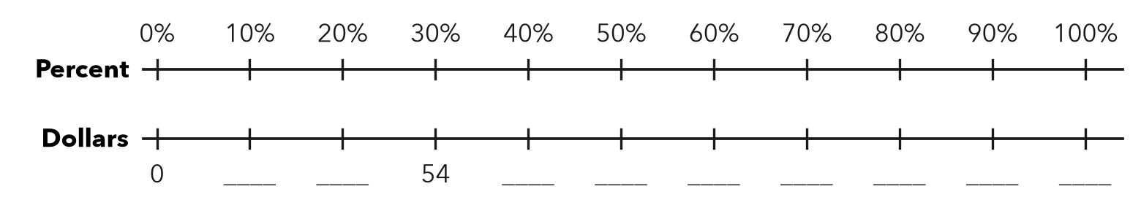
a. What dollar amount matches 10%?
b. What is the full cost of the trip?

3. Puzzle Pieces. Nadia has placed 84 pieces. That is 70% of the puzzle.  a. 10% of the puzzle  b. Total pieces | 4. Water Bottle. A bottle has 36 mL of water left. That is 15% of the full bottle.  Hint 15% ÷ 3 = 5%.  a. 5% of the bottle mL  b. Full bottle mL

5. Library Books. A class has returned 48 library books. That is 60% of the books it borrowed. How many books did it borrow?  Hint Step down to 10% first.  Answer books | 6. Sale Claim. A hat sells for $21. That is 70% of its first price. Kip says the first price was $14.70. Is he right?  Hint The first price must be greater than the sale price.  First price
  Show your work.
  Show your work.

7. Movie Tickets. A theater sold 96 tickets. That is 75% of all its seats. Fill in the double number line. How many seats are there?
Hint 75% ÷ 3 = 25%.
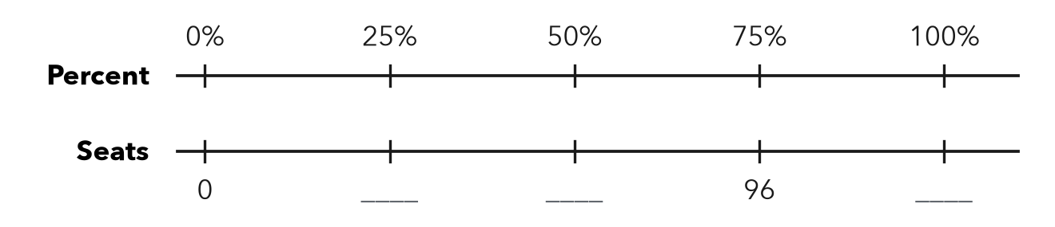
Answer seats

8. Book Fair. A book fair sold 84 books on Friday. That was 28% of the week’s total sales.
a. How many books were sold all week?
b. How many were sold on the other days?
c. Show a one-step check of part a.

Show your work.

FIND THE ERROR explain the mistake, then fix it

9. Caleb’s Work. A jacket is on sale for $36, which is 80% of its first price. Caleb wrote: “First price = 0.8 × 36 = $28.80.” Explain his mistake. Then find the first price.

TEST PRACTICE choose the best answer

10. If 30 is 50% of a number, the number is —
A 15 | B 60 | C 80 | D 1,500

11. If 12 is 25% of a number, the number is —
A 3 | B 37 | C 48 | D 300

SELF-CHECK CODE find your answer · copy its letter into that problem’s box · spell a math word
300  G | 128  N | $30  I | $16.20  X | 72  Z | 120  C | 240  A | $14.70  Q | $180  S | 80  L

#2b | #3b | #4b | #5 | #6 | #7 | #8a

CHECK YOURSELF | □ I can do this on my own | □ I need a little help | □ I have a question about #

