Name Date Period
Lesson 4-5 · Session 1 · Practice · Form B
Find the Whole
Learning target — I can find the whole when I know a part and the percent it represents. · 6.RP.A.3c

REMEMBER  • The whole is 100%. If the percent is less than 100%, the whole is greater than the part.  • Step down to a friendly percent (10%, 5%, or 25%), then build up to 100%.  • Check: the percent of your whole should give back the part. | WORKED EXAMPLE  24 stickers are 40% of a pack. How many stickers are in the pack?  Step 1 40% ÷ 4 = 10%, so 24 ÷ 4 = 6.  Step 2 10% × 10 = 100%, so 6 × 10 = 60.  Step 3 Check: 0.40 × 60 = 24.  Answer 60 stickers
WORDS part (parte) · whole (entero) · double number line (doble recta numérica)
PRACTICE show your work · label units

1. Find each whole.
a. 7 is 10% of | b. 18 is 20% of | c. 42 is 50% of
d. 15 is 25% of | e. 72 is 90% of | f. 21 is 70% of

2. Field Trip Deposit. A class paid a $42 deposit. That is 30% of the full cost of the trip. Use the double number line.
Hint 30% ÷ 3 = 10%, so divide $42 by 3.
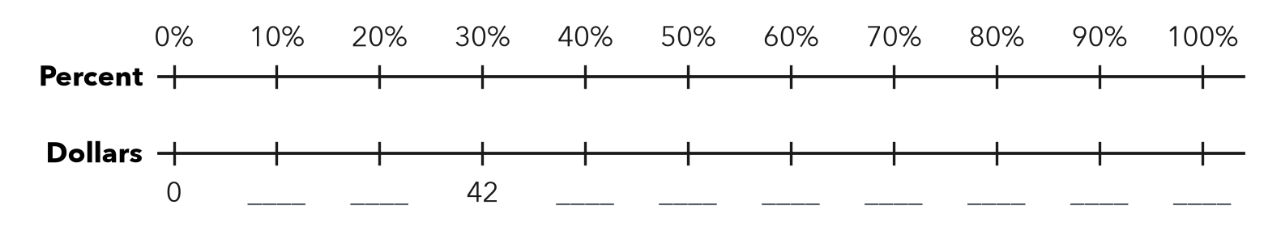
a. What dollar amount matches 10%?
b. What is the full cost of the trip?

3. Puzzle Pieces. Omar has placed 63 pieces. That is 70% of the puzzle.  a. 10% of the puzzle  b. Total pieces | 4. Water Bottle. A bottle has 27 mL of water left. That is 15% of the full bottle.  Hint 15% ÷ 3 = 5%.  a. 5% of the bottle mL  b. Full bottle mL

5. Library Books. A class has returned 42 library books. That is 60% of the books it borrowed. How many books did it borrow?  Hint Step down to 10% first.  Answer books | 6. Sale Claim. A cap sells for $28. That is 70% of its first price. Zara says the first price was $19.60. Is she right?  Hint The first price must be greater than the sale price.  First price
  Show your work.
  Show your work.

7. Movie Tickets. A theater sold 108 tickets. That is 75% of all its seats. Fill in the double number line. How many seats are there?
Hint 75% ÷ 3 = 25%.
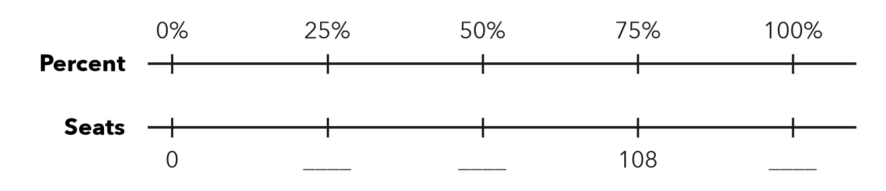
Answer seats

8. Book Fair. A book fair sold 72 books on Monday. That was 24% of the week’s total sales.
a. How many books were sold all week?
b. How many were sold on the other days?
c. Show a one-step check of part a.

Show your work.

FIND THE ERROR explain the mistake, then fix it

9. Mila’s Work. A backpack is on sale for $45, which is 90% of its first price. Mila wrote: “First price = 0.9 × 45 = $40.50.” Explain her mistake. Then find the first price.

TEST PRACTICE choose the best answer

10. If 45 is 90% of a number, the number is —
A 40.5 | B 50 | C 55 | D 405

11. If 20 is 40% of a number, the number is —
A 8 | B 40 | C 50 | D 60

SELF-CHECK CODE find your answer · copy its letter into that problem’s box · spell a math word
$12.60  X | 300  T | 81  Z | 70  C | $19.60  Q | 144  N | $40  E | 90  E | $140  P | 180  R

#2b | #3b | #4b | #5 | #6 | #7 | #8a

CHECK YOURSELF | □ I can do this on my own | □ I need a little help | □ I have a question about #

