Name Date Period
Lesson 4-5 · Session 1 · Guided Notes
Find the Whole
Learning target — I can find the whole when I know a part and the percent it represents. · 6.RP.A.3c
WORDS TO KNOW fill in the missing words
WORD | WHAT IT MEANS | EXAMPLE
part  parte | The amount you ; it matches a percent. | 24 stickers = 40%
whole  entero | The full amount. It is . | the whole sticker pack
double number line  doble recta numérica | Two lines that amounts with percents. | $6 at 10%, $60 at 100%
KEY IDEA complete each sentence
• The whole is 100%. When the percent is less than 100%, the whole is than the part.
• Divide to find a small percent like , then multiply up to 100%.
• Check: the percent of your whole gives back the .
WORKED EXAMPLE fill in the blanks as we solve
24 stickers are 40% of a pack. How many stickers are in the whole pack?
Step 1 40% ÷ 4 = 10%, so 24 ÷ 4 = stickers.
Step 2 10% × 10 = 100%, so 6 × 10 = stickers.
Step 3 Check: 0.40 × 60 =
Answer The pack has stickers.
YOU TRY use the example as a model

1. Find each whole.
a. 8 is 10% of | b. 15 is 25% of | c. 30 is 60% of

2. 18 students ride the bus. That is 75% of the class. How many students are in the class?
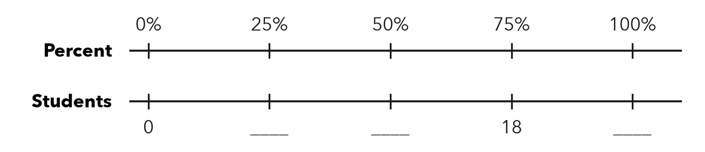
Answer students

SUM IT UP in your own words
To find the whole, I first find because .
Name Date Period
Lesson 4-5 · Session 2 · Guided Notes
Solve for the Whole
Learning target — I can write and solve an equation to find the whole from a part and a percent. · 6.RP.A.3c
WORDS TO KNOW fill in the missing words
WORD | WHAT IT MEANS | EXAMPLE
variable  variable | A letter that stands for an number. | w = the whole
equation  ecuación | A math sentence with an sign. | 0.6 × w = 138
inverse operation  operación inversa | An operation that another. Division undoes multiplication. | w = 138 ÷ 0.6
KEY IDEA complete each sentence
• Write the equation percent × whole = part, with the percent as a .
• Divide the part by the decimal to find .
• Check: multiply your w by the percent to get the .
WORKED EXAMPLE fill in the blanks as we solve
A player scored 42 points. That is 35% of the team’s points. Find the team’s total w.
Step 1 35% =
Step 2 Equation: 0.35 × w =
Step 3 w = 42 ÷ 0.35 =
Answer The team scored points.
YOU TRY use the example as a model

1. Solve each equation for w.
a. 0.5 × w = 23 | b. 0.2 × w = 9 | c. 0.8 × w = 40

2. A tip of $7.20 is 15% of a bill. Write an equation and find the bill.

Show your work.
Equation, bill

SUM IT UP in your own words
To solve for the whole, I divide because .

