Name Date Period
Lesson 5-1 · Session 2 · Practice · Form A
Area of Rhombuses
Learning target — I can find the area of a rhombus using the base and height or the two diagonals. · 6.G.A.1

REMEMBER  • A rhombus has 4 equal sides. It is a parallelogram, so A = b × h works.  • With two diagonals: A = d1 × d2 ÷ 2.  • Missing diagonal: double the area, then divide (24 × 2 = 48, 48 ÷ 6 = 8). | WORKED EXAMPLE  A rhombus has diagonals of 10 cm and 8 cm. Find its area.  Step 1 Use A = d1 × d2 ÷ 2.  Step 2 10 × 8 = 80  Step 3 80 ÷ 2 = 40  Answer 40 cm²
WORDS rhombus (rombo) · diagonal (diagonal) · congruent (congruente)
PRACTICE show your work · label units

1. Find the area of each rhombus. Choose the formula that fits.
a. diagonals 10 in and 14 in | b. base 9 cm, height 6 cm
c. diagonals 20 ft and 13 ft | d. base 11 cm, height 5 cm

2. Backsplash Tile. A rhombus tile has sides of 10 cm and a height of 9 cm. Find its area.  Hint Any side can be the base.  Answer cm² | 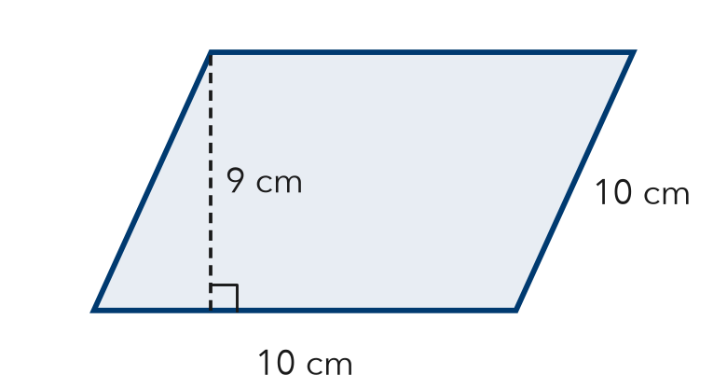
  Show your work.

3. Paper Kite. A kite is a rhombus. Find its area.  Hint Multiply the diagonals, then divide by 2.  Answer in² | 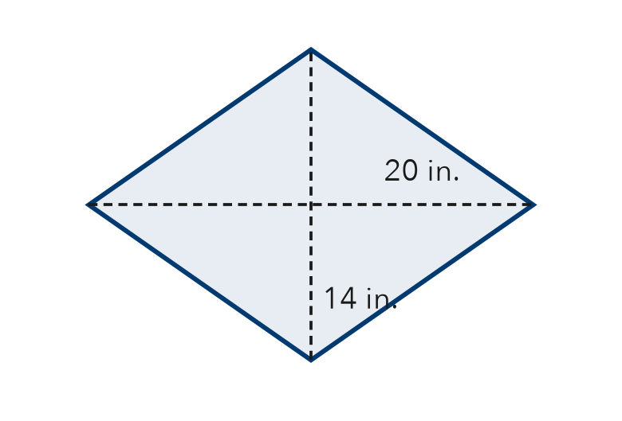
  Show your work.

4. Quilt Patch. A rhombus patch has an area of 84 cm². Its sides are 12 cm. Find its height.  Answer cm | 5. Window. A rhombus window has an area of 150 cm² and a height of 10 cm. Find its base.  Answer cm

6. Sail Panel. A rhombus sail panel has diagonals of 18 ft and 24 ft. Find its area.

Show your work.
Answer ft²

7. Missing Diagonal. A rhombus sign has an area of 60 m². One diagonal is 12 m. Find the other diagonal.
Hint Double the area, then divide by 12.

Show your work.
Answer m

8. Bike-Lane Marker. A rhombus marker has diagonals of 30 in. and 16 in. One strip of tape covers 60 in².
Hint Doubling both diagonals multiplies the area by 2 × 2.
a. Find the area. in²
b. How many strips cover it?
c. Both diagonals are doubled. Find the new area. How many times larger is it?

Show your work.

FIND THE ERROR explain the mistake, then fix it

9. Priya’s Work. A rhombus has diagonals of 10 cm and 16 cm. Priya wrote: “A = 10 × 16 = 160 cm².” Explain her mistake. Then find the area.

TEST PRACTICE choose the best answer

10. A rhombus has diagonals of 8 ft and 6 ft. What is its area?
A 14 ft² | B 24 ft² | C 48 ft² | D 96 ft²

11. Which statement is always true about a rhombus?
A All four sides are the same length. | B All four angles are right angles.
C Its diagonals are the same length. | D It has only one pair of parallel sides.

SELF-CHECK CODE find your answer · copy its letter into that problem’s box · spell a math word
7  O | 15  M | 90  R | 432  Z | 216  B | 480  X | 10  U | 140  H | 240  S | 280  Q

#2 | #3 | #4 | #5 | #6 | #7 | #8a

CHECK YOURSELF | □ I can do this on my own | □ I need a little help | □ I have a question about #

