Name Date Period
Lesson 5-1 · Session 2 · Practice · Form B
Area of Rhombuses
Learning target — I can find the area of a rhombus using the base and height or the two diagonals. · 6.G.A.1

REMEMBER  • A rhombus has 4 equal sides. It is a parallelogram, so A = b × h works.  • With two diagonals: A = d1 × d2 ÷ 2.  • Missing diagonal: double the area, then divide (24 × 2 = 48, 48 ÷ 6 = 8). | WORKED EXAMPLE  A rhombus has diagonals of 10 cm and 8 cm. Find its area.  Step 1 Use A = d1 × d2 ÷ 2.  Step 2 10 × 8 = 80  Step 3 80 ÷ 2 = 40  Answer 40 cm²
WORDS rhombus (rombo) · diagonal (diagonal) · congruent (congruente)
PRACTICE show your work · label units

1. Find the area of each rhombus. Choose the formula that fits.
a. diagonals 12 m and 9 m | b. base 13 in, height 8 in
c. diagonals 16 m and 5 m | d. base 7 cm, height 5 cm

2. Backsplash Tile. A rhombus tile has sides of 12 cm and a height of 11 cm. Find its area.  Hint Any side can be the base.  Answer cm² | 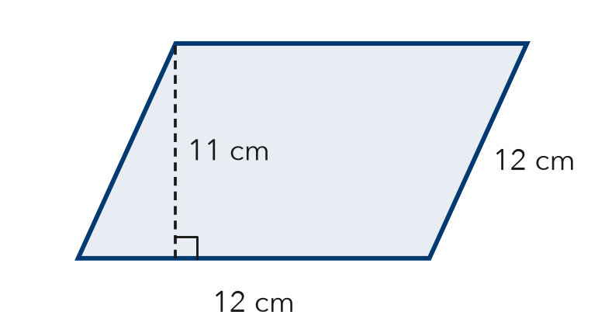
  Show your work.

3. Paper Kite. A kite is a rhombus. Find its area.  Hint Multiply the diagonals, then divide by 2.  Answer in² | 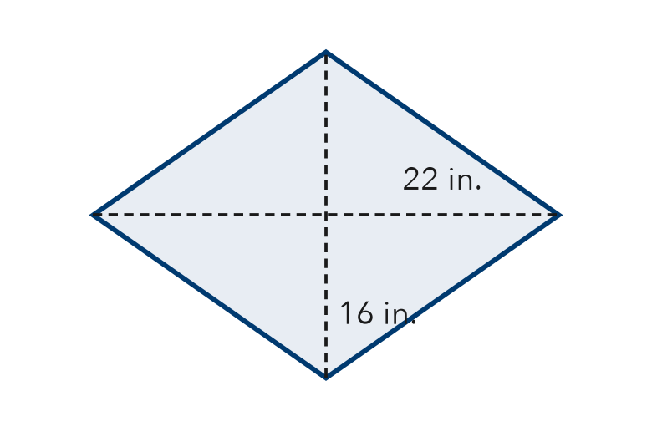
  Show your work.

4. Quilt Patch. A rhombus patch has an area of 126 cm². Its sides are 14 cm. Find its height.  Answer cm | 5. Window. A rhombus window has an area of 108 cm² and a height of 9 cm. Find its base.  Answer cm

6. Sail Panel. A rhombus sail panel has diagonals of 20 ft and 26 ft. Find its area.

Show your work.
Answer ft²

7. Missing Diagonal. A rhombus sign has an area of 45 m². One diagonal is 9 m. Find the other diagonal.
Hint Double the area, then divide by 9.

Show your work.
Answer m

8. Bike-Lane Marker. A rhombus marker has diagonals of 24 in. and 18 in. One strip of tape covers 54 in².
Hint Doubling both diagonals multiplies the area by 2 × 2.
a. Find the area. in²
b. How many strips cover it?
c. Both diagonals are doubled. Find the new area. How many times larger is it?

Show your work.

FIND THE ERROR explain the mistake, then fix it

9. Nia’s Work. A rhombus has diagonals of 12 ft and 9 ft. Nia wrote: “A = 12 × 9 = 108 ft².” Explain her mistake. Then find the area.

TEST PRACTICE choose the best answer

10. A rhombus has diagonals of 20 in. and 9 in. What is its area?
A 29 in² | B 45 in² | C 90 in² | D 180 in²

11. Which expression finds the area of a rhombus from its diagonals?
A d1 + d2 | B d1 × d2 | C (d1 × d2) ÷ 2 | D 2 × d1 × d2

SELF-CHECK CODE find your answer · copy its letter into that problem’s box · spell a math word
10  O | 9  L | 5  X | 352  Q | 520  Z | 176  O | 216  N | 260  G | 12  Y | 132  P

#2 | #3 | #4 | #5 | #6 | #7 | #8a

CHECK YOURSELF | □ I can do this on my own | □ I need a little help | □ I have a question about #

