Name Date Period
Lesson 5-2 · Session 1 · Practice · Form A
Area of Triangles
Learning target — I can find the area of a triangle using one half the base times the height. · 6.G.A.1

REMEMBER  • Two matching triangles make a parallelogram, so a triangle is half: A = ½ × b × h.  • The height makes a square corner with the base.  • In a right triangle, the two legs at the square corner are the base and height. | WORKED EXAMPLE  A triangle has a base of 14 cm and a height of 9 cm. Find its area.  Step 1 14 × 9 = 126  Step 2 126 is the parallelogram made by two triangles.  Step 3 126 ÷ 2 = 63  Answer 63 cm²
WORDS right triangle (triángulo rectángulo) · height (altura) · congruent (congruente)
PRACTICE show your work · label units

1. Find the area of each triangle with base b and height h.
a. b = 12 cm, h = 5 cm | b. b = 14 in, h = 3 in
c. b = 20 ft, h = 7 ft | d. b = 11 m, h = 8 m

2. Pennant Flag. Two copies of this flag fit together to make a parallelogram.  a. Area of the parallelogram in²  b. Area of one flag in² | 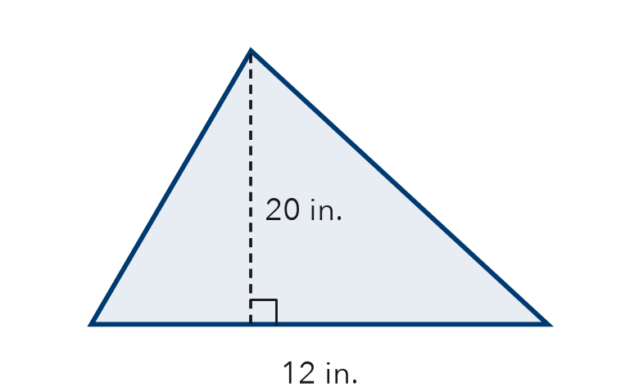

3. Cut Sandwich. A sandwich is cut on a diagonal into two equal triangles. Each has a base of 10 cm and a height of 8 cm.  a. Area of one triangle cm²  b. Whole sandwich cm² | 4. Right-Triangle Sail. A sail is a right triangle. Its two legs are 6 ft and 11 ft. Find its area.  Hint The legs meet at a square corner.  Answer ft²

5. Warning Sign. Find the area of the sign.  Hint Multiply, then take half.  Answer cm² | 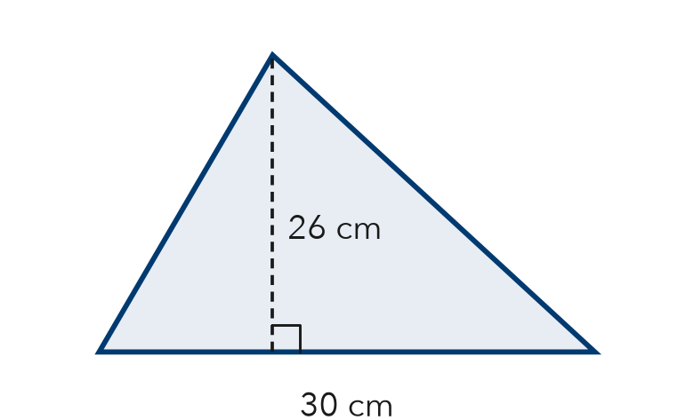

6. Recess Wedge. A wedge of the recess yard is a right triangle. Find its area.  Hint In a right triangle, the legs are the base and height.  Answer ft² | 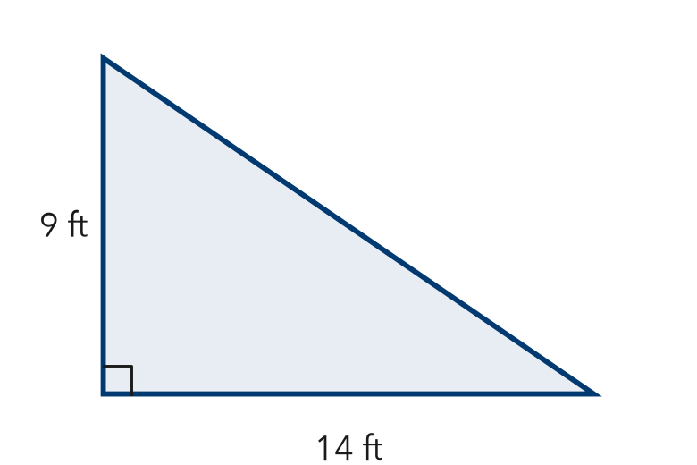

7. Two Banners. Banner P is a triangle with base 18 m and height 10 m. Banner Q has base 12 m and height 13 m. Find each area. Which covers more space?

Show your work.
Areas, which

8. Garden Plot. A triangular garden has a base of 24 ft and a height of 15 ft. One bag of mulch covers 30 ft² and costs $6.
a. Find the area. ft²
b. How many bags are needed?
c. Find the total cost. What happens to the cost if the base is doubled?

Show your work.

FIND THE ERROR explain the mistake, then fix it

9. Andre’s Work. A triangle has a base of 22 cm and a height of 10 cm. Andre wrote: “A = 22 × 10 = 220 cm².” Explain his mistake. Then find the area.

TEST PRACTICE choose the best answer

10. A triangle with base 14 in. and height 6 in. has area —
A 20 in² | B 42 in² | C 84 in² | D 168 in²

11. The area of a triangle is what fraction of a rectangle with the same base and height?
A 1/4 | B 1/3 | C 1/2 | D 2

SELF-CHECK CODE find your answer · copy its letter into that problem’s box · spell a math word
120  H | 33  L | 126  Z | 780  Q | 66  X | 63  I | 180  N | 390  V | 40  A | $36  G

#2b | #3a | #4 | #5 | #6 | #8a | #8c

CHECK YOURSELF | □ I can do this on my own | □ I need a little help | □ I have a question about #

