Name Date Period
Lesson 5-2 · Session 1 · Practice · Form B
Area of Triangles
Learning target — I can find the area of a triangle using one half the base times the height. · 6.G.A.1

REMEMBER  • Two matching triangles make a parallelogram, so a triangle is half: A = ½ × b × h.  • The height makes a square corner with the base.  • In a right triangle, the two legs at the square corner are the base and height. | WORKED EXAMPLE  A triangle has a base of 14 cm and a height of 9 cm. Find its area.  Step 1 14 × 9 = 126  Step 2 126 is the parallelogram made by two triangles.  Step 3 126 ÷ 2 = 63  Answer 63 cm²
WORDS right triangle (triángulo rectángulo) · height (altura) · congruent (congruente)
PRACTICE show your work · label units

1. Find the area of each triangle with base b and height h.
a. b = 16 cm, h = 5 cm | b. b = 9 in, h = 4 in
c. b = 22 ft, h = 6 ft | d. b = 13 m, h = 8 m

2. Pennant Flag. Two copies of this flag fit together to make a parallelogram.  a. Area of the parallelogram in²  b. Area of one flag in² | 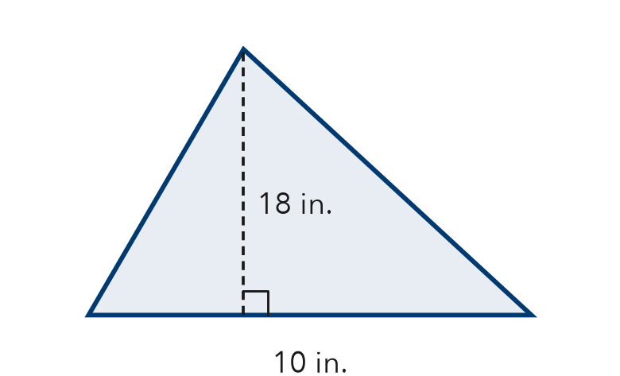

3. Cut Sandwich. A sandwich is cut on a diagonal into two equal triangles. Each has a base of 12 cm and a height of 9 cm.  a. Area of one triangle cm²  b. Whole sandwich cm² | 4. Right-Triangle Sail. A sail is a right triangle. Its two legs are 8 ft and 15 ft. Find its area.  Hint The legs meet at a square corner.  Answer ft²

5. Warning Sign. Find the area of the sign.  Hint Multiply, then take half.  Answer cm² | 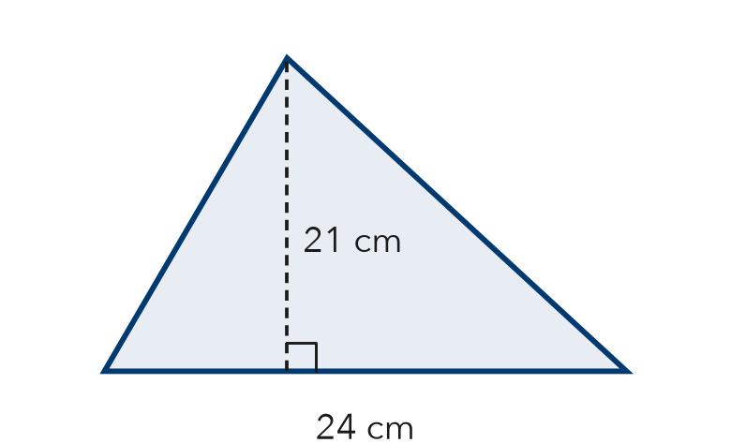

6. Recess Wedge. A wedge of the recess yard is a right triangle. Find its area.  Hint In a right triangle, the legs are the base and height.  Answer ft² | 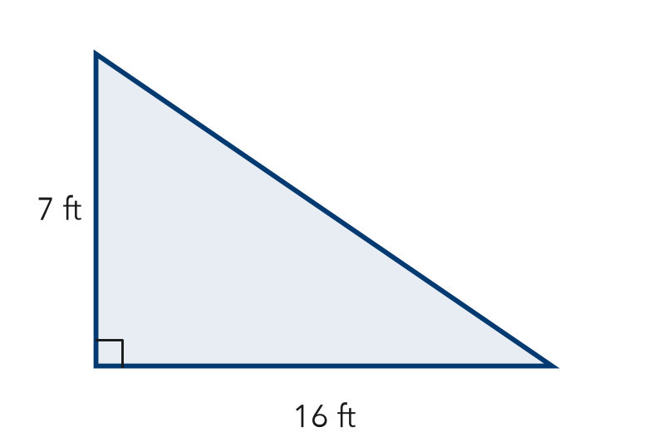

7. Two Banners. Banner P is a triangle with base 16 m and height 9 m. Banner Q has base 12 m and height 14 m. Find each area. Which covers more space?

Show your work.
Areas, which

8. Garden Plot. A triangular garden has a base of 20 ft and a height of 18 ft. One bag of mulch covers 30 ft² and costs $5.
a. Find the area. ft²
b. How many bags are needed?
c. Find the total cost. What happens to the cost if the base is doubled?

Show your work.

FIND THE ERROR explain the mistake, then fix it

9. Marta’s Work. A triangle has a base of 20 m and a height of 7 m. Marta wrote: “A = 20 × 7 = 140 m².” Explain her mistake. Then find the area.

TEST PRACTICE choose the best answer

10. A triangle with base 16 m and height 5 m has area —
A 21 m² | B 40 m² | C 80 m² | D 160 m²

11. The height of a triangle must meet the base at —
A a square corner (right angle) | B the longest side
C the middle of the base | D any angle

SELF-CHECK CODE find your answer · copy its letter into that problem’s box · spell a math word
504  Q | $30  T | 112  Z | 90  P | 56  U | 120  X | 54  R | 180  C | 60  O | 252  D

#2b | #3a | #4 | #5 | #6 | #8a | #8c

CHECK YOURSELF | □ I can do this on my own | □ I need a little help | □ I have a question about #

