Name Date Period
Lesson 5-2 · Session 2 · Practice · Form A
Missing Measures in Triangles
Learning target — I can find a missing base or height of a triangle when I know its area. · 6.G.A.1

REMEMBER  • Work backward from A = ½ × b × h.  • Double the area to undo the half, then divide by the measure you know.  • Check: ½ × b × h gives the area. A base or height is in cm, not cm². | WORKED EXAMPLE  Area 40 cm², base 10 cm. Find the height.  Step 1 40 = ½ × 10 × h  Step 2 2 × 40 = 80  Step 3 80 ÷ 10 = 8  Answer 8 cm
WORDS area (área) · formula (fórmula) · inverse operation (operación inversa)
PRACTICE show your work · label units

1. Find the missing measure of each triangle.
a. A = 18 cm², h = 4 cm; b = | b. A = 36 in², b = 9 in; h =
c. A = 50 m², h = 10 m; b = | d. A = 63 ft², b = 14 ft; h =

2. Park Lot. A triangular lot covers 126 yd². Its height is 18 yd.  Hint Double the area first.  a. Fill in the formula: 126 = ½ × ×  b. Find the base b. yd | 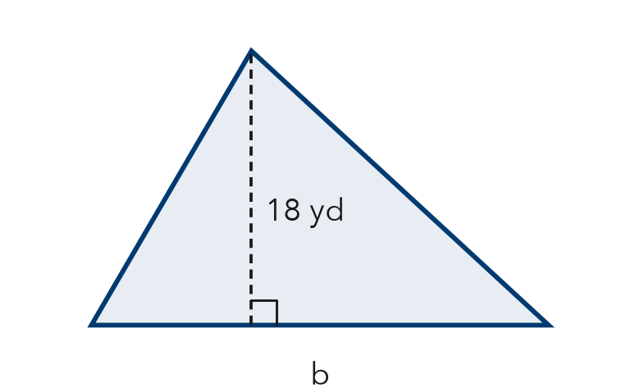

3. Quilt Piece. A triangular quilt piece has an area of 54 in² and a base of 12 in. Find the height.  Answer in. | 4. Roof Gable. A triangular gable covers 117 ft². Its height is 9 ft. Find the base.  Answer ft

5. Awning Panel. The awning panel covers 60 ft². Find the height h.  Hint Undo the ½ by doubling 60.  Answer ft | 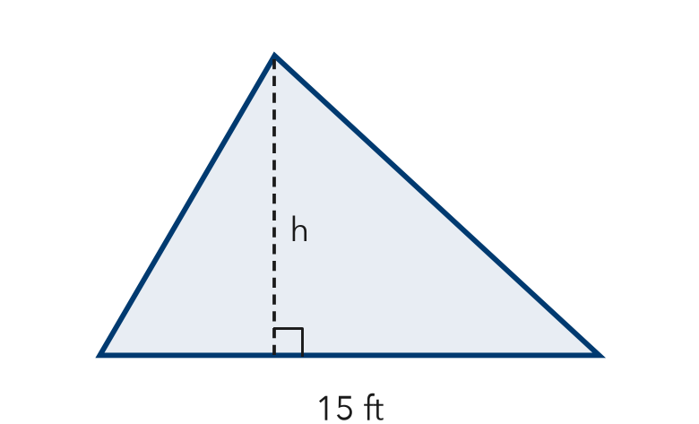

6. Sign Claim. A triangular sign has an area of 84 cm² and a height of 7 cm. Rosa says the base must be 28 cm. Is she right? Use the formula.  Hint Put Rosa’s base into ½ × b × h and check.  Base | 7. Sandbox Wedge. A triangular wedge of a sandbox covers 45 m². Its height is 5 m. Find the base.  Answer m
  Show your work.
  Show your work.

8. Two Signs. Sign A is a triangle with area 120 ft² and base 16 ft. Sign B is a triangle with area 120 ft² and height 12 ft.
a. Find the height of Sign A. ft
b. Find the base of Sign B. ft
c. Both signs have the same area. How can their shapes be different?

Show your work.

FIND THE ERROR explain the mistake, then fix it

9. Bennett’s Work. A triangle has an area of 66 ft² and a base of 11 ft. Bennett wrote: “66 ÷ 11 = 6, so the height is 6 ft.” Explain his mistake. Then find the height.

TEST PRACTICE choose the best answer

10. A triangle has area 60 cm² and base 10 cm. Its height is —
A 6 cm | B 12 cm | C 50 cm | D 600 cm

11. A triangle has area 45 in² and height 9 in. Its base is —
A 5 in. | B 36 in. | C 10 in. | D 405 in.

SELF-CHECK CODE find your answer · copy its letter into that problem’s box · spell a math word
13  Z | 14  M | 26  S | 20  G | 7  Q | 9  I | 24  I | 18  N | 4  X | 8  S

#2b | #3 | #4 | #5 | #6 | #7 | #8b

CHECK YOURSELF | □ I can do this on my own | □ I need a little help | □ I have a question about #

