EXIT TICKET · LESSON 5-2 · SESSION 1 Name
Area of Triangles

1. Find the area of each triangle.
a. b = 18 in, h = 11 in in² | b. b = 7 cm, h = 4 cm cm²

2. Find the area. The height falls outside the triangle.  Answer in² | 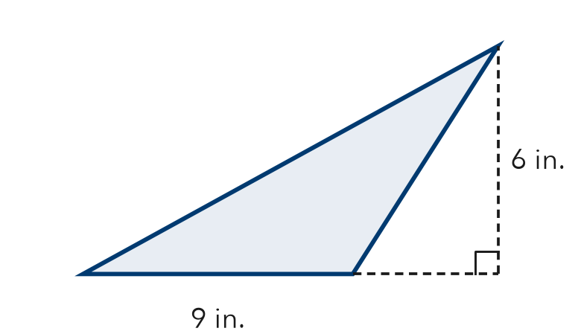

3. Which formula gives the area of a triangle?
A A = b × h | B A = ½ × b × h | C A = b + h | D A = 2 × b × h

HOW DID IT GO? □ I got it □ Almost □ I need help
cut here
EXIT TICKET · LESSON 5-2 · SESSION 1 Name
Area of Triangles

1. Find the area of each triangle.
a. b = 18 in, h = 11 in in² | b. b = 7 cm, h = 4 cm cm²

2. Find the area. The height falls outside the triangle.
Answer in²

3. Which formula gives the area of a triangle?
A A = b × h | B A = ½ × b × h | C A = b + h | D A = 2 × b × h

HOW DID IT GO? □ I got it □ Almost □ I need help
EXIT TICKET · LESSON 5-2 · SESSION 2 Name
Missing Measures in Triangles

1. Find the missing measure.
a. A = 72 cm², b = 12 cm; h = cm | b. A = 135 in², h = 15 in; b = in

2. The area is 35 ft². Find the base b.  Answer ft | 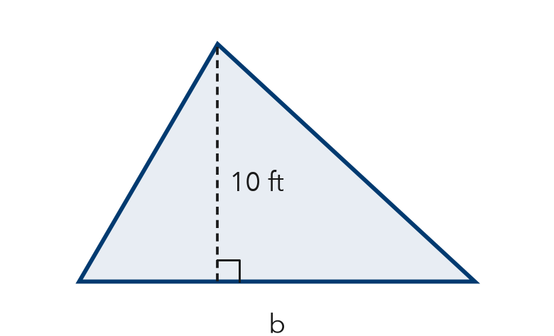

3. Forgetting to double the area gives a missing measure that is —
A twice as big as it should be | B half as big as it should be
C exactly right | D in square units

HOW DID IT GO? □ I got it □ Almost □ I need help
cut here
EXIT TICKET · LESSON 5-2 · SESSION 2 Name
Missing Measures in Triangles

1. Find the missing measure.
a. A = 72 cm², b = 12 cm; h = cm | b. A = 135 in², h = 15 in; b = in

2. The area is 35 ft². Find the base b.
Answer ft

3. Forgetting to double the area gives a missing measure that is —
A twice as big as it should be | B half as big as it should be
C exactly right | D in square units

HOW DID IT GO? □ I got it □ Almost □ I need help

