Name Date Period
Lesson 5-2 · Session 1 · Guided Notes
Area of Triangles
Learning target — I can find the area of a triangle using one half the base times the height. · 6.G.A.1
WORDS TO KNOW fill in the missing words
WORD | WHAT IT MEANS | EXAMPLE
right triangle  triángulo rectángulo | A triangle with one corner. | its two legs are b and h
height  altura | The distance from the base to the opposite corner, at a angle. | h in A = ½ × b × h
congruent  congruente | Exactly the same and shape. | 2 congruent triangles make a parallelogram
KEY IDEA complete each sentence
• Two congruent triangles make a .
• So a triangle’s area is of base × height: A = ½ × b × h.
• In a right triangle, the two are the base and the height.
WORKED EXAMPLE fill in the blanks as we solve
A triangle has a base of 14 cm and a height of 9 cm. Find its area.
Step 1 14 × 9 =
Step 2 126 cm² is the area of the parallelogram made by two triangles.
Step 3 126 ÷ 2 =
Answer The area is cm².
YOU TRY use the example as a model

1. Find the area of each triangle.
a. b = 10 m, h = 7 m m² | b. b = 8 ft, h = 5 ft ft²

2. Find the area of the right triangle.  Answer cm² | 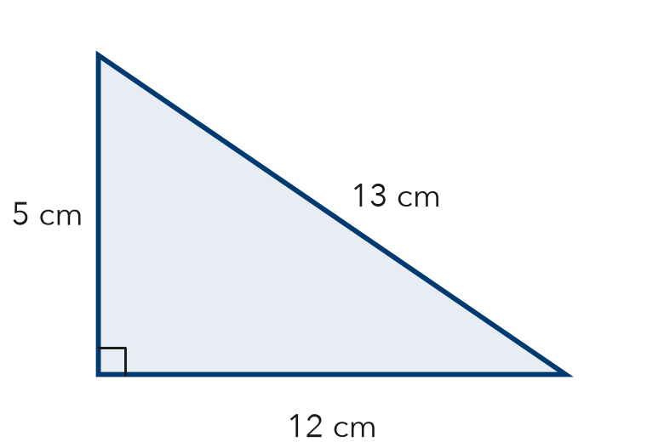
  Show your work.

SUM IT UP in your own words
The triangle formula has a ½ because .
Name Date Period
Lesson 5-2 · Session 2 · Guided Notes
Missing Measures in Triangles
Learning target — I can find a missing base or height of a triangle when I know its area. · 6.G.A.1
WORDS TO KNOW fill in the missing words
WORD | WHAT IT MEANS | EXAMPLE
area  área | The space inside a shape, measured in units. | 40 cm²
formula  fórmula | A rule written with and symbols. | A = ½ × b × h
inverse operation  operación inversa | An operation that another. | doubling undoes taking half
KEY IDEA complete each sentence
• Undo the half first: the area.
• Then by the measure you know.
• A base or height is a length, so use units like cm, not .
WORKED EXAMPLE fill in the blanks as we solve
A triangle has an area of 40 cm² and a base of 10 cm. Find the height.
Step 1 40 = ½ × 10 × h
Step 2 Double the area: 2 × 40 =
Step 3 Divide by the base: 80 ÷ 10 =
Answer The height is cm.
YOU TRY use the example as a model

1. Find the missing measure.
a. A = 30 ft², h = 6 ft; b = ft | b. A = 21 m², b = 7 m; h = m

2. The area of the triangle is 48 m². Find the height h.  Answer m | 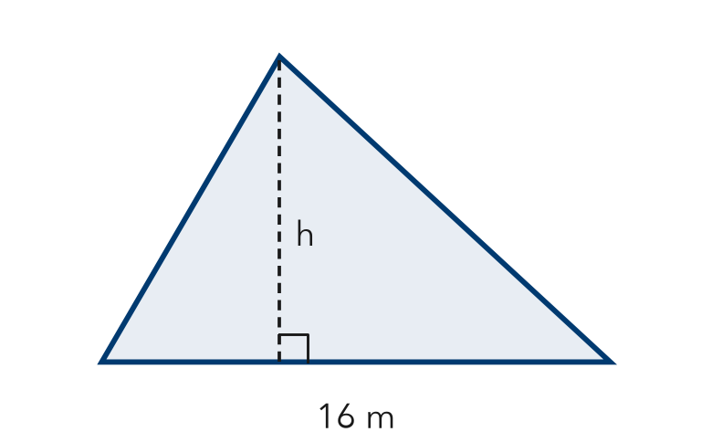
  Show your work.

SUM IT UP in your own words
To find a missing base or height, I double the area first because .

