Name Date Period
Lesson 5-2 · Homework Packet · Level 1 · Sheet 1 of 2
Area of Triangles
Maryland Standard 6.G.A.1 · Learning target — I can find the area of a triangle using one half the base times the height.

REMEMBER  • A triangle is half of a parallelogram with the same base and height: A = ½ × b × h.  • The height meets the base at a right angle. It can fall outside the triangle.  • Area is in square units (cm², in², ft²). | WORKED EXAMPLE  Find the area of a triangle with base 14 cm and height 9 cm.  Step 1 Write the formula: A = ½ × b × h  Step 2 Substitute: A = ½ × 14 × 9  Step 3 Multiply: ½ × 14 = 7, and 7 × 9 = 63  Answer 63 cm²

WORD BANK  base — the bottom side of the triangle  height — straight up from the base, at a square corner | ½ × b × h — half of base times height  area — space inside, in square units
PRACTICE show your work · label units

1. Find the area of the triangle.  Step 1 Multiply the base and the height.  Step 2 Take half of that.  Answer cm² | 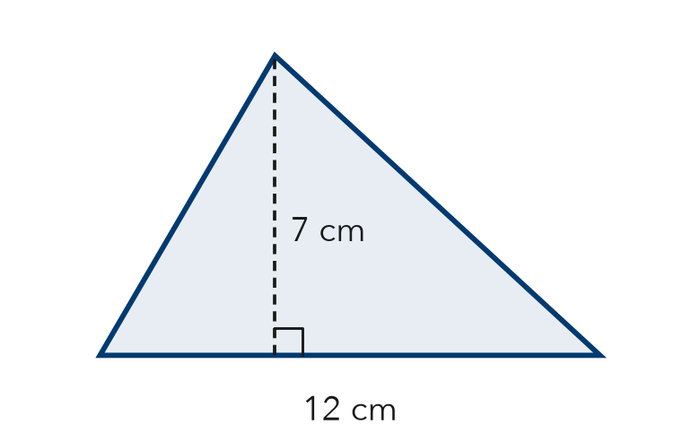
  Show your work.

2. Find the area of the triangle. The height falls outside the triangle.  Step 1 Use 9 in and 8 in. The dashed line is the height.  Step 2 Multiply, then take half.  Answer in² | 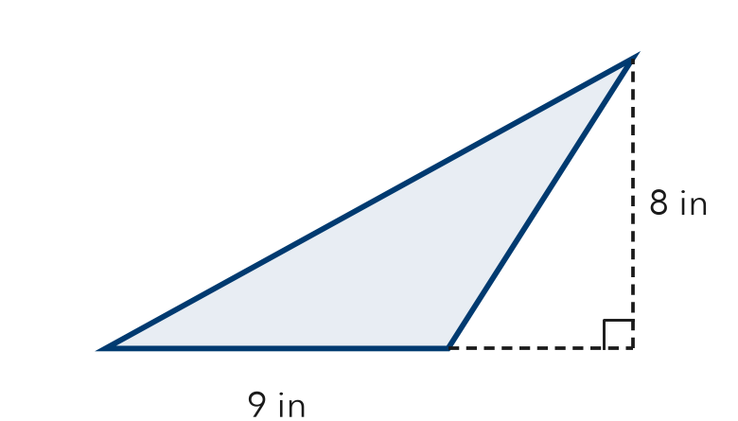
  Show your work.

3. Find the area of each triangle with base b and height h.
Step 1 Multiply b × h for each one.
Step 2 Take half.
a. b = 10 cm, h = 9 cm cm² | b. b = 5 ft, h = 11 ft ft²

4. Garden Bed. Maya’s garden bed is a triangle: base 15 feet, height 6 feet. One bag of soil covers 9 square feet. How many bags does she need?
Step 1 Find the area: ½ × 15 × 6.
Step 2 Divide the area by 9.

Show your work.
Answer bags

5. Find the Error. Jon says the area of a triangle with base 8 m and height 5 m is 40 m². Explain his mistake and find the correct area.
Frame Jon forgot to . The area is ½ × 8 × 5 = m².

CHECK YOURSELF | □ I can do this on my own | □ I need a little help | □ I have a question about #
AT HOME Find a triangle at home (a sign, a sandwich half, a roof). Estimate its base and height and its area.
Name Date Period
Lesson 5-2 · Homework Packet · Level 1 · Sheet 2 of 2
Missing Measures in Triangles
Maryland Standard 6.G.A.1 · Learning target — I can find a missing base or height of a triangle when I know its area.

REMEMBER  • Know the area and one measure? Double the area, then divide by the measure you know: h = 2A ÷ b and b = 2A ÷ h.  • Check: ½ × b × h should equal the given area. | WORKED EXAMPLE  Area = 30 in², base = 12 in. Find the height.  Step 1 Double the area: 2 × 30 = 60  Step 2 Divide by the base: 60 ÷ 12 = 5  Step 3 Check: ½ × 12 × 5 = 30, so it checks  Answer h = 5 in

WORD BANK  missing measure — the base or height you need to find  double — multiply by 2 | divide — share into equal groups; undo multiplying  check — put your answer back in ½ × b × h
PRACTICE show your work · label units

1. Complete the table. Each row describes one triangle.
Step 1 Double the area.
Step 2 Divide by the measure you know.
 | Base | Height | Area
Triangle A | 8 in |  | 28 in²
Triangle B |  | 9 ft | 54 ft²

2. The area of the triangle is 48 m². Find the height h.  Step 1 Double the area: 2 × 48.  Step 2 Divide by the base, 16.  Answer m | 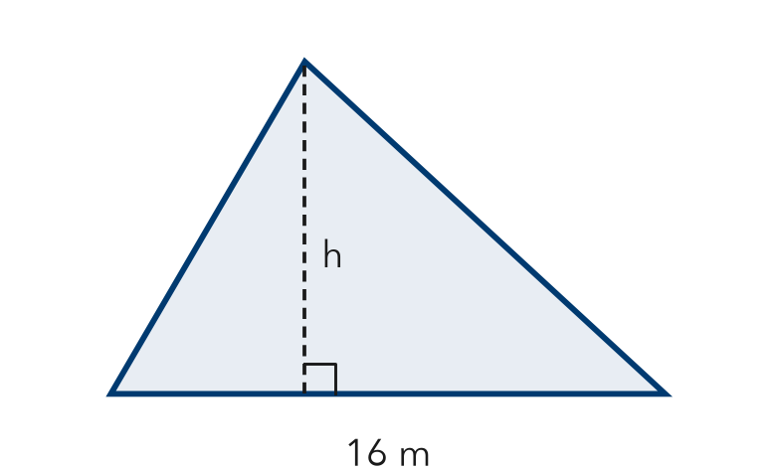
  Show your work.

3. Find the missing measure of each triangle.
a. A = 40 m², b = 10 m; h = m | b. A = 27 in², h = 6 in; b = in

4. Sail. A sail is a triangle. Its area is 35 square feet. Its height is 10 feet. How long is its base?
Step 1 Double the area: 2 × 35.
Step 2 Divide by 10.
Answer ft

5. Compare. Triangle P: base 12 cm, height 5 cm. Triangle Q: base 6 cm, height 10 cm. Which has more area? Explain.
Frame P has cm² and Q has cm², so .

TEST PRACTICE choose the best answer

6. A triangle has an area of 24 square units and a height of 4 units. What is the length of its base?
Step 1 Double 24.
Step 2 Divide by 4.
A 3 units | B 6 units | C 12 units | D 48 units

7. Which expression gives the area of a triangle with base 18 m and height 5 m?
A 18 × 5 | B ½ × 18 × 5 | C 18 + 5 | D 2 × 18 × 5

CHECK YOURSELF | □ I can do this on my own | □ I need a little help | □ I have a question about #

