Name Date Period
Lesson 5-2 · Session 1 · Prerequisite Practice B · Skill 1 of 2
Area of Parallelograms
Builds on Lesson 5-1 Session 1 · 6.G.A.1
TODAY’S LESSON | You will see that two flags make a parallelogram with area 12 × 20 = 240 in².
YOU NEED TO | Find the area of a parallelogram: base × height. You will use it in Practice Form A, problems 2 and 3.
STEPS TO FOLLOW use these same steps on every problem
1 | Find the base and the height.
2 | Multiply: A = b × h.
3 | Write square units.
WATCH ME the steps in action
Base 14 cm, height 6 cm. Find the area.  Step 1 Base 14 cm. Height 6 cm.  Step 2 14 × 6 = 84.  Step 3 The area is 84 cm².  Answer 84 cm² | 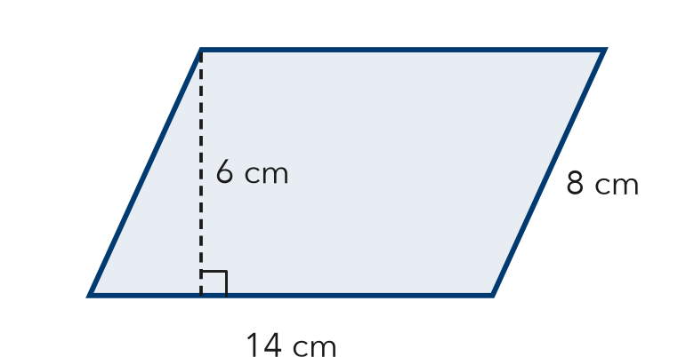

TRY IT WITH HELP fill in each step
1. Base 12 in., height 20 in. Find the area.
Step 1 Base in. Height in.
Step 2 12 × 20 =
Step 3 The area is in².

2. Base 10 cm, height 8 cm. Find the area.
Step 1 Base cm. Height cm.
Step 2 10 × 8 =
Step 3 The area is cm².

YOUR TURN use the steps on your own

3. Find each area.
a. b = 9, h = 4: | b. b = 15, h = 6: | c. b = 11, h = 8:
d. b = 20, h = 7: | e. b = 12, h = 5: | f. b = 25, h = 4:

Lesson 5-2 · Session 1 · Prerequisite Practice B · Skill 2 of 2
Identify Base and Height
Builds on Lesson 5-1 Session 1 · 6.G.A.1
TODAY’S LESSON | You will use the two legs of a right triangle as base and height.
YOU NEED TO | Find the base and the height, which meet at a square corner. You will use it in Practice Form A, problems 4 and 6.
STEPS TO FOLLOW use these same steps on every problem
1 | Find the square corner (right angle).
2 | The two sides at that corner are the base and the height.
3 | The longest side is never used.
WATCH ME the steps in action
Sides 6 ft, 8 ft, 10 ft. Name the base and height.
Step 1 The square corner is between the 6 ft and 8 ft sides.
Step 2 Base 6 ft and height 8 ft.
Step 3 The 10 ft side is longest. Do not use it.
Answer Base 6 ft, height 8 ft
TRY IT WITH HELP fill in each step
4. A right triangle has sides 9 m, 12 m, and 15 m.
Step 1 The square corner is between m and m.
Step 2 Base and height: m and m.
Step 3 The longest side is m. Do not use it.

5. A right triangle has sides 5 in., 12 in., and 13 in.
Step 1 The square corner is between in. and in.
Step 2 Base and height: in. and in.
Step 3 The longest side is in. Do not use it.

YOUR TURN use the steps on your own

6. Write the base and the height of each right triangle.
a. sides 3, 4, 5 | b. sides 8, 15, 17
c. sides 7, 24, 25 | d. sides 6, 8, 10

READY CHECK a problem like the one in today’s lesson

7. A sail has sides 14, 9, and 16.6 ft. Which are base and height?
A 14 and 9 | B 14 and 16.6 | C 9 and 16.6 | D All three

CHECK YOURSELF | □ I can do this on my own | □ I need a little help | □ I have a question about #

