Name Date Period
Lesson 5-3 · Session 1 · Practice · Form B
Trapezoids by Decomposing
Learning target — I can find the area of a trapezoid by decomposing it into a rectangle and triangles. · 6.G.A.1

REMEMBER  • A trapezoid has one pair of parallel sides, called the bases. The height meets the bases at a square corner.  • Decompose: cut it into a rectangle and one or two triangles. Find each area, then add.  • The triangle bases together equal the long base − short base. Two matching triangles split it in half. | WORKED EXAMPLE  Bases 6 cm and 14 cm, height 5 cm, two matching triangles.  Step 1 Rectangle: 6 × 5 = 30 cm².  Step 2 Each triangle base: (14 − 6) ÷ 2 = 4 cm.  Step 3 Triangles: 2 × (½ × 4 × 5) = 20 cm².  Answer 30 + 20 = 50 cm²
WORDS trapezoid (trapecio) · decompose (descomponer) · height (altura)
PRACTICE show your work · label units

1. Each trapezoid is cut into a rectangle and two matching triangles. Find the base of one triangle.
a. bases 12 in and 20 in | b. bases 6 m and 16 m
c. bases 9 cm and 21 cm | d. bases 15 ft and 23 ft

2. Craft Tabletop. A craft tabletop is an isosceles trapezoid. It is cut into a rectangle and two matching triangles.  a. Area of the rectangle in²  b. Area of both triangles in²  c. Area of the tabletop in² | 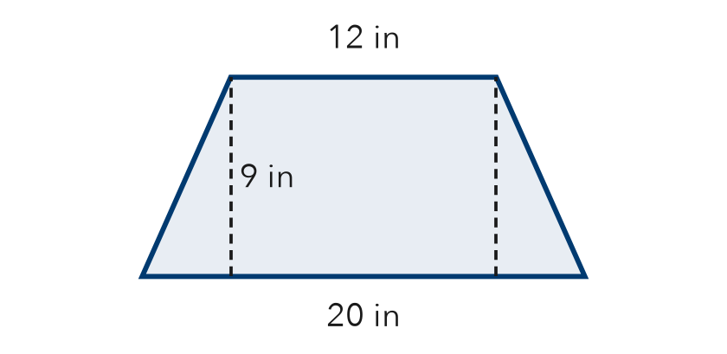

3. Right-Angle Deck. A deck is a trapezoid with one square corner. Decompose it into a rectangle and a triangle. Find its area.  Hint One triangle only. Its base is the long side minus the short side.  Answer ft² | 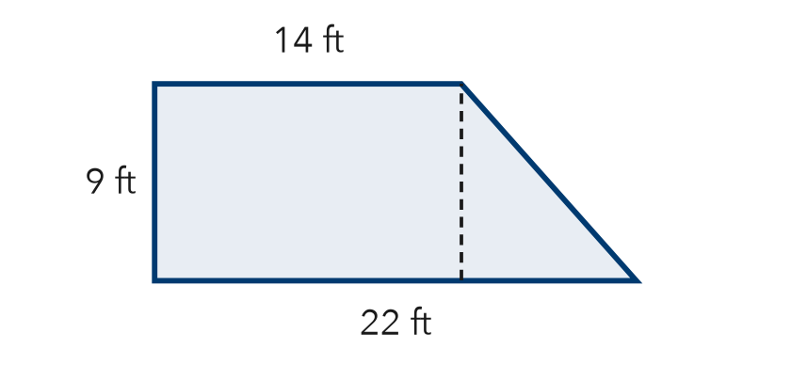
  Show your work.

4. Bus Shelter Roof. A roof panel is an isosceles trapezoid with bases 6 m and 16 m and a height of 8 m. Find its area.  Hint Split the leftover 16 − 6 into two equal triangle bases.  Answer m² | 5. Corner Garden. A garden is a trapezoid with one square corner. Its parallel sides are 9 yd and 15 yd, and the height is 14 yd. Find its area.  Answer yd²
  Show your work.
  Show your work.

6. Tray and Mat. A lunch tray is an isosceles trapezoid with bases 14 in and 24 in and a height of 12 in. A placemat is a rectangle 19 in by 12 in. Find each area. Do they cover the same space?
Hint Find the tray by decomposing, then the mat as length × width.

Show your work.
Same or not

7. Stage Apron. A stage apron is an isosceles trapezoid with bases 15 m and 25 m and a height of 8 m. Decompose it and find its total area.  Hint Slice off the two end triangles. A rectangle is left in the middle.  Answer m² | 8. Deck Plan. A deck is a trapezoid with bases 12 ft and 20 ft and a height of 5 ft. Decking costs $9 per square foot.  a. Area of each piece  b. Total area ft²  c. Total cost
  Show your work.
  Show your work.

FIND THE ERROR explain the mistake, then fix it

9. Amina’s Work. A trapezoid has bases 13 m and 23 m and a height of 8 m. Amina cut it into a rectangle and two triangles, then wrote: “Area = 13 × 8 = 104 m².” Explain the mistake and find the correct area.

TEST PRACTICE choose the best answer

10. Every piece of a decomposed trapezoid has the same —
A base | B area | C height | D slanted side

11. A rectangle 8 cm by 5 cm plus a triangle with area 12 cm² gives a total area of —
A 25 cm² | B 40 cm² | C 52 cm² | D 64 cm²

SELF-CHECK CODE find your answer · copy its letter into that problem’s box · spell a math word
228  I | 168  T | 162  E | 144  S | 128  X | 720  N | 160  O | 120  Z | 88  C | 200  Q

#2c | #3 | #4 | #5 | #6 | #7 | #8c

CHECK YOURSELF | □ I can do this on my own | □ I need a little help | □ I have a question about #

