EXIT TICKET · LESSON 5-3 · SESSION 1 Name
Trapezoids by Decomposing

1. This trapezoid has one square corner. Decompose it and find its area.  Answer yd² | 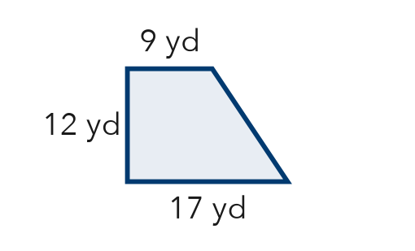
  Show your work.

2. A trapezoid has bases 12 cm and 20 cm and a height of 7 cm. It is cut into a rectangle and two triangles.
a. rectangle = cm² | b. both triangles = cm²

3. After you decompose a trapezoid, how do you find its total area?
A Add the areas of the pieces.
B Multiply the areas of the pieces.
C Use only the rectangle.
D Subtract the triangles from the rectangle.

HOW DID IT GO? □ I got it □ Almost □ I need help
cut here
EXIT TICKET · LESSON 5-3 · SESSION 1 Name
Trapezoids by Decomposing

1. This trapezoid has one square corner. Decompose it and find its area.

Show your work.
Answer yd²

2. A trapezoid has bases 12 cm and 20 cm and a height of 7 cm. It is cut into a rectangle and two triangles.
a. rectangle = cm² | b. both triangles = cm²

3. After you decompose a trapezoid, how do you find its total area?
A Add the areas of the pieces.
B Multiply the areas of the pieces.
C Use only the rectangle.
D Subtract the triangles from the rectangle.

HOW DID IT GO? □ I got it □ Almost □ I need help
EXIT TICKET · LESSON 5-3 · SESSION 2 Name
The Trapezoid Area Formula

1. Find each area.
a. 5 cm, 9 cm; h = 4 cm cm² | b. 10 ft, 16 ft; h = 3 ft ft²

2. A patio is shaped like this trapezoid. Find its area.  Answer ft² | 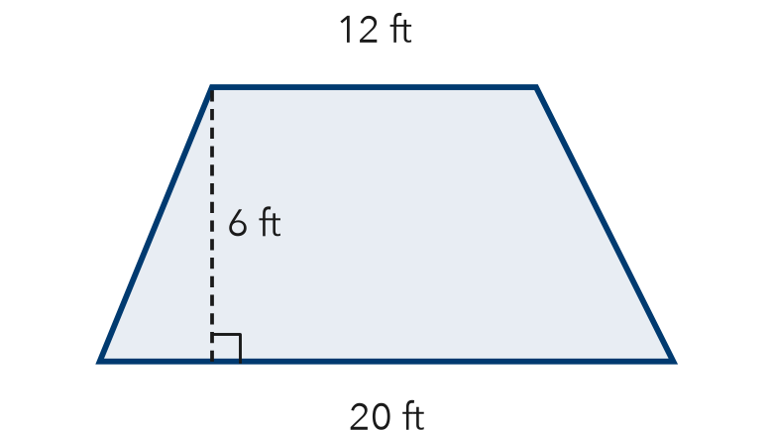
  Show your work.

3. Which expression finds the area of a trapezoid with bases 5 cm and 13 cm and height 4 cm?
A ½ × 5 × 13 × 4 | B (5 + 13) × 4 | C ½ × (5 + 13) × 4 | D 5 + 13 × 4 ÷ 2

HOW DID IT GO? □ I got it □ Almost □ I need help
cut here
EXIT TICKET · LESSON 5-3 · SESSION 2 Name
The Trapezoid Area Formula

1. Find each area.
a. 5 cm, 9 cm; h = 4 cm cm² | b. 10 ft, 16 ft; h = 3 ft ft²

2. A patio is shaped like this trapezoid. Find its area.

Show your work.
Answer ft²

3. Which expression finds the area of a trapezoid with bases 5 cm and 13 cm and height 4 cm?
A ½ × 5 × 13 × 4 | B (5 + 13) × 4 | C ½ × (5 + 13) × 4 | D 5 + 13 × 4 ÷ 2

HOW DID IT GO? □ I got it □ Almost □ I need help

