Name Date Period
Lesson 5-3 · Session 1 · Guided Notes
Trapezoids by Decomposing
Learning target — I can find the area of a trapezoid by decomposing it into a rectangle and triangles. · 6.G.A.1
WORDS TO KNOW fill in the missing words
WORD | WHAT IT MEANS | EXAMPLE
trapezoid  trapecio | A with one pair of parallel sides (the bases). | bases 6 cm and 14 cm
height  altura | The distance between the two bases. | h, at a square corner
decompose  descomponer | To a shape into smaller shapes you know. | rectangle + 2 triangles
KEY IDEA complete each sentence
• Cut a trapezoid into a and one or two triangles.
• Find the area of each piece, then the areas.
• Together, the triangle bases equal the of the two bases.
WORKED EXAMPLE fill in the blanks as we solve
An isosceles trapezoid has bases 6 cm and 14 cm and a height of 5 cm. Find its area.
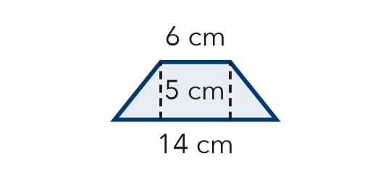
Step 1 Rectangle: 6 × 5 = cm².
Step 2 Leftover: 14 − 6 = 8, so each triangle base is cm.
Step 3 Both triangles: 2 × (½ × 4 × 5) = cm².
Answer Area = 30 + 20 = cm²
YOU TRY use the example as a model

1. This trapezoid has one square corner. Decompose it and find its area.  Answer in² | 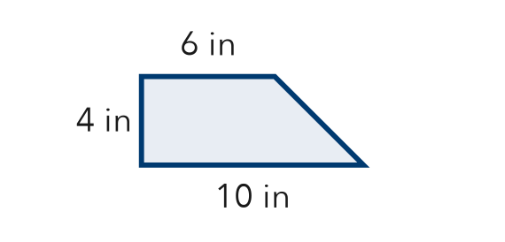
  Show your work.

2. Each trapezoid has two matching end triangles. Find the base of one triangle.
a. bases 8 m and 14 m | b. bases 12 cm and 20 cm

SUM IT UP in your own words
To find a trapezoid’s area by decomposing, I and then .
Name Date Period
Lesson 5-3 · Session 2 · Guided Notes
The Trapezoid Area Formula
Learning target — I can find the area of a trapezoid using the trapezoid area formula. · 6.G.A.1
WORDS TO KNOW fill in the missing words
WORD | WHAT IT MEANS | EXAMPLE
base  base | One of the two sides of a trapezoid. | b1 and b2
height  altura | The distance between the two bases. | h
formula  fórmula | A written with letters and numbers. | A = ½(b1 + b2)h
right trapezoid  trapecio rectángulo | A trapezoid with two angles. | its straight side is the height
KEY IDEA complete each sentence
• Area of a trapezoid: A = ½ × ( ) × h.
• the bases first, then multiply by the height, then take half.
• Two copies of a trapezoid make a , so the trapezoid is half of it.
WORKED EXAMPLE fill in the blanks as we solve
A trapezoid has bases 6 m and 12 m and a height of 4 m. Find its area.
Step 1 Add the bases: 6 + 12 = .
Step 2 Multiply by the height: 18 × 4 = .
Step 3 Take half: 72 ÷ 2 = .
Answer A = m²
YOU TRY use the example as a model

1. Find the area of the trapezoid.  Answer cm² | 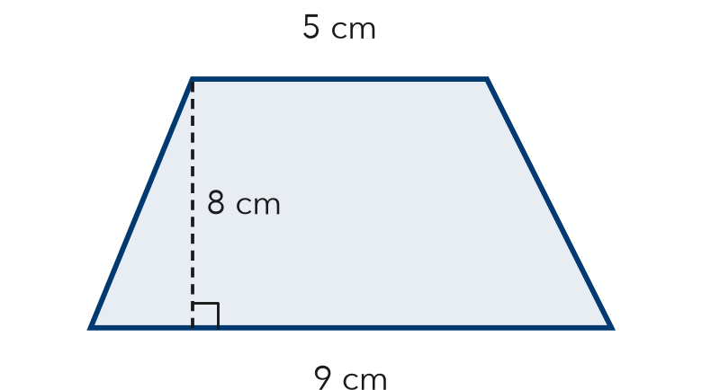
  Show your work.

2. Find each area.
a. 3 m, 7 m; h = 4 m m² | b. 10 in, 12 in; h = 5 in in²

SUM IT UP in your own words
To use the trapezoid formula, I first because .

