Name Date Period
Lesson 5-3 · Session 1 · Prerequisite Practice B · Skill 1 of 2
Area of Triangles
Builds on Lesson 5-2 Session 1 · 6.G.A.1
TODAY’S LESSON | Each end piece of the trapezoid is a triangle. You find its area with 1/2 × b × h.
YOU NEED TO | Find a triangle’s area, like 1/2 × 4 × 6 = 12. You will use it in Practice Form A, problems 2 and 8.
STEPS TO FOLLOW use these same steps on every problem
1 | Find the base and the height.
2 | Multiply base × height.
3 | Halve the product.
WATCH ME the steps in action
A triangle has base 5 m and height 10 m. Find its area.
Step 1 b = 5, h = 10.
Step 2 5 × 10 = 50.
Step 3 50 ÷ 2 = 25.
Answer 25 m²
TRY IT WITH HELP fill in each step
1. A triangle has base 4 ft and height 6 ft. Find its area.
Step 1 b = , h =
Step 2 4 × 6 =
Step 3 24 ÷ 2 = ft²

2. A triangle has base 6 in and height 16 in. Find its area.
Step 1 b = , h =
Step 2 6 × 16 =
Step 3 96 ÷ 2 = in²

YOUR TURN use the steps on your own

3. Find the area of each triangle.
a. b = 8, h = 5 | b. b = 3, h = 10 | c. b = 7, h = 4
d. b = 9, h = 6 | e. b = 12, h = 5 | f. b = 10, h = 13

Lesson 5-3 · Session 1 · Prerequisite Practice B · Skill 2 of 2
Identify Base and Height
Builds on Lesson 5-1 Session 1 · 6.G.A.1
TODAY’S LESSON | Every piece you cut from a trapezoid deck uses the same height, like 6 ft.
YOU NEED TO | Pick the height: the distance that makes a square corner, never a slanted side. You will use it in Practice Form A, problems 3 and 8.
STEPS TO FOLLOW use these same steps on every problem
1 | Pick a side as the base.
2 | Find the segment that makes a square corner with it.
3 | That segment is the height. Skip slanted sides.
WATCH ME the steps in action
Bases 10 ft and 18 ft, slanted sides about 7 ft, dashed line 6 ft. Which is the height?  Step 1 The base is the 18 ft side.  Step 2 The 6 ft line makes a square corner.  Step 3 The height is 6 ft, not the 7 ft slanted side.  Answer h = 6 ft | 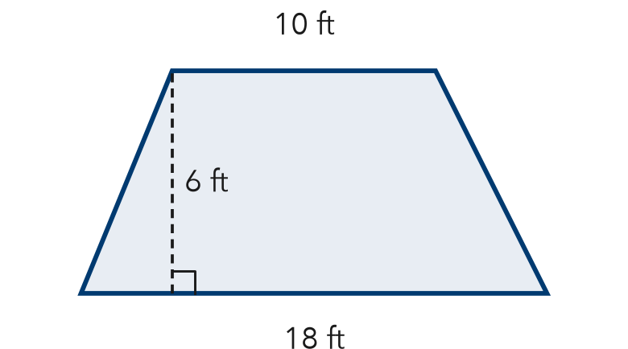

TRY IT WITH HELP fill in each step
4. A triangle has base 12 cm, slanted side 10 cm, dashed line 8 cm. Find the height.
Step 1 The base is cm.
Step 2 The cm line makes a square corner.
Step 3 The height is cm.

5. Bases 9 in and 15 in, slanted sides 5 in, dashed line 4 in. Find the height.
Step 1 The long base is in.
Step 2 The in line makes a square corner.
Step 3 The height is in.

YOUR TURN use the steps on your own

6. Write the height. “Corner” is the line that makes a square corner.
a. base 10, slanted 6, corner 5 | b. base 14, corner 9, slanted 11
c. slanted 13, base 20, corner 12 | d. base 8, corner 3, slanted 5

READY CHECK a problem like the one in today’s lesson

7. Bases 8 m and 18 m, slanted sides 13 m, height 12 m. Which number is h?
A 8 m | B 12 m | C 13 m | D 18 m

CHECK YOURSELF | □ I can do this on my own | □ I need a little help | □ I have a question about #

