Name Date Period
Lesson 5-4 · Session 1 · Practice · Form A
Area of Regular Polygons
Learning target — I can find the area of a regular polygon by finding the area of one triangle and multiplying. · 6.G.A.1

REMEMBER  • A regular polygon has equal sides and equal angles. Lines from the center make congruent triangles.  • Each triangle’s base is one side. Its height is the apothem.  • Area = n × (½ × side × apothem). Use ≈ when the apothem is rounded. | WORKED EXAMPLE  Regular pentagon: sides 10 cm, apothem about 7 cm.  Step 1 5 sides make 5 triangles.  Step 2 One triangle: ½ × 10 × 7 = 35 cm².  Step 3 Five triangles: 5 × 35 = 175.  Answer Area ≈ 175 cm²
WORDS regular polygon (polígono regular) · apothem (apotema) · congruent (congruente)
PRACTICE show your work · label units

1. Find the area of one center triangle: ½ × side × apothem.
a. side 10 cm, apothem 7 cm cm² | b. side 16 in, apothem 11 in in²
c. side 7 m, apothem 8 m m² | d. side 6 ft, apothem 9 ft ft²

2. Gazebo Floor. A gazebo floor is a regular hexagon with sides of 9 ft. The apothem is about 7.8 ft.  a. How many center triangles?  b. Area of one triangle ft²  c. Area of the floor ft² | 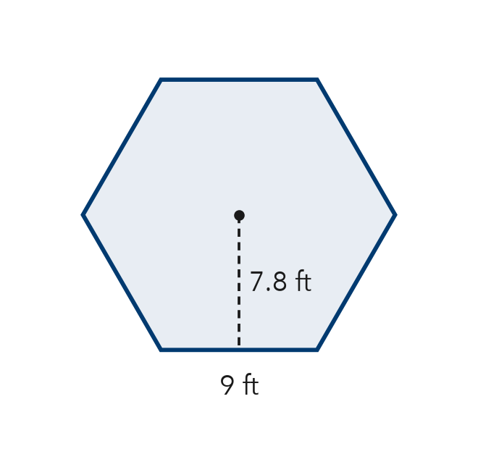

3. Pentagon Sign. A regular pentagon road sign has sides of 16 in and an apothem of about 11 in. Find its area.  Hint A pentagon has 5 center triangles.  Answer in² | 4. Stepping Stone. A stepping stone is a regular octagon with sides of 7 cm and an apothem of about 8 cm. Find its area.  Hint Find one triangle, then multiply by the number of sides.  Answer cm²
  Show your work.
  Show your work.

5. Flower Bed. A flower bed is a regular hexagon with sides of 24 ft. Each center triangle has a height of about 21 ft. Find the area of the flower bed.

Show your work.
Answer ft²

6. Pentagon Patio. A patio is a regular pentagon. Decompose it into center triangles and find its area.  Hint All the triangles share the same base and height.  Answer m² | 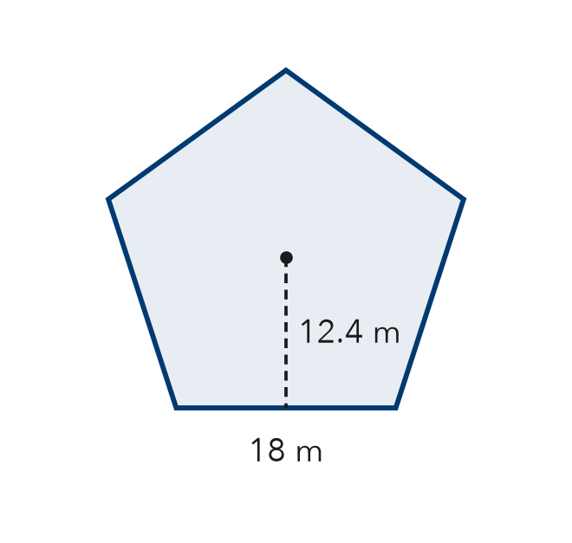
  Show your work.

7. Jamal’s Tile. A tile is a regular hexagon with sides of 10 cm and an apothem of about 9 cm. Jamal says the tile’s area is 45 cm². Is Jamal right? Explain.
Hint How many triangles make up the whole tile?

Show your work.
True area

8. Tile Design. A floor uses regular hexagon tiles with sides of 8 cm and an apothem of 6.9 cm.
a. Find the area of one tile. cm²
b. Find the area covered by 25 tiles. cm²

Show your work.

FIND THE ERROR explain the mistake, then fix it

9. Lena’s Work. A regular pentagon has sides of 22 in and an apothem of 15 in. Lena wrote: “A = 22 × 15 × 5 = 1,650 in².” Explain the mistake and find the correct area.

TEST PRACTICE choose the best answer

10. A regular hexagon splits into how many congruent center triangles?
A 4 | B 5 | C 6 | D 8

11. One center triangle of a regular pentagon has an area of 20 cm². The pentagon’s area is —
A 25 cm² | B 40 cm² | C 100 cm² | D 120 cm²

SELF-CHECK CODE find your answer · copy its letter into that problem’s box · spell a math word
440  O | 45  Q | 1,512  Y | 1,116  Z | 558  G | 224  L | 4,140  N | 210.6  P | 270  O | 880  X

#2c | #3 | #4 | #5 | #6 | #7 | #8b

CHECK YOURSELF | □ I can do this on my own | □ I need a little help | □ I have a question about #

