Name Date Period
Lesson 5-4 · Session 1 · Practice · Form B
Area of Regular Polygons
Learning target — I can find the area of a regular polygon by finding the area of one triangle and multiplying. · 6.G.A.1

REMEMBER  • A regular polygon has equal sides and equal angles. Lines from the center make congruent triangles.  • Each triangle’s base is one side. Its height is the apothem.  • Area = n × (½ × side × apothem). Use ≈ when the apothem is rounded. | WORKED EXAMPLE  Regular pentagon: sides 10 cm, apothem about 7 cm.  Step 1 5 sides make 5 triangles.  Step 2 One triangle: ½ × 10 × 7 = 35 cm².  Step 3 Five triangles: 5 × 35 = 175.  Answer Area ≈ 175 cm²
WORDS regular polygon (polígono regular) · apothem (apotema) · congruent (congruente)
PRACTICE show your work · label units

1. Find the area of one center triangle: ½ × side × apothem.
a. side 12 cm, apothem 8 cm cm² | b. side 14 in, apothem 9 in in²
c. side 5 m, apothem 6 m m² | d. side 9 ft, apothem 10 ft ft²

2. Gazebo Floor. A gazebo floor is a regular hexagon with sides of 12 ft. The apothem is about 10.4 ft.  a. How many center triangles?  b. Area of one triangle ft²  c. Area of the floor ft² | 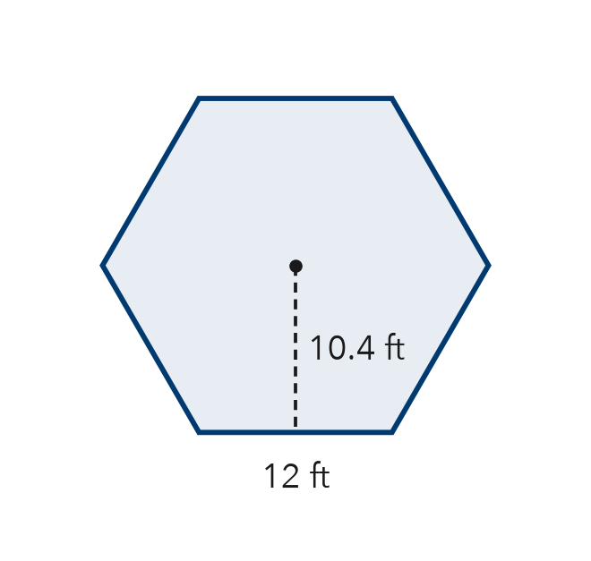

3. Pentagon Sign. A regular pentagon road sign has sides of 14 in and an apothem of about 9.6 in. Find its area.  Hint A pentagon has 5 center triangles.  Answer in² | 4. Stepping Stone. A stepping stone is a regular octagon with sides of 6 cm and an apothem of about 7.2 cm. Find its area.  Hint Find one triangle, then multiply by the number of sides.  Answer cm²
  Show your work.
  Show your work.

5. Flower Bed. A flower bed is a regular hexagon with sides of 20 ft. Each center triangle has a height of about 17.3 ft. Find the area of the flower bed.

Show your work.
Answer ft²

6. Pentagon Patio. A patio is a regular pentagon. Decompose it into center triangles and find its area.  Hint All the triangles share the same base and height.  Answer m² | 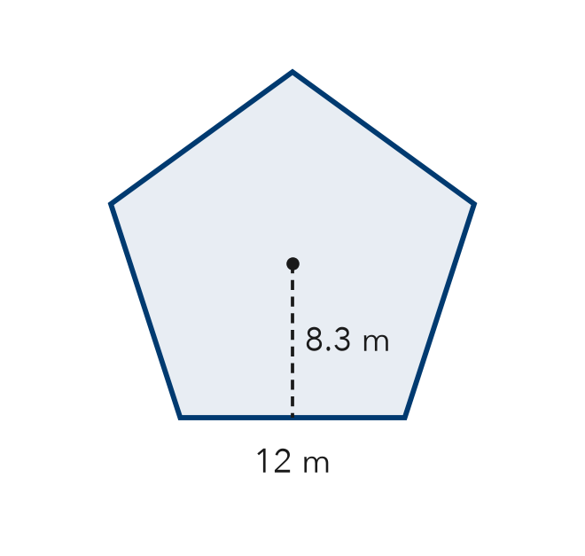
  Show your work.

7. Keisha’s Tile. A tile is a regular hexagon with sides of 8 cm and an apothem of about 7 cm. Keisha says the tile’s area is 28 cm². Is Keisha right? Explain.
Hint How many triangles make up the whole tile?

Show your work.
True area

8. Tile Design. A floor uses regular hexagon tiles with sides of 6 cm and an apothem of 5.2 cm.
a. Find the area of one tile. cm²
b. Find the area covered by 30 tiles. cm²

Show your work.

FIND THE ERROR explain the mistake, then fix it

9. Mateo’s Work. A regular octagon has sides of 10 in and an apothem of 12 in. Mateo wrote: “A = 10 × 12 × 8 = 960 in².” Explain the mistake and find the correct area.

TEST PRACTICE choose the best answer

10. A regular octagon splits into how many congruent center triangles?
A 6 | B 7 | C 8 | D 10

11. To find a regular polygon’s area, multiply one triangle’s area by the —
A apothem | B number of sides | C side length | D perimeter

SELF-CHECK CODE find your answer · copy its letter into that problem’s box · spell a math word
28  Q | 1,038  A | 336  E | 374.4  H | 172.8  X | 672  J | 168  O | 249  G | 2,808  N | 498  Z

#2c | #3 | #4 | #5 | #6 | #7 | #8b

CHECK YOURSELF | □ I can do this on my own | □ I need a little help | □ I have a question about #

