Name Date Period
Lesson 5-4 · Session 2 · Practice · Form B
Composite Figures
Learning target — I can find the area of a composite figure by adding or subtracting the areas of simpler shapes. · 6.G.A.1

REMEMBER  • A composite figure is made of simpler shapes: rectangles, triangles, squares.  • Add the areas of pieces that are joined. Subtract the area of a piece that is cut out.  • Use each piece’s own formula: rectangle l × w, triangle ½ × b × h. | WORKED EXAMPLE  A 14 cm by 9 cm rectangle has a triangle (base 6 cm, height 4 cm) cut out.  Step 1 Whole rectangle: 14 × 9 = 126 cm².  Step 2 Cut-out triangle: ½ × 6 × 4 = 12 cm².  Step 3 Removed, so subtract: 126 − 12.  Answer 114 cm² left
WORDS composite figure (figura compuesta) · add (sumar) · subtract (restar)
PRACTICE show your work · label units

1. Decide whether to add or subtract. Then find each area.
a. 36 cm² rectangle + 10 cm² triangle cm² | b. 81 in² square, 25 in² cut out in²
c. 8 ft square, 2 ft square cut out ft² | d. 12 m × 5 m, 3 m square cut out m²

2. Swallowtail Flag. A flag starts as a rectangle 24 in by 16 in. A triangle notch 6 in deep is cut out of the right edge.  a. Area of the whole rectangle in²  b. Area of the notch in²  c. Area of the flag in² | 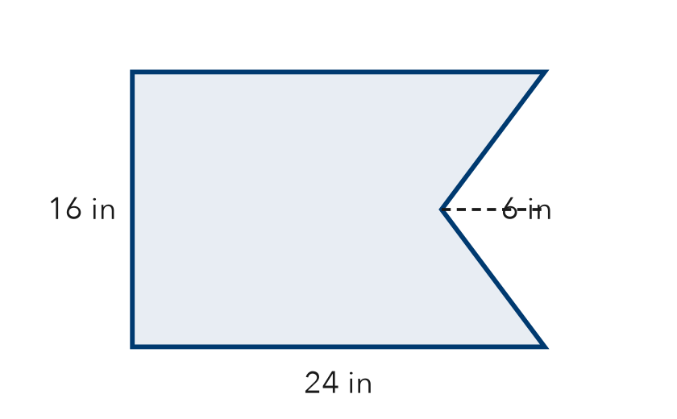

3. L-Shaped Room. An L-shaped floor splits into a 12 ft by 9 ft rectangle and a 4 ft by 10 ft rectangle. Find the floor area.  Answer ft² | 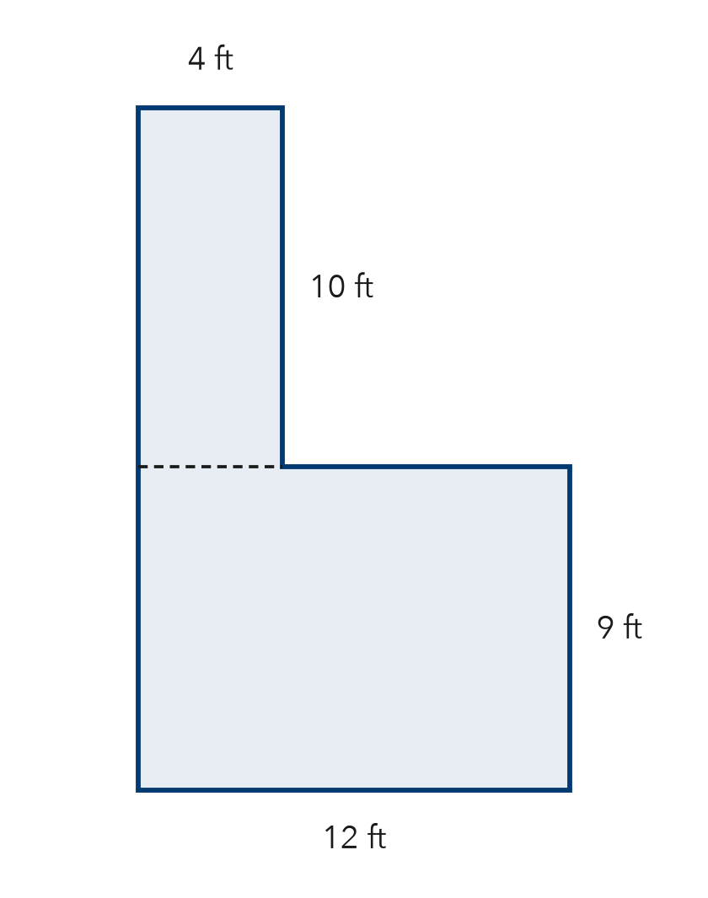
  Show your work.

4. Wall and Window. A wall is 18 ft long and 9 ft tall. A square window 4 ft on each side is not painted. Find the painted area.  Hint The window is taken away.  Answer ft² | 5. Plywood Sheet. A plywood sheet is 20 ft by 8 ft. A 5 ft by 3 ft opening is cut out. How much plywood is left?  Answer ft²
  Show your work.
  Show your work.

6. House Front. A house front is a rectangle with a triangle roof. Find the total area.  Hint Use each shape’s own formula, then add.  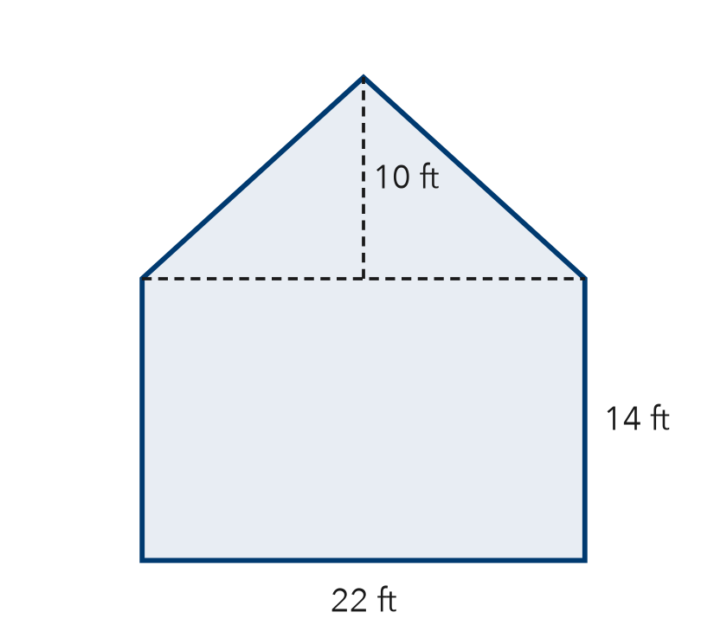  Answer ft² | 7. Nico’s Poster. A poster is 30 in by 24 in. An 8 in square is cut from one corner. Nico says 720 in² is left. Is Nico right?  Hint Did the corner square get taken away?  Area left
  Show your work.
  Show your work.

8. Playground Plan. A playground is 28 m by 18 m. Rubber covers all of it except a triangle sandbox (base 10 m, height 8 m). Rubber costs $12 per m².
a. Area of the whole rectangle m²
b. Area covered with rubber m²
c. Cost of the rubber

Show your work.

FIND THE ERROR explain the mistake, then fix it

9. Lila’s Work. A wall is 17 ft by 10 ft with a 4 ft by 4 ft vent that is not painted. Lila wrote: “Painted area = 170 + 16 = 186 ft².” Explain the mistake and fix it.

TEST PRACTICE choose the best answer

10. A 64 in² square with a 9 in² square cut out has an area of —
A 55 in² | B 73 in² | C 61 in² | D 576 in²

11. A 50 cm² rectangle joined to a 15 cm² triangle has a total area of —
A 35 cm² | B 50 cm² | C 65 cm² | D 750 cm²

SELF-CHECK CODE find your answer · copy its letter into that problem’s box · spell a math word
656  N | 432  Q | 146  M | 784  Z | 5,568  D | 464  E | 336  C | 418  I | 148  O | 145  B

#2c | #3 | #4 | #5 | #6 | #7 | #8b | #8c

CHECK YOURSELF | □ I can do this on my own | □ I need a little help | □ I have a question about #

