Name Date Period
Lesson 5-4 · Homework Packet · Level 1 · Sheet 1 of 2
Area of Regular Polygons
Maryland Standard 6.G.A.1 · Learning target — I can find the area of a regular polygon by finding the area of one triangle and multiplying.

REMEMBER  • Regular polygon: equal sides, equal angles.  • Lines from the center to each vertex make n congruent triangles. Each one’s height is the apothem.  • A = n × (½ × side × apothem). Use ≈ if rounded. | WORKED EXAMPLE  Regular hexagon: side 8 cm, apothem ≈ 6.9 cm.  Step 1 A hexagon makes 6 congruent triangles.  Step 2 One triangle: ½ × 8 × 6.9 = 27.6  Step 3 Six triangles: 6 × 27.6 = 165.6  Answer ≈ 165.6 cm²

WORD BANK  regular polygon — all sides equal, all angles equal  apothem — center to the middle of a side | congruent — same size and same shape  ≈ — about
PRACTICE show your work · label units

1. Find the area of the regular octagon. The apothem is rounded.  Step 1 Find one triangle: ½ × 10 × 12.1.  Step 2 An octagon has 8 triangles. Multiply by 8.  Answer m² | 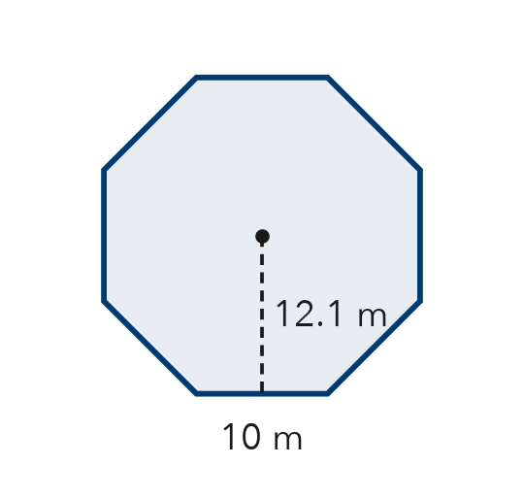
  Show your work.

2. Complete the table. Each apothem is rounded, so mark each area with ≈.
Step 1 Perimeter = number of sides × side.
Step 2 Area ≈ ½ × perimeter × apothem.
Regular polygon | Side | Apothem | Perimeter | Area
Hexagon | 4 cm | 3.5 cm
Pentagon | 10 ft | 6.9 ft

3. Each regular polygon has perimeter P and rounded apothem a. Find each area. Mark it with ≈.
a. pentagon: P = 30 cm, a ≈ 4.1 cm cm² | b. hexagon: P = 60 ft, a ≈ 8.7 ft ft²

4. Gazebo Floor. A gazebo floor is a regular hexagon. Each side is 6 ft. The apothem is about 5.2 ft. Tile costs $3 for each square foot. About how much does the tile cost?
Step 1 Find the area: 6 × (½ × 6 × 5.2).
Step 2 Multiply the area by $3.

Show your work.
Answer

5. Find the Error. Andre says a regular pentagon with sides of 8 cm and an apothem of 5.5 cm has area ½ × 8 × 5.5 = 22 cm². Explain his mistake and find the area.
Frame Andre found only triangle. A pentagon has triangles, so the area is .

CHECK YOURSELF | □ I can do this on my own | □ I need a little help | □ I have a question about #
Name Date Period
Lesson 5-4 · Homework Packet · Level 1 · Sheet 2 of 2
Composite Figures
Maryland Standard 6.G.A.1 · Learning target — I can find the area of a composite figure by adding or subtracting the areas of simpler shapes.

REMEMBER  • A composite figure is made of simpler shapes.  • Add the areas of joined shapes. Subtract a piece that is cut out.  • Use the sides you know to find missing sides. | WORKED EXAMPLE  House front: a 10 ft × 6 ft rectangle with a triangular roof on top. The roof’s base is 10 ft and it is 4 ft tall.  Step 1 Rectangle: 10 × 6 = 60  Step 2 Triangle: ½ × 10 × 4 = 20  Step 3 The shapes are joined, so add: 60 + 20 = 80  Answer 80 ft²

WORD BANK  composite figure — a shape made of simpler shapes  add — put areas together | subtract — take away a cut-out area  right angle — a square corner
PRACTICE show your work · label units

1. Find the area of the L-shaped figure. All corners are right angles.  Step 1 Cut the L into two rectangles.  Step 2 Find each rectangle’s area.  Step 3 Add the two areas.  Answer m² | 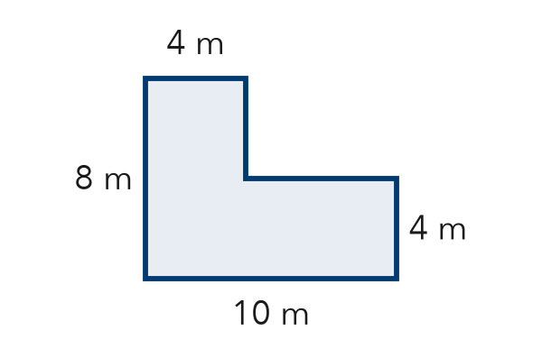
  Show your work.

2. Write add or subtract to tell how you would find each area.
a. a wall, not counting its window: | b. a bedroom plus its closet:

3. Find the area of the T-shaped figure. All corners are right angles.  Step 1 Cut the T into a top bar and a stem.  Step 2 Find each rectangle’s area.  Step 3 Add the two areas.  Answer in² | 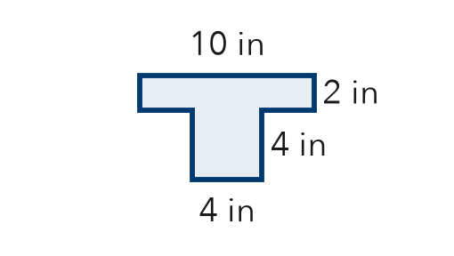

4. A triangle notch 4 cm deep is cut from the top of a rectangle. Find the area that is left.  Step 1 Find the rectangle: 12 × 8.  Step 2 Notch base: 12 − 3 − 3. Find the triangle.  Step 3 Subtract the triangle.  Answer cm² | 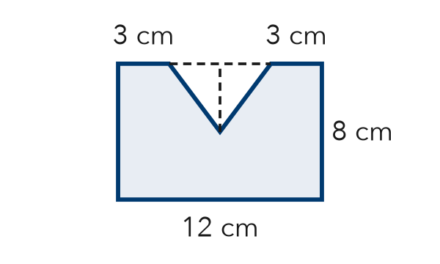

5. Backyard. A yard is a rectangle, 20 ft by 12 ft. A square garden is in one corner. Each side of the garden is 5 ft. The garden is not paved. Find the paved area.
Step 1 Find the yard area.
Step 2 Subtract the garden area.
Answer ft²

TEST PRACTICE choose the best answer

6. A rectangle 9 m by 6 m has a square 2 m by 2 m cut out. What area is left?
A 50 m² | B 58 m² | C 54 m² | D 13 m²

7. A 10 in by 4 in rectangle is joined to a triangle with base 4 in and height 3 in. What is the total area?
A 34 in² | B 40 in² | C 46 in² | D 52 in²

CHECK YOURSELF | □ I can do this on my own | □ I need a little help | □ I have a question about #

