Name Date Period
Lesson 5-4 · Session 2 · Prerequisite Practice B · Skill 1 of 2
Area of Triangles
Builds on Lesson 5-2 Session 1 · 6.G.A.1
TODAY’S LESSON | You will add a triangle roof to a rectangle, like ½ × 26 × 11 for the house front.
YOU NEED TO | Find a triangle’s area with A = ½ × b × h, like ½ × 18 × 7. You will use it in Practice Form A, problems 2, 6, and 8.
STEPS TO FOLLOW use these same steps on every problem
1 | Write A = ½ × b × h with the numbers.
2 | Halve the even number first.
3 | Multiply what is left. Write square units.
WATCH ME the steps in action
A roof triangle has a base of 18 ft and a height of 7 ft. Find its area.
Step 1 A = ½ × 18 × 7.
Step 2 Half of 18 is 9.
Step 3 9 × 7 = 63, so 63 ft².
Answer 63 ft²
TRY IT WITH HELP fill in each step
1. Base 16 ft, height 6 ft. Find the area.
Step 1 A = ½ × ×
Step 2 Half of 16 is
Step 3 8 × 6 = ft²

2. Base 18 in, height 5 in. Find the area.
Step 1 A = ½ × ×
Step 2 Half of 18 is
Step 3 9 × 5 = in²

YOUR TURN use the steps on your own

3. Find each area. Use A = ½ × b × h.
a. ½ × 12 × 10 = | b. ½ × 26 × 9 = | c. ½ × 30 × 7 =
d. ½ × 16 × 11 = | e. ½ × 22 × 8 = | f. ½ × 9 × 6 =

Lesson 5-4 · Session 2 · Prerequisite Practice B · Skill 2 of 2
Area of Regular Polygons
Builds on Lesson 5-4 Session 1 · 6.G.A.1
TODAY’S LESSON | You will split a figure into pieces, like the 18 m patio into 5 triangles.
YOU NEED TO | Split a regular polygon into equal triangles. Find one, then multiply. You will use it in Session 1 Practice Form A, problem 6.
STEPS TO FOLLOW use these same steps on every problem
1 | Count the sides. That is the number of center triangles.
2 | Find one triangle: ½ × side × apothem.
3 | Multiply one triangle by the number of triangles.
WATCH ME the steps in action
A regular pentagon has sides of 10 m and an apothem of 7 m. Find its area.  Step 1 A pentagon has 5 sides, so 5 triangles.  Step 2 ½ × 10 × 7 = 35.  Step 3 5 × 35 = 175.  Answer 175 m² | 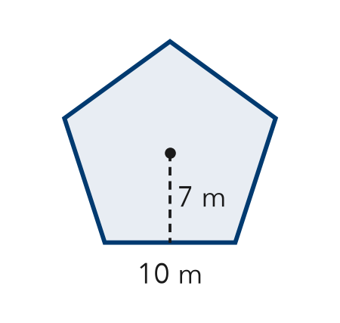

TRY IT WITH HELP fill in each step
4. A regular hexagon has sides of 8 in and an apothem of 7 in. Find its area.
Step 1 Number of triangles:
Step 2 ½ × 8 × 7 = in²
Step 3 6 × 28 = in²

5. A regular octagon has sides of 4 ft and an apothem of 5 ft. Find its area.
Step 1 Number of triangles:
Step 2 ½ × 4 × 5 = ft²
Step 3 8 × 10 = ft²

YOUR TURN use the steps on your own

6. Find the area of each regular polygon.
a. hexagon, side 6, apothem 5 | b. pentagon, side 8, apothem 6
c. octagon, side 4, apothem 6 | d. square, side 6, apothem 3

READY CHECK a problem like the one in today’s lesson

7. A 10 in by 6 in rectangle has a triangle roof: b = 10 in, h = 4 in. Total area?
A 60 in² | B 80 in² | C 100 in² | D 40 in²

CHECK YOURSELF | □ I can do this on my own | □ I need a little help | □ I have a question about #

