Name Date Period
Lesson 5-5 · Session 1 · Practice · Form B
Volume of Rectangular Prisms
Learning target — I can find the volume of a rectangular prism by multiplying length, width, and height. · 6.G.A.2

REMEMBER  • Volume is the space inside a solid, counted in unit cubes. Write cubic units: cm³, in³, ft³.  • One layer = length × width = base area B. The height counts the layers.  • V = l × w × h or V = B × h. | WORKED EXAMPLE  A box is 6 cm long, 3 cm wide, and 4 cm tall.  Step 1 One layer: 6 × 3 = 18 cubes.  Step 2 4 layers stack up.  Step 3 18 × 4 = 72.  Answer V = 72 cm³
WORDS volume (volumen) · rectangular prism (prisma rectangular) · cubic units (unidades cúbicas)
PRACTICE show your work · label units

1. Find the volume of each rectangular prism.
a. 9 cm × 5 cm × 6 cm cm³ | b. 8 ft × 3 ft × 2 ft ft³
c. 10 ft × 7 ft × 2 ft ft³ | d. B = 36 in², h = 8 in in³

2. Toy Chest. A toy chest is packed with cubes 1 ft on each edge, as shown.  a. Cubes in the bottom layer  b. Number of layers  c. Volume of the chest ft³ | 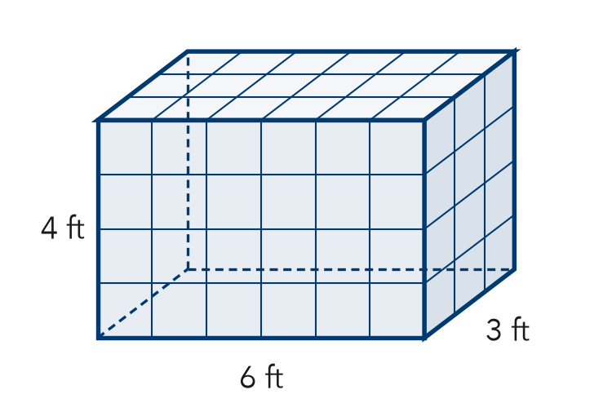

3. Fish Tank. A fish tank is 18 in long, 12 in wide, and 6 in tall.  Hint Find the base first. The height counts the layers.  a. Area of the base in²  b. Volume of the tank in³ | 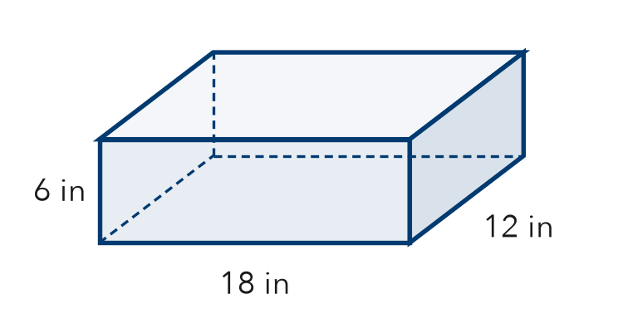
  Show your work.

4. Locker Space. A locker is 14 in wide, 12 in deep, and 50 in tall. Find its volume.  Hint Base = width × depth. Then multiply by the height.  Answer in³ | 5. Sandbox Fill. A sandbox is 24 ft long and 12 ft wide. Sand is poured in 2 ft deep. How much sand is needed?  Hint The depth of the sand is the height.  Answer ft³
  Show your work.
  Show your work.

6. Rosa’s Box. A box is 19 cm long, 11 cm wide, and 4 cm tall. Rosa says its volume is 209 cm³. Is Rosa right?
Hint How many edges did Rosa use? A prism has three.

Show your work.
True volume

7. Two Cartons. Carton A is 16 cm by 6 cm by 10 cm. Carton B is 12 cm by 10 cm by 7 cm. Which carton holds more? How much more?

Show your work.
Carton, how much

8. Aquarium. An aquarium is 50 cm long, 30 cm wide, and 40 cm tall. One liter of water fills 1,000 cm³.
a. Find the volume. cm³
b. How many liters fill it? L
c. It is filled only 30 cm deep. How many liters? L

Show your work.

FIND THE ERROR explain the mistake, then fix it

9. Malik’s Work. A crate is 12 ft long, 9 ft wide, and 5 ft tall. Malik wrote: “V = 12 + 9 + 5 = 26 ft³.” Explain the mistake and find the correct volume.

TEST PRACTICE choose the best answer

10. A prism is 2 m by 6 m by 5 m. Its volume is —
A 13 m³ | B 60 m² | C 60 m³ | D 70 m³

11. In V = B × h, the letter B stands for the —
A base area | B biggest edge | C box | D base edge

SELF-CHECK CODE find your answer · copy its letter into that problem’s box · spell a math word
72  C | 60  N | 836  A | 8,400  N | 209  Q | 45  S | 576  T | 120  I | 1,296  O | 168  Z

#2c | #3b | #4 | #5 | #6 | #7 | #8b | #8c

CHECK YOURSELF | □ I can do this on my own | □ I need a little help | □ I have a question about #

