Name Date Period
Lesson 5-5 · Session 2 · Practice · Form A
Missing Fractional Edges
Learning target — I can find a missing edge of a prism and find volumes with fractional edge lengths. · 6.G.A.2

REMEMBER  • V = l × w × h works with fractions: 12 × 10 × 3/4 = 120 × 3/4 = 90.  • 1 1/2 of a number is the number plus half of it.  • Missing edge: multiply the two known edges, then divide the volume by that product. | WORKED EXAMPLE  A box holds 72 cm³. It is 6 cm long and 4 cm wide.  Step 1 Known edges: 6 × 4 = 24 cm².  Step 2 Divide: 72 ÷ 24 = 3.  Step 3 Check: 6 × 4 × 3 = 72.  Answer height = 3 cm
WORDS edge (arista) · fraction (fracción) · volume (volumen)
PRACTICE show your work · label units

1. Find each volume or missing edge.
a. 1/2 ft × 3/4 ft × 2 ft ft³ | b. 14 in × 11 in × 1/2 in in³
c. V = 336 in³, w = 8 in, h = 6 in; l = in | d. V = 96 in³, B = 12 in²; h = in

2. Shipping Box Limit. A shipping box holds 990 in³. It is 9 in wide and 10 in tall. Boxes may be at most 13 in long.
Hint Multiply the two known edges, then divide.
a. Multiply the two known edges. in²
b. Find the length. in
c. Does the box meet the rule?

Show your work.

3. Planter Depth. A planter holds 1,170 cm³ of soil. Its base is 13 cm by 10 cm. How tall is it?  Answer cm | 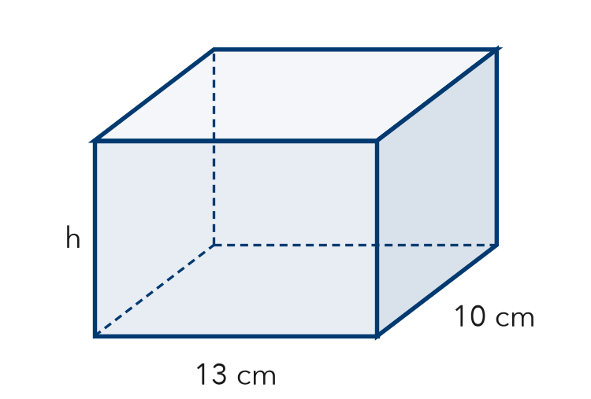
  Show your work.

4. Thin Box. A flat box is 20 in long, 16 in wide, and 3/4 in tall. Find its volume.  Hint Find the base, then take 3/4 of it.  Answer in³ | 5. Seed Flat. A seed flat is 20 in long, 12 in wide, and 1 1/2 in deep. Find its volume.  Hint 1 1/2 means the base plus half the base.  Answer in³
  Show your work.
  Show your work.

6. Concrete Slab. A concrete slab is 22 ft long, 9 ft wide, and 1/2 ft thick. Concrete costs $5 per ft³. Find the volume and the cost.
Hint The thickness is the height.

Show your work.
Volume, cost

7. Aquarium Width. An aquarium holds 5,400 in³ of water. It is 30 in long and 18 in tall. The width label wore off. Find the width.

Show your work.
Answer in

8. Planter Box. A planter is 3/4 m long, 1/2 m wide, and 2 m tall. Soil costs $18 per m³.
a. Find the volume. m³
b. Find the cost to fill it.
c. A second planter is twice as tall. Find its volume. m³

Show your work.

FIND THE ERROR explain the mistake, then fix it

9. Hana’s Work. A box holds 1,980 cm³. It is 11 cm wide and 9 cm tall. Hana wrote: “1,980 ÷ 11 = 180, so the length is 180 cm.” Explain the mistake and find the length.

TEST PRACTICE choose the best answer

10. A prism has a volume of 120 cm³, a length of 5 cm, and a width of 4 cm. Its height is —
A 6 cm | B 20 cm | C 24 cm | D 111 cm

11. A block is 1/2 m by 1/2 m by 4 m. Its volume is —
A 1 m³ | B 2 m³ | C 4 m³ | D 5 m³

SELF-CHECK CODE find your answer · copy its letter into that problem’s box · spell a math word
10  I | 9  R | 1 1/2  N | 495  T | 3/4  O | 180  Q | 240  A | 360  C | 11  F | 110  Z

#2b | #3 | #4 | #5 | #6 | #7 | #8a | #8c

CHECK YOURSELF | □ I can do this on my own | □ I need a little help | □ I have a question about #

