Name Date Period
Lesson 5-5 · Session 1 · Prerequisite Practice B · Skill 1 of 2
Find the Base Area
Builds on Lesson 5-1 Session 1 · 6.G.A.1
TODAY’S LESSON | You will find the base of a box first, like 16 in × 11 in for the fish tank.
YOU NEED TO | Find the area of the bottom face: length × width. You will use it in Practice Form A, problems 3 and 4.
STEPS TO FOLLOW use these same steps on every problem
1 | Find the bottom face: the length and the width.
2 | Leave out the height. It is not part of the base.
3 | Multiply length × width. Write square units.
WATCH ME the steps in action
A box is 18 in long, 12 in wide, and 7 in tall. Find the base area.  Step 1 Bottom: 18 in by 12 in.  Step 2 Leave out the 7 in height.  Step 3 18 × 12 = 216, so 216 in².  Answer 216 in² | 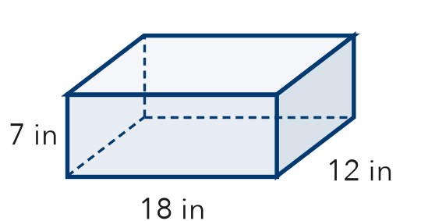

TRY IT WITH HELP fill in each step
1. A box is 14 cm long, 9 cm wide, and 5 cm tall. Find the base area.
Step 1 Bottom: cm by cm
Step 2 Leave out the height: cm
Step 3 14 × 9 = cm²

2. A box is 20 in long, 13 in wide, and 6 in tall. Find the base area.
Step 1 Bottom: in by in
Step 2 Leave out the height: in
Step 3 20 × 13 = in²

YOUR TURN use the steps on your own

3. Find each base area. Each box is length × width × height.
a. 15 ft × 12 ft × 4 ft | b. 17 m × 6 m × 9 m
c. 25 cm × 11 cm × 3 cm | d. 19 in × 10 in × 7 in

Lesson 5-5 · Session 1 · Prerequisite Practice B · Skill 2 of 2
Count Cubes in Layers
Builds on Grade 5 · 5.MD.C.5a
TODAY’S LESSON | You will count cubes in a toy chest: one layer × layers.
YOU NEED TO | Find the cubes in one layer, then multiply by the layers. You will use it in Practice Form A, problems 2 and 3.
STEPS TO FOLLOW use these same steps on every problem
1 | Count the cubes in one layer: length × width.
2 | Count the layers. That is the height.
3 | Multiply: cubes in one layer × number of layers.
WATCH ME the steps in action
A box is 5 cubes long, 2 cubes wide, and 3 cubes tall. How many cubes fill it?  Step 1 One layer: 5 × 2 = 10 cubes.  Step 2 There are 3 layers.  Step 3 10 × 3 = 30.  Answer 30 cubes | 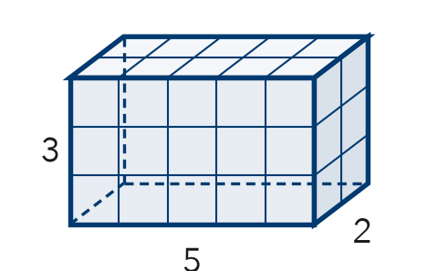

TRY IT WITH HELP fill in each step
4. A box is 4 cubes long, 2 cubes wide, and 3 cubes tall. How many cubes fill it?
Step 1 One layer: 4 × 2 = cubes
Step 2 Number of layers:
Step 3 8 × 3 = cubes

5. A box is 6 cubes long, 3 cubes wide, and 2 cubes tall. How many cubes fill it?
Step 1 One layer: 6 × 3 = cubes
Step 2 Number of layers:
Step 3 18 × 2 = cubes

YOUR TURN use the steps on your own

6. Find the number of cubes.
a. 3 long, 2 wide, 4 tall | b. 5 long, 4 wide, 2 tall
c. 6 long, 5 wide, 3 tall | d. 7 long, 2 wide, 5 tall

READY CHECK a problem like the one in today’s lesson

7. A box is 6 cubes long, 3 wide, and 4 tall. How many cubes fill it?
A 13 | B 18 | C 72 | D 36

CHECK YOURSELF | □ I can do this on my own | □ I need a little help | □ I have a question about #

