Name Date Period
Lesson 5-6 · Session 1 · Prerequisite Practice B · Skill 1 of 2
Find the Faces of a Box
Builds on Lesson 5-5 Session 1 · 6.G.A.2
TODAY’S LESSON | You will list the 3 pairs of matching rectangles in a box net.
YOU NEED TO | Use two edges at a time to name each pair of faces. You will use it in Practice Form A, problems 3 and 8.
STEPS TO FOLLOW use these same steps on every problem
1 | Top and bottom: length × width.
2 | Front and back: length × height.
3 | Two sides: width × height.
WATCH ME the steps in action
A box is 8 cm long, 5 cm wide, and 3 cm tall. Name its faces.  Step 1 Top and bottom: 8 cm by 5 cm.  Step 2 Front and back: 8 cm by 3 cm.  Step 3 Two sides: 5 cm by 3 cm.  Answer 3 pairs: 8 by 5, 8 by 3, 5 by 3 | 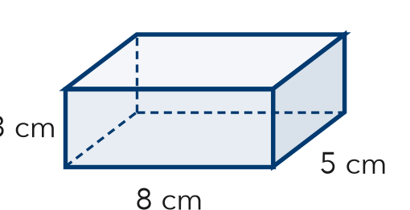

TRY IT WITH HELP fill in each step
1. A box is 12 in long, 7 in wide, and 3 in tall. Name its faces.
Step 1 Top and bottom: by
Step 2 Front and back: by
Step 3 Two sides: by

2. A box is 6 ft long, 4 ft wide, and 2 ft tall. Name its faces.
Step 1 Top and bottom: by
Step 2 Front and back: by
Step 3 Two sides: by

YOUR TURN use the steps on your own

3. Write the top, front, and side of each box (l × w × h).
a. 11 × 5 × 4 cm | b. 15 × 10 × 2 m
c. 8 × 6 × 5 ft | d. 20 × 9 × 4 cm

Lesson 5-6 · Session 1 · Prerequisite Practice B · Skill 2 of 2
Area of Triangles
Builds on Lesson 5-2 Session 1 · 6.G.A.1
TODAY’S LESSON | You will find one triangle in a pyramid net, like ½ × 14 × 11.
YOU NEED TO | Find a triangle’s area with A = ½ × b × h, like ½ × 8 × 7. You will use it in Practice Form A, problems 2, 4, and 6.
STEPS TO FOLLOW use these same steps on every problem
1 | Write A = ½ × b × h with the numbers.
2 | Halve the even number first.
3 | Multiply what is left. Write square units.
WATCH ME the steps in action
A triangle in a net has a base of 8 in and a height of 7 in. Find its area.
Step 1 A = ½ × 8 × 7.
Step 2 Half of 8 is 4.
Step 3 4 × 7 = 28, so 28 in².
Answer 28 in²
TRY IT WITH HELP fill in each step
4. Base 12 cm, height 5 cm. Find the area.
Step 1 A = ½ × ×
Step 2 Half of 12 is
Step 3 6 × 5 = cm²

5. Base 10 ft, height 9 ft. Find the area.
Step 1 A = ½ × ×
Step 2 Half of 10 is
Step 3 5 × 9 = ft²

YOUR TURN use the steps on your own

6. Find each area. Use A = ½ × b × h.
a. ½ × 8 × 5 = | b. ½ × 12 × 7 = | c. ½ × 6 × 9 =
d. ½ × 16 × 7 = | e. ½ × 20 × 13 = | f. ½ × 18 × 11 =

READY CHECK a problem like the one in today’s lesson

7. A pyramid net triangle has a base of 10 in and a height of 7 in. What is its area?
A 70 in² | B 35 in² | C 17 in² | D 140 in²

CHECK YOURSELF | □ I can do this on my own | □ I need a little help | □ I have a question about #

