Name Date Period
Lesson 5-8 · Session 1 · Practice · Form A
Surface Area of Pyramids
Learning target — I can find the surface area of a pyramid by adding the base area and the areas of its triangular faces. · 6.G.A.4

REMEMBER  • SA of a pyramid = base area + area of all the triangular faces.  • Each triangle: ½ × base edge × slant height (not the straight-up height).  • A square pyramid has 1 square + 4 matching triangles. | WORKED EXAMPLE  Square base 10 cm; slant height 7 cm.  Step 1 Base: 10 × 10 = 100 cm².  Step 2 One triangle: ½ × 10 × 7 = 35 cm².  Step 3 Four triangles: 140. Add: 100 + 140.  Answer SA = 240 cm²
WORDS slant height (altura inclinada) · lateral face (cara lateral) · apex (ápice)
PRACTICE show your work · label units

1. Find the surface area of each square pyramid.
a. base 8 m, slant height 10 m m² | b. base 5 ft, slant height 8 ft ft²
c. base 2 cm, slant height 3 cm cm² | d. base 7 in, slant height 10 in in²

2. Pyramid Model. A class model is a square pyramid. Its net is shown.  a. Area of the square base cm²  b. Area of one triangle cm²  c. Surface area cm² | 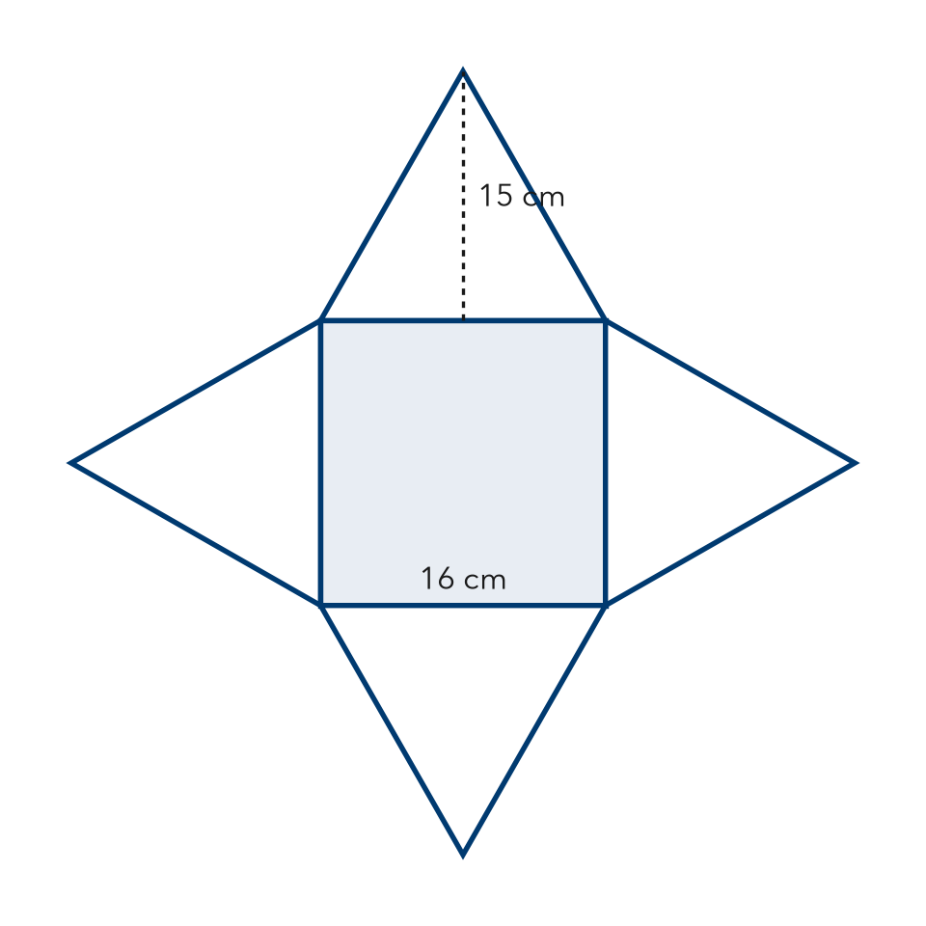

3. Gift Topper. A gift topper is a square pyramid with a base 8 in on each side and a slant height of 11 in. Find its surface area.  Hint Base first, then four triangles.  Answer in² | 4. Trophy Top. A trophy top is a square pyramid with a base 12 cm on each side and a slant height of 9 cm. Every face is plated. Find its surface area.  Answer cm²
  Show your work.
  Show your work.

5. Roof Cap. Every face of this roof cap, including the bottom, will be shingled. Find its surface area.  Hint Use the slant height for each triangle.  Answer ft² | 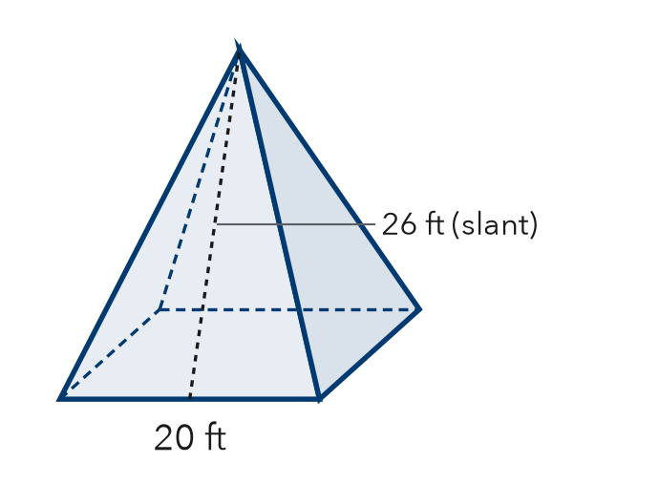
  Show your work.

6. Priya’s Pyramid. A square pyramid has base 18 cm and slant height 13 cm. Priya says its surface area is 117 cm². Is Priya right?  Hint Which faces of the net are missing from 117?  Answer cm² | 7. Sand Mold. A sand mold is a square pyramid: base 16 in, slant height 10 in. Every face counts. Find its surface area.  Hint Add the base to all 4 triangles.  Answer in²
  Show your work.
  Show your work.

8. Museum Model. A museum model is a square pyramid: base 14 in, slant height 15 in. Gold foil covers only the four triangles. Foil costs $0.04 per in².
a. Base area and one triangle
b. Total surface area in²
c. Cost of the foil

Show your work.

FIND THE ERROR explain the mistake, then fix it

9. Ethan’s Work. A square pyramid has a base 22 in on each side and a slant height of 17 in. Ethan wrote: “SA = 484 + 187 = 671 in².” Explain the mistake and fix it.

TEST PRACTICE choose the best answer

10. How many triangular faces does a square pyramid have?
A 3 | B 4 | C 5 | D 6

11. A base of 25 cm² plus four triangles of 20 cm² each gives a surface area of —
A 45 cm² | B 80 cm² | C 100 cm² | D 105 cm²

SELF-CHECK CODE find your answer · copy its letter into that problem’s box · spell a math word
360  R | 576  I | 16.80  S | 1,040  Z | 240  Y | 736  P | 1,440  A | 616  D | 792  M | 117  Q

#2c | #3 | #4 | #5 | #6 | #7 | #8b | #8c

CHECK YOURSELF | □ I can do this on my own | □ I need a little help | □ I have a question about #

