Name Date Period
Lesson 5-8 · Homework Packet · Sheet 1 of 2
Surface Area of Pyramids
Maryland Standard 6.G.A.4 · Learning target — I can find the surface area of a pyramid by adding the base area and the areas of its triangular faces.

REMEMBER  • SA of a pyramid = base area + area of all the triangular faces.  • Each triangle’s height is the slant height, not the height of the pyramid. | WORKED EXAMPLE  Square pyramid: base 8 cm, slant height 7 cm.  Step 1 Base: 8 × 8 = 64  Step 2 One triangle: ½ × 8 × 7 = 28; four: 112  Step 3 Add: 64 + 112 = 176  Answer 176 cm²
PRACTICE show your work · label units

1. Find the surface area of the square pyramid.  Answer m² | 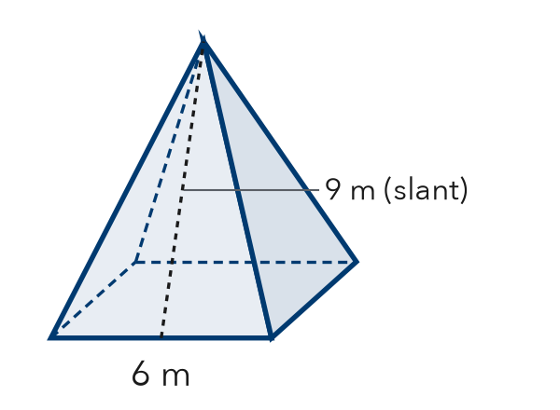
  Show your work.

2. Use the net of the square pyramid.  a. Area of the base cm²  b. Area of one triangle cm²  Surface area cm² | 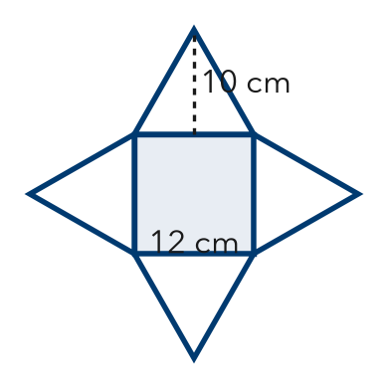

3. Find the surface area of each square pyramid.
a. base 4 in, slant height 5 in in² | b. base 10 cm, slant height 12 cm cm²

4. Gift Box. A gift box is a square pyramid with a base 9 in on each side and a slant height of 11 in. How much paper covers every face?

Show your work.
Answer in²

5. Find the Error. A square pyramid has a base 6 ft on each side, a height of 4 ft, and a slant height of 5 ft. Kofi wrote SA = 36 + 4 × (½ × 6 × 4) = 84 ft². Explain his mistake and find the surface area.

CHECK YOURSELF | □ I can do this on my own | □ I need a little help | □ I have a question about #
AT HOME Use a folded paper tent to show someone a pyramid’s height and its slant height.
Name Date Period
Lesson 5-8 · Homework Packet · Sheet 2 of 2
Lateral Area of Pyramids
Maryland Standard 6.G.A.4 · Learning target — I can find the lateral area of a pyramid, which covers only its slanted faces.

REMEMBER  • Lateral area is the area of the slanted faces only. Do not include the base.  • Lateral area = surface area − base area. | WORKED EXAMPLE  Square pyramid: base 10 m, slant height 13 m. Find the lateral area.  Step 1 One face: ½ × 10 × 13 = 65  Step 2 Four faces: 4 × 65 = 260  Answer 260 m²
PRACTICE show your work · label units

1. Find the lateral area of the square pyramid.  Answer ft² | 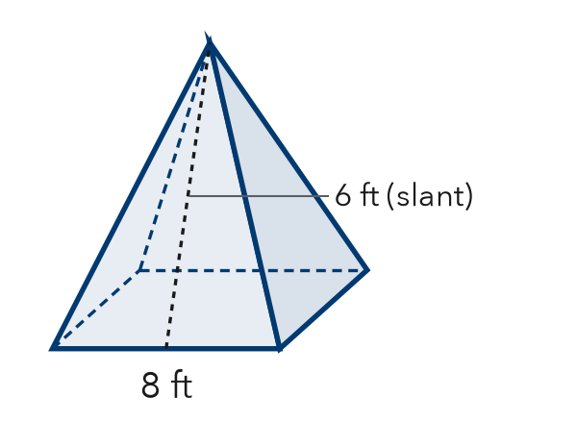
  Show your work.

2. Find each lateral area.
a. SA = 200 in², base = 64 in² in² | b. 4 faces, each 18 cm² cm²
c. square base, side 6 m; slant height 10 m m² | d. square base, side 3 ft; slant height 4 ft ft²

3. Tower Roof. A roof is a square pyramid with a base 14 ft on each side and a slant height of 10 ft. Shingles cover only the slanted faces. One bundle covers 35 ft². How many bundles are needed?
Answer bundles

4. Lampshade. A lampshade is a square pyramid with no base. Its lateral area is 160 in² and each base edge is 8 in. What is its slant height?
Answer in

5. Play Tent. A play tent is a square pyramid with a base 5 ft on each side and a slant height of 6 ft. It has no floor. Sasha says it needs 85 ft² of fabric. Is she right? Explain.

TEST PRACTICE choose the best answer
6. A square pyramid has a base 4 cm on each side and a slant height of 7 cm. What is its lateral area?
A 14 cm² | B 56 cm² | C 72 cm² | D 112 cm²

7. A pyramid has a surface area of 120 m² and a lateral area of 84 m². What is its base area?
A 204 m² | B 120 m² | C 36 m² | D 42 m²

CHECK YOURSELF | □ I can do this on my own | □ I need a little help | □ I have a question about #

