Name Date Period
Lesson 6-1 · Session 1 · Practice · Form A
Dividing by a Unit Fraction
Learning target — I can divide a whole number by a unit fraction and explain what the quotient counts. · 6.NS.A.1

REMEMBER  • A unit fraction has 1 on top, like 1/3. Dividing by it asks: how many pieces of that size fit?  • Keep, Change, Flip: keep the first number, change ÷ to ×, flip the divisor. 4 ÷ 1/3 = 4 × 3.  • The quotient is greater than the number you start with. Check: quotient × divisor = start. | WORKED EXAMPLE  A cook has 4 cups of broth. How many 1/3-cup servings can she pour?  Step 1 Write the division: 4 ÷ 1/3.  Step 2 Keep 4, change ÷ to ×, flip 1/3 to 3: 4 × 3 = 12.  Step 3 Check: 12 × 1/3 = 4 cups.  Answer 12 servings
WORDS unit fraction (fracción unitaria) · reciprocal (recíproco) · quotient (cociente)
PRACTICE show your work · label units

1. Divide. Think: how many of the unit fraction fit into the whole number?
a. 8 ÷ 1/2 = | b. 3 ÷ 1/4 = | c. 10 ÷ 1/3 =
d. 3 ÷ 1/5 = | e. 4 ÷ 1/10 = | f. 7 ÷ 1/6 =

2. Clay and Wax. An art teacher has 8 pounds of clay and a 2-pound block of wax. Each bar is 1 pound.
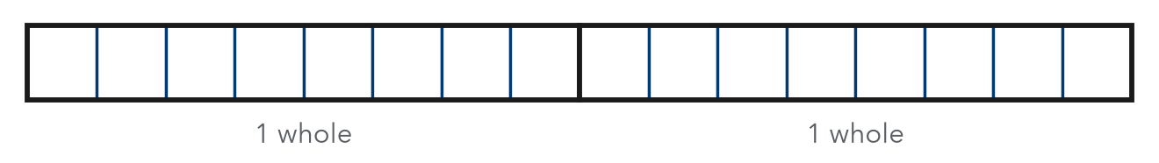
a. Each project uses 1/4 pound of clay. How many projects? projects
b. She cuts the wax into 1/8-pound cubes. Use the bars: how many cubes? cubes

3. Garden Edging. A gardener has 12 feet of edging. Each small bed needs 1/3 foot. How many beds can she edge?  Hint Each foot holds 3 thirds.  Answer beds | 4. Frozen Yogurt. A snack cart has 6 quarts of frozen yogurt. Each sample cup holds 1/8 quart. How many cups can it fill?  Hint Count eighths: 8 in each quart.  Answer cups
  Show your work.
  Show your work.

5. Water Bottles. A camp has 8 gallons of water. Each bottle holds 1/2 gallon. Mia says only 4 bottles can be filled. Justify or correct her answer.  Hint Ask: how many halves are in 8 wholes?  Answer bottles | 6. Tape Pieces. Ivan cuts a 2-yard roll of tape into pieces that are each 1/12 yard long. He gives 8 pieces to a friend.  Hint Divide first, then subtract the 8 pieces.  a. How many pieces does he cut? pieces  b. How many are left? pieces
  Show your work.
  Show your work.

7. Craft Table. A teacher has 15 meters of yarn for bracelets.
a. Each bracelet uses 1/5 meter. How many bracelets? bracelets
b. Each bracelet uses 1/3 meter instead. How many bracelets? bracelets
c. Why does a larger piece for each bracelet give fewer bracelets?

Show your work.

8. Explain It. Find 9 ÷ 1/3.
Hint How many thirds are in 1 whole? In 9 wholes?
a. Write the multiplication that matches this division and solve.
b. Explain why the answer is greater than 9.

FIND THE ERROR explain the mistake, then fix it

9. Rosa’s Work. Rosa solved 4 ÷ 1/3. She flipped the first number and wrote 1/4 × 1/3 = 1/12. Explain her mistake. Then find the correct quotient.

TEST PRACTICE choose the best answer

10. Find 5 ÷ 1/4.
A 5/4 | B 20 | C 9 | D 1/20

11. Dividing 6 by 1/2 gives a quotient that is —
A less than 6 | B equal to 6 | C greater than 6 | D equal to 1/2

SELF-CHECK CODE find your answer · copy its letter into that problem’s box · spell a math word
3  X | 16  V | 27  E | 75  D | 4  Q | 24  I | 3/4  Z | 36  D | 48  I

#3 | #4 | #5 | #6a | #7a | #8a

CHECK YOURSELF | □ I can do this on my own | □ I need a little help | □ I have a question about #

