Name Date Period
Lesson 6-1 · Session 1 · Practice · Form B
Dividing by a Unit Fraction
Learning target — I can divide a whole number by a unit fraction and explain what the quotient counts. · 6.NS.A.1

REMEMBER  • A unit fraction has 1 on top, like 1/3. Dividing by it asks: how many pieces of that size fit?  • Keep, Change, Flip: keep the first number, change ÷ to ×, flip the divisor. 4 ÷ 1/3 = 4 × 3.  • The quotient is greater than the number you start with. Check: quotient × divisor = start. | WORKED EXAMPLE  A cook has 4 cups of broth. How many 1/3-cup servings can she pour?  Step 1 Write the division: 4 ÷ 1/3.  Step 2 Keep 4, change ÷ to ×, flip 1/3 to 3: 4 × 3 = 12.  Step 3 Check: 12 × 1/3 = 4 cups.  Answer 12 servings
WORDS unit fraction (fracción unitaria) · reciprocal (recíproco) · quotient (cociente)
PRACTICE show your work · label units

1. Divide. Think: how many of the unit fraction fit into the whole number?
a. 7 ÷ 1/2 = | b. 2 ÷ 1/4 = | c. 8 ÷ 1/3 =
d. 4 ÷ 1/5 = | e. 6 ÷ 1/10 = | f. 5 ÷ 1/8 =

2. Oats and Seeds. Ms. Patel has 6 pounds of oats and 3 pounds of seeds. Each bar is 1 pound.
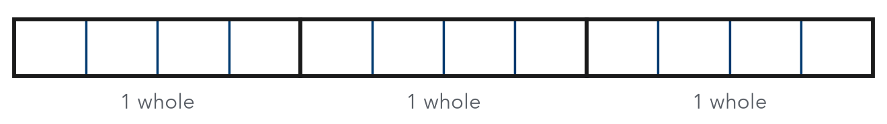
a. Each bird feeder uses 1/3 pound of oats. How many feeders? feeders
b. She splits the seeds into 1/4-pound packets. Use the bars: how many packets? packets

3. Garden Edging. A gardener has 10 feet of edging. Each small bed needs 1/4 foot. How many beds can he edge?  Hint Each foot holds 4 fourths.  Answer beds | 4. Frozen Yogurt. A snack cart has 4 quarts of frozen yogurt. Each sample cup holds 1/6 quart. How many cups can it fill?  Hint Count sixths: 6 in each quart.  Answer cups
  Show your work.
  Show your work.

5. Water Bottles. A camp has 9 gallons of water. Each bottle holds 1/2 gallon. Theo says only 4.5 bottles can be filled. Justify or correct his answer.  Hint Ask: how many halves are in 9 wholes?  Answer bottles | 6. Tape Pieces. Keisha cuts a 3-yard roll of tape into pieces that are each 1/10 yard long. She gives 12 pieces to a friend.  Hint Divide first, then subtract the 12 pieces.  a. How many pieces does she cut? pieces  b. How many are left? pieces
  Show your work.
  Show your work.

7. Craft Table. A teacher has 10 meters of yarn for bracelets.
a. Each bracelet uses 1/5 meter. How many bracelets? bracelets
b. Each bracelet uses 1/2 meter instead. How many bracelets? bracelets
c. Why does a larger piece for each bracelet give fewer bracelets?

Show your work.

8. Explain It. Find 7 ÷ 1/5.
Hint How many fifths are in 1 whole? In 7 wholes?
a. Write the multiplication that matches this division and solve.
b. Explain why the answer is greater than 7.

FIND THE ERROR explain the mistake, then fix it

9. Amir’s Work. Amir solved 4 ÷ 1/5. He flipped the first number and wrote 1/4 × 1/5 = 1/20. Explain his mistake. Then find the correct quotient.

TEST PRACTICE choose the best answer

10. Find 3 ÷ 1/6.
A 1/2 | B 1/18 | C 9 | D 18

11. The reciprocal of 1/9 is —
A 1/9 | B 9 | C 0.9 | D −9

SELF-CHECK CODE find your answer · copy its letter into that problem’s box · spell a math word
2/3  Z | 40  G | 4.5  Q | 30  U | 18  O | 50  P | 42  X | 35  S | 24  R

#3 | #4 | #5 | #6a | #7a | #8a

CHECK YOURSELF | □ I can do this on my own | □ I need a little help | □ I have a question about #

