Name Date Period
Lesson 6-1 · Session 1 · Guided Notes
Dividing by a Unit Fraction
Learning target — I can divide a whole number by a unit fraction and explain what the quotient counts. · 6.NS.A.1
WORDS TO KNOW fill in the missing words
WORD | WHAT IT MEANS | EXAMPLE
unit fraction  fracción unitaria | A fraction with as its numerator. | 1/3, 1/8, 1/10
reciprocal  recíproco | The number you multiply by to get a product of . | 1/4 and 4: 1/4 × 4 = 1
quotient  cociente | The to a division problem. | In 8 ÷ 1/2 = 16, 16 is the quotient
KEY IDEA complete each sentence
• Dividing by a unit fraction asks how many of that size fit into the number.
• Dividing by 1/4 is the same as multiplying by , so 3 ÷ 1/4 = 3 × 4 = 12.
• The quotient is than the whole number you started with.
WORKED EXAMPLE fill in the blanks as we solve
How many 1/4-pound balls of clay can you make from 3 pounds of clay?
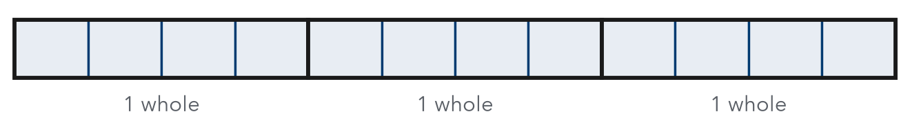
Step 1 Each pound holds fourths.
Step 2 3 pounds hold 3 × 4 = fourths.
Step 3 Check: 12 × 1/4 = pounds.
Answer 3 ÷ 1/4 = balls of clay
YOU TRY use the example as a model

1. Divide.
a. 6 ÷ 1/2 = | b. 5 ÷ 1/5 =

2. A 2-yard ribbon is cut into 1/8-yard pieces. Use the bars to find how many pieces.
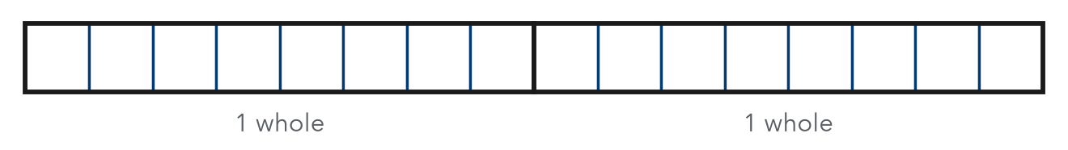
Answer pieces

SUM IT UP in your own words
Dividing a whole number by a unit fraction gives a greater number because .
Name Date Period
Lesson 6-1 · Session 2 · Guided Notes
Dividing a Fraction by a Whole Number
Learning target — I can divide a fraction by a whole number and explain the result. · 6.NS.A.1
WORDS TO KNOW fill in the missing words
WORD | WHAT IT MEANS | EXAMPLE
reciprocal  recíproco | Two numbers are reciprocals when their product is . | 8 and 1/8: 8 × 1/8 = 1
multiplicative inverse  inverso multiplicativo | Another name for the . | 2/3 and 3/2
divisor  divisor | The number you by. | In 3/4 ÷ 2, the divisor is 2
KEY IDEA complete each sentence
• Dividing a fraction by a whole number it into equal parts.
• To divide by 4, multiply by its reciprocal, .
• Each share is than the fraction you started with.
WORKED EXAMPLE fill in the blanks as we solve
Share 2/5 pound of rice equally among 4 people.
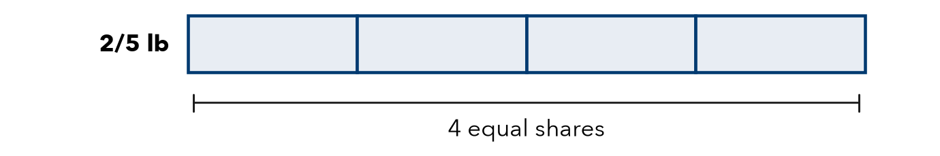
Step 1 Write 4 as a fraction: 2/5 ÷ .
Step 2 Multiply by the reciprocal: 2/5 × = 2/20.
Step 3 Simplify: 2/20 = .
Answer Each person gets pound of rice.
YOU TRY use the example as a model

1. Divide. Write each quotient in simplest form.
a. 1/3 ÷ 4 = | b. 4/7 ÷ 2 =

2. 5 friends share 5/8 of a pizza equally. What fraction of the whole pizza does each friend get?

Show your work.
Each gets

SUM IT UP in your own words
When I divide a fraction by a whole number, each share is because .

