Name Date Period
Lesson 6-1 · Session 1 · Prerequisite Practice A · Skill 1 of 2
Write Division for Equal Groups
Builds on Grade 3 · 3.OA.A.2
TODAY’S LESSON | You will find how many 1/3-foot beds fit in 12 feet of edging: 12 ÷ 1/3.
YOU NEED TO | Write total ÷ size of each group, like 48 ÷ 6. You will use it in Practice Form A, problems 3 and 4.
STEPS TO FOLLOW use these same steps on every problem
1 | Find the total amount.
2 | Find the size of each group.
3 | Write total ÷ size. Divide.
WATCH ME the steps in action
A coach has 48 feet of rope. Each jump rope uses 6 feet. How many jump ropes?
Step 1 The total is 48 feet.
Step 2 The size of each group is 6 feet.
Step 3 48 ÷ 6 = 8.
Answer 8 jump ropes
TRY IT WITH HELP fill in each step
1. Max has 32 cups of juice. Each pitcher holds 4 cups. How many pitchers?
Step 1 The total is cups.
Step 2 The size of each group is cups.
Step 3 ÷ =

2. A ribbon is 45 inches long. Each bow uses 5 inches. How many bows?
Step 1 The total is inches.
Step 2 The size of each group is inches.
Step 3 ÷ =

YOUR TURN use the steps on your own

3. Write total ÷ size. Then divide.
a. How many 3-ft pieces are in 27 ft? | b. How many 5-cup bowls are in 40 cups?
c. How many 7-m pieces are in 42 m? | d. How many 12-in. pieces are in 60 in.?

Lesson 6-1 · Session 1 · Prerequisite Practice A · Skill 2 of 2
Write Wholes as Fractions
Builds on Grade 3 · 3.NF.A.3c
TODAY’S LESSON | You will find 8 ÷ 1/2. That asks how many halves are in 8 wholes.
YOU NEED TO | Write a whole number as a fraction, like 3 = 12/4. You will use it in Practice Form A, problems 1 and 5.
STEPS TO FOLLOW use these same steps on every problem
1 | Look at the bottom number. That many parts make 1 whole.
2 | Multiply the whole number by the bottom number.
3 | Write the product over the bottom number.
WATCH ME the steps in action
Write 3 as fourths.  Step 1 The bottom number is 4. Four fourths make 1 whole.  Step 2 3 × 4 = 12.  Step 3 3 = 12/4.  Answer 3 = 12/4. There are 12 fourths in 3. | 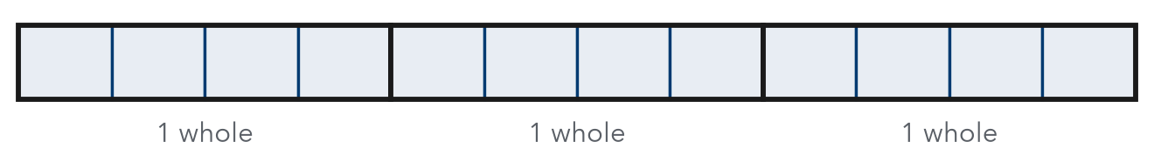

TRY IT WITH HELP fill in each step
4. Write 5 as halves.
Step 1 The bottom number is .
Step 2 5 × =
Step 3 5 = /2

5. Write 4 as thirds.
Step 1 The bottom number is .
Step 2 4 × =
Step 3 4 = /3

YOUR TURN use the steps on your own

6. Write each whole number as a fraction.
a. 2 as thirds | b. 6 as halves | c. 3 as fifths
d. 4 as fourths | e. 7 as halves | f. 5 as tenths

READY CHECK a problem like the one in today’s lesson

7. How many halves are in 8? This is the same as 8 ÷ 1/2.
A 4 | B 16 | C 10 | D 1/16

CHECK YOURSELF | □ I can do this on my own | □ I need a little help | □ I have a question about #

