Name Date Period
Lesson 6-3 · Session 2 · Practice · Form B
Finding the Value of a Power
Learning target — I can find the value of a power by multiplying the base the number of times the exponent shows. · 6.EE.A.1

REMEMBER  • Write the expanded form, then multiply one factor at a time.  • 4³ = 4 × 4 × 4 = 64, not 4 × 3 = 12.  • Decimals and fractions work the same way: 0.3² = 0.3 × 0.3 = 0.09. | WORKED EXAMPLE  Find the value of 3⁴.  Step 1 Expand: 3⁴ = 3 × 3 × 3 × 3.  Step 2 Multiply: 3 × 3 = 9, 9 × 3 = 27, 27 × 3 = 81.  Step 3 Check: I used 3 as a factor 4 times.  Answer 3⁴ = 81
WORDS evaluate (evaluar) · squared (al cuadrado) · cubed (al cubo) · expanded form (forma desarrollada)
PRACTICE show your work · label units

1. Find the value of each power.
a. 9² = | b. 2³ = | c. 5² =
d. 13² = | e. 1.3² = | f. (2/5)² =

2. Power Table. A garden club makes a table of powers of 3. Complete it. Then tell what each value is multiplied by to get the next one.
Power | Expanded form | Value
3¹
3²
3³
3⁴
Multiply by

3. Storage Cube. A storage cube has edges of 5 units, so its volume is 5³ cubic units. Find the volume.  Hint Use 5 as a factor three times.  Answer cubic units | 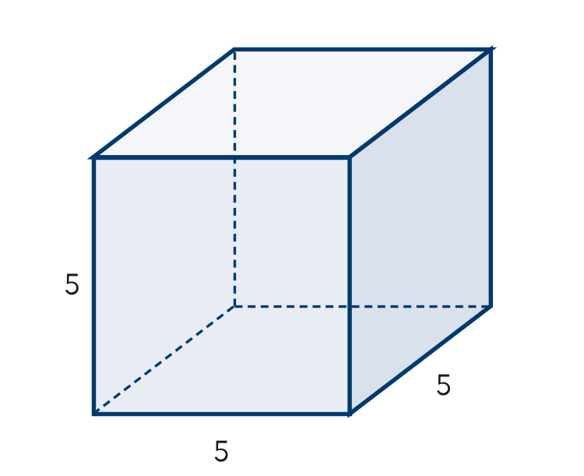
  Show your work.

4. Plant Cuttings. A count of plant cuttings is multiplied by 6 each week for 3 weeks, so it is 6³. Evaluate it.  Hint 6 × 6 = 36, then multiply by 6 again.  Value | 5. Poster Claim. A classroom poster says 8² = 16. Justify or correct the poster.  Hint Expand the power into factors first.  Value
  Show your work.
  Show your work.

6. Which Is Biggest? Evaluate 3⁴, 4³ and 2⁷. Order them from least to greatest.  Hint Evaluate each power before comparing.  Order | 7. Decimal Powers. Evaluate each power.  Hint Count decimal places: 0.4 × 0.4 has two.  a. 0.4² =  b. 2.5² =
  Show your work.

8. Tile Stages. A tile design has 4 times as many tiles at each new stage. It starts with 1 tile.
a. Write the number of tiles after 3 stages as a power of 4, then evaluate. tiles
b. How many tiles after 4 stages? tiles
c. How many more tiles after 4 stages than after 3 stages? tiles

FIND THE ERROR explain the mistake, then fix it

9. Malik’s Work. Malik evaluated 9³. He wrote 9 × 3 = 27 and said the value is 27. Explain his mistake. Then find the correct value.

TEST PRACTICE choose the best answer

10. 10³ equals —
A 30 | B 13 | C 100 | D 1,000

11. 6² equals —
A 12 | B 8 | C 36 | D 66

SELF-CHECK CODE find your answer · copy its letter into that problem’s box · spell a math word
15  Q | 16  X | 18  Z | 6.25  O | 64  C | 216  A | 125  F | 256  R | 192  S | 0.16  T

#3 | #4 | #5 | #7a | #7b | #8b | #8c

CHECK YOURSELF | □ I can do this on my own | □ I need a little help | □ I have a question about #

