Name Date Period
Lesson 6-4 · Session 1 · Practice · Form A
Writing Numerical Expressions
Learning target — I can write a numerical expression that matches a situation. · 6.EE.A.2

REMEMBER  • A numerical expression has numbers and operations but no equal sign.  • “Each” or “per” means equal groups, so multiply. Totals of groups are added. “5 less than 12” is 12 − 5.  • Use parentheses for a part done first: the sum of 4 and 6, tripled, is 3 × (4 + 6). | WORKED EXAMPLE  Ms. Ortiz buys 4 pizzas at $9 each and one $6 salad. Write an expression for the total. Evaluate it.  Step 1 Pizzas are equal groups: 4 × 9.  Step 2 Add the salad: 4 × 9 + 6.  Step 3 Evaluate: 36 + 6 = 42.  Answer 4 × 9 + 6 = $42
WORDS numerical expression (expresión numérica) · evaluate (evaluar) · product (producto)
PRACTICE show your work · label units

1. Write a numerical expression for each phrase. Do not evaluate.
a. 4 more than the product of 6 and 3 | b. 20 less than 75
c. the sum of 5 and 9, tripled | d. the quotient of 48 and 8, plus 7

2. School Store Order. A school store orders 5 boxes of pens at $12 a box and 4 packs of paper at $3 a pack. It also stacks notebooks in 10 rows of 10.
a. Write one expression for the total order cost. Evaluate it. dollars
b. Write the notebooks as a power. Evaluate it. notebooks

Show your work.

3. Field Trip. A field trip costs $13 for each of 20 students, plus one $25 bus fee. Write one expression for the total cost. Evaluate it.  Hint One product for the students, then add the fee.  Answer dollars | 4. Square Garden. A square garden has 15 plants along each side, filling the whole square. Write the number of plants as a power. Evaluate it.  Hint A square uses the same number twice.  Answer plants
  Show your work.
  Show your work.

5. Cracker Bags. Leo fills 3 bags with 16 crackers each, then eats 5 crackers. He wrote 3 + 16 − 5 for the crackers left. Justify or correct his expression.
Hint Which operation matches the word “each”?
Answer crackers

6. Cube Bin. A cube-shaped bin is 12 inches on every edge. Write the number of 1-inch cubes that fill it as a power. Evaluate it.  Hint A cube has 3 equal dimensions.  Answer cubes | 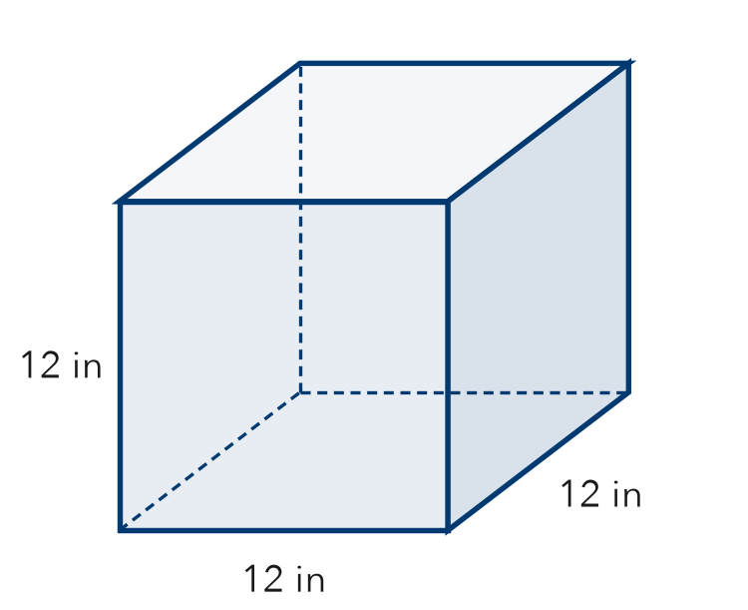
  Show your work.

7. Supply Change. A class buys 12 notebooks at $3 each and 20 pens at $2 each. It pays with $100.
a. Write an expression for the total cost.
b. Write an expression for the change. Evaluate it. dollars
c. Why do parentheses help in part b?

8. Tickets and Programs. A group buys 4 tickets at $9 each and 3 programs at $6 each. Write one expression for the total cost. Evaluate it.
Hint Write a product for each item, then add.

Show your work.
Answer dollars

FIND THE ERROR explain the mistake, then fix it

9. Ines’s Work. Snacks cost $3 each. Ines buys 4 snacks and one $10 poster. She wrote 3 + 4 × 10 for the total. Explain her mistake. Then write and evaluate a correct expression.

TEST PRACTICE choose the best answer

10. “3 more than the product of 5 and 4” is written —
A 5 × 4 + 3 | B 3 × 5 + 4 | C (3 + 5) × 4 | D 5 + 4 × 3

11. “15 less than 40” is written —
A 15 − 40 | B 40 − 15 | C 40 + 15 | D 15 × 40

SELF-CHECK CODE find your answer · copy its letter into that problem’s box · spell a math word
24  C | 43  D | 54  T | 285  R | 30  X | 14  Q | 36  Z | 1,728  U | 72  P | 225  O

#2a | #3 | #4 | #5 | #6 | #7b | #8

CHECK YOURSELF | □ I can do this on my own | □ I need a little help | □ I have a question about #

