Name Date Period
Lesson 6-4 · Session 1 · Practice · Form B
Writing Numerical Expressions
Learning target — I can write a numerical expression that matches a situation. · 6.EE.A.2

REMEMBER  • A numerical expression has numbers and operations but no equal sign.  • “Each” or “per” means equal groups, so multiply. Totals of groups are added. “5 less than 12” is 12 − 5.  • Use parentheses for a part done first: the sum of 4 and 6, tripled, is 3 × (4 + 6). | WORKED EXAMPLE  Ms. Ortiz buys 4 pizzas at $9 each and one $6 salad. Write an expression for the total. Evaluate it.  Step 1 Pizzas are equal groups: 4 × 9.  Step 2 Add the salad: 4 × 9 + 6.  Step 3 Evaluate: 36 + 6 = 42.  Answer 4 × 9 + 6 = $42
WORDS numerical expression (expresión numérica) · evaluate (evaluar) · product (producto)
PRACTICE show your work · label units

1. Write a numerical expression for each phrase. Do not evaluate.
a. 6 more than the product of 7 and 2 | b. 18 less than 60
c. the sum of 3 and 7, doubled | d. the quotient of 56 and 7, minus 3

2. Art Club Order. An art club buys 6 sets of brushes at $11 a set and 3 packs of canvas at $8 a pack. It also lays out mosaic tiles in 9 rows of 9.
a. Write one expression for the total supply cost. Evaluate it. dollars
b. Write the mosaic tiles as a power. Evaluate it. tiles

Show your work.

3. Field Trip. A field trip costs $12 for each of 25 students, plus one $30 bus fee. Write one expression for the total cost. Evaluate it.  Hint One product for the students, then add the fee.  Answer dollars | 4. Square Garden. A square garden has 14 plants along each side, filling the whole square. Write the number of plants as a power. Evaluate it.  Hint A square uses the same number twice.  Answer plants
  Show your work.
  Show your work.

5. Pretzel Bags. Mia fills 4 bags with 15 pretzels each, then eats 6 pretzels. She wrote 4 + 15 − 6 for the pretzels left. Justify or correct her expression.
Hint Which operation matches the word “each”?
Answer pretzels

6. Cube Bin. A cube-shaped bin is 10 inches on every edge. Write the number of 1-inch cubes that fill it as a power. Evaluate it.  Hint A cube has 3 equal dimensions.  Answer cubes | 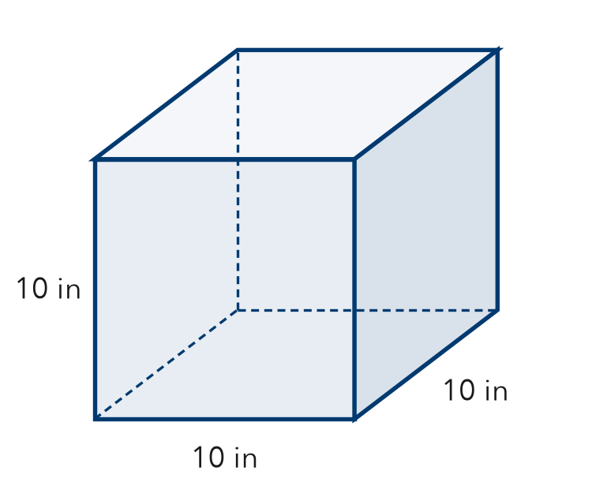
  Show your work.

7. Supply Change. A class buys 10 notebooks at $4 each and 15 pens at $3 each. It pays with $100.
a. Write an expression for the total cost.
b. Write an expression for the change. Evaluate it. dollars
c. Why do parentheses help in part b?

8. Tickets and Programs. A group buys 5 tickets at $8 each and 4 programs at $5 each. Write one expression for the total cost. Evaluate it.
Hint Write a product for each item, then add.

Show your work.
Answer dollars

FIND THE ERROR explain the mistake, then fix it

9. Jaden’s Work. Jaden counts seedlings in 6 trays of 8 seedlings each, plus 9 extra seedlings. He wrote 6 + 8 + 9 = 23. Explain his mistake. Then write and evaluate a correct expression.

TEST PRACTICE choose the best answer

10. “The sum of 8 and 2, doubled” is written —
A 8 + 2 × 2 | B 2 × (8 + 2) | C 8 × 2 + 2 | D 2 + 8 × 2

11. Parentheses tell you which part to —
A do first | B skip | C do last | D always multiply

SELF-CHECK CODE find your answer · copy its letter into that problem’s box · spell a math word
60  S | 1,000  E | 196  M | 13  Q | 54  B | 28  X | 330  U | 30  Z | 90  N | 15  R

#2a | #3 | #4 | #5 | #6 | #7b | #8

CHECK YOURSELF | □ I can do this on my own | □ I need a little help | □ I have a question about #

