Name Date Period
Lesson 6-8 · Homework Packet · Level 1 · Sheet 1 of 2
Using Properties to Rewrite Expressions
Maryland Standard 6.EE.A.3 · Learning target — I can use the distributive property and like terms to rewrite an expression in simplest form.

REMEMBER  • Distributive property: multiply the outside number by each term inside: 4(x + 5) = 4x + 20.  • Commutative: change the order. Associative: change the grouping.  • Simplest form: distribute, put like terms together, then combine them. | WORKED EXAMPLE  Write 3(k + 4) + 2k in simplest form.  Step 1 Distribute: 3k + 12 + 2k  Step 2 Reorder (commutative): 3k + 2k + 12  Step 3 Combine like terms: 5k + 12  Answer 5k + 12

WORD BANK  distribute — multiply the outside number by every term inside  like terms — terms with the same variable, like 4c and 5c | simplest form — no like terms left to combine
PRACTICE show your work · label units

1. Use the distributive property to rewrite each expression.
Step 1 Multiply the outside number by the first term.
Step 2 Multiply it by the second term too. Keep the + or − sign.
a. 6(n + 2) = | b. 3(4x + 1) = | c. 5(2 + y) =
d. 7(a − 3) = | e. 2(3b + 5) = | f. 10(m − 1) =

2. Use the distributive property to find each product. Show the sum you used.
a. 6 × 34 = | b. 8 × 52 =

3. Write each expression in simplest form.
a. 4(c + 3) + 5c = | b. 2(x + 6) + x + 1 =
c. 3(m + 2) + 4(m + 1) = | d. 8 + 5(t + 2) =

4. Garden. A garden is 6 feet wide and (x + 4) feet long. Its area is 6(x + 4) square feet. Write the area without parentheses. Then find the area when x = 5.  Step 1 Multiply 6 by x and 6 by 4.  Step 2 Put 5 in for x and find the value.  Answer | 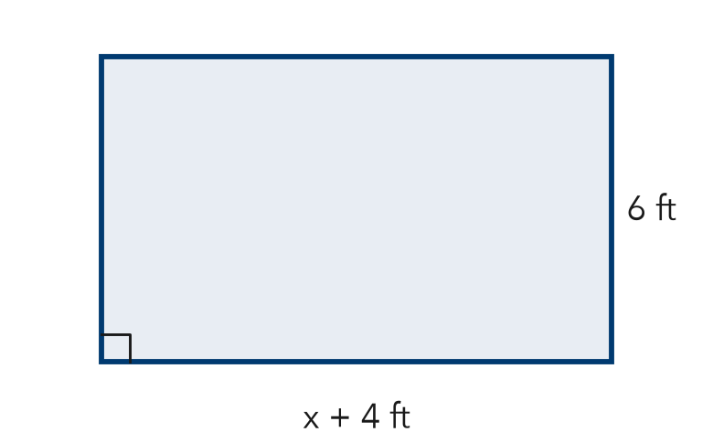
  Show your work.

5. Find the Error. Ana simplified 2(3x + 4) + x and got 7x + 4. Explain her mistake. Then simplify correctly.
Frame Ana forgot to multiply by 2. The correct answer is .

CHECK YOURSELF | □ I can do this on my own | □ I need a little help | □ I have a question about #
AT HOME Show someone at home how 3(10 + 2) = 30 + 6 helps you find 3 × 12 in your head.
Name Date Period
Lesson 6-8 · Homework Packet · Level 1 · Sheet 2 of 2
Expanding and Factoring Expressions
Maryland Standard 6.EE.A.3 · Learning target — I can expand an expression and factor one using the greatest common factor.

REMEMBER  • Expand: distribute to remove parentheses: 5(2x + 3) = 10x + 15.  • Factor: put the GCF outside the parentheses; divide each term by it.  • Check a factored form by expanding it. | WORKED EXAMPLE  Factor 24y + 36.  Step 1 The GCF of 24 and 36 is 12. Divide: 24y ÷ 12 = 2y and 36 ÷ 12 = 3  Step 2 Write 12(2y + 3). Check: 12 × 2y + 12 × 3 = 24y + 36  Answer 12(2y + 3)

WORD BANK  expand — multiply to remove the parentheses  factor — write as a number times ( + ) | GCF — the biggest number that divides both numbers
PRACTICE show your work · label units

1. Expand each expression.
a. 3(5x + 2) = | b. 8(y + 7) = | c. 4(3 + 2n) =

2. Factor each expression using the GCF.
Step 1 Find the GCF of the two numbers.
Step 2 Divide each term by the GCF.
Step 3 Write GCF( + ) and check by expanding.
a. 6x + 15 = | b. 20y + 32 = | c. 14a + 49 =
d. 36 + 27k = | e. 40m + 60 = | f. 11b + 33 =

3. Rectangle. A rectangle has an area of 8x + 56 square units. Its width is 8 units. Write an expression for its length.

Show your work.
Length

4. Stretch. Write two different factored forms of 12x + 24. Then write the form that uses the GCF.

5. Reason. Leon factored 30n + 45 as 5(6n + 9). Did he use the GCF?
Frame 6n and 9 share the factor . So Leon use the GCF. The GCF form is .
□ Yes | □ No

TEST PRACTICE choose the best answer

6. Which is 16x + 40 factored using the GCF?
Step 1 Find the GCF of 16 and 40.
Step 2 Pick the choice with the GCF outside the parentheses.
A 2(8x + 20) | B 8(2x + 5) | C 4(4x + 10) | D 8(2x + 40)

7. Which expression is equivalent to 6(3a + 2)?
A 18a + 2 | B 9a + 8 | C 18a + 12 | D 3a + 12

CHECK YOURSELF | □ I can do this on my own | □ I need a little help | □ I have a question about #
AT HOME Show someone at home how to factor 6x + 9 as 3(2x + 3). Then expand it to check.

