Name Date Period
Lesson 7-1 · Session 1 · Practice · Form B
Integers and Opposites
Learning target — I can write an integer for a real situation and name its opposite. · 6.NS.C.5

REMEMBER  • Positive and negative numbers show opposite directions from 0. First decide what 0 means.  • Above, gain, and deposit are positive. Below, loss, and debt are negative.  • Opposites are the same distance from 0 on different sides. Zero is its own opposite. | WORKED EXAMPLE  A game score starts at 0. You earn 8 points, then you lose 8 points. Write each as an integer.  Step 1 0 means the starting score.  Step 2 Earn 8 points: 8. Lose 8 points: −8.  Step 3 Both are 8 units from 0, on opposite sides.  Answer 8 and −8 are opposites
WORDS integer (entero) · opposite (opuesto) · negative number (número negativo)
PRACTICE show your work · label units

1. Write an integer for each situation.
a. a rocket rises 17 meters | b. an unpaid bill of 32 dollars
c. 6 degrees below zero | d. 4 floors below the street

2. Write the opposite of each number.
a. −23 | b. 9 | c. 0

3. Ocean Research Map. A map lists four spots: Lookout 28 m above sea level, Reef 16 m below, Dock 12 m above, and Dive Station 28 m below.
Hint Sea level is 0. Below sea level is negative.
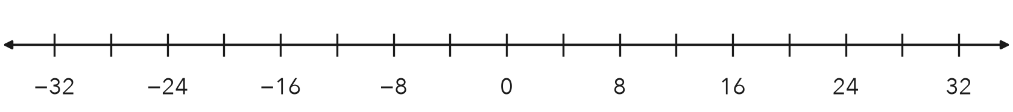
a. Write the integers: Lookout Reef Dock Dive Station
b. Plot and label all four. Which two spots are opposites?

4. Freezer Temperature. A freezer is 15 degrees below zero. Write the integer. Then write its opposite.  Hint Below zero means negative.  Integer, opposite | 5. Lena’s Claim. Lena says the opposite of −21 is −21, because it already has a negative sign. Is she right?  Hint Opposites sit on different sides of 0.  Opposite
  Show your work.
  Show your work.

6. Golf Scores. Three golfers finished at 5 under par, 5 over par, and even par. Write an integer for each. Plot them. Name the opposite pair.
Hint Even par is 0. Under par is negative.
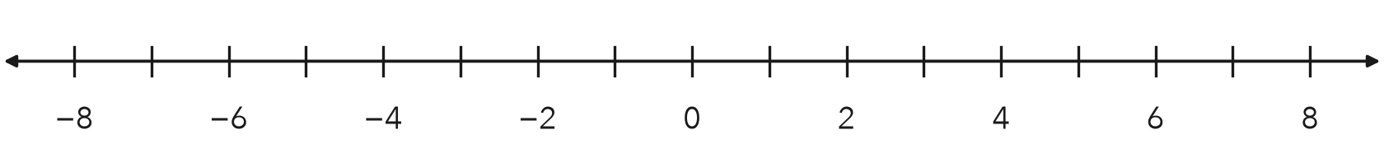
Opposite pair

7. Tower and Tunnel. A water tower top is 44 feet above the ground. A tunnel bottom sits at the opposite elevation.
a. Integer for the tunnel bottom: ft
b. What does 0 represent here?

8. Elevator Trip. An elevator starts at the lobby, marked 0. It goes down 5 floors, then up 8 floors.
a. Write an integer for each move.
b. Integer for the floor where it ends:
c. What would the opposite of that floor mean?

Show your work.

FIND THE ERROR explain the mistake, then fix it

9. Darius’s Work. A cave floor sits 26 meters below sea level. Darius wrote the elevation as 26 and said its opposite is also 26. Explain his two mistakes. Then give the correct elevation and its opposite.

TEST PRACTICE choose the best answer

10. A rise of 9 degrees is written as —
A −9 | B 9 | C 0 | D −(9)

11. The opposite of −15 is —
A −15 | B 0 | C 15 | D 1/15

SELF-CHECK CODE find your answer · copy its letter into that problem’s box · spell a math word
−21  Q | 3  E | 23  A | −32  E | −15  T | 21  I | −6  G | 17  N | −44  V | 13  Z

#1a | #1b | #1c | #2a | #4 | #5 | #7a | #8b

CHECK YOURSELF | □ I can do this on my own | □ I need a little help | □ I have a question about #

