Name Date Period
Lesson 7-1 · Session 1 · Guided Notes
Integers and Opposites
Learning target — I can write an integer for a real situation and name its opposite. · 6.NS.C.5
WORDS TO KNOW fill in the missing words
WORD | WHAT IT MEANS | EXAMPLE
integer  entero | Zero, a counting number, or the of a counting number. | −9, −1, 0, 6, 230
opposite  opuesto | A number the same from 0, on the other side of 0. | −6 and 6
negative number  número negativo | A number than 0, written with a − sign. | −9 is read “negative nine”
positive number  número positivo | A number than 0. | 6, 19, 230
KEY IDEA complete each sentence
• First decide what means in the situation.
• Gains, above, and deposits are . Losses, below, and debts are .
WORKED EXAMPLE fill in the blanks as we solve
In a game, 0 is your starting score. You earn 8 points, then you lose 8 points. Write each as an integer.
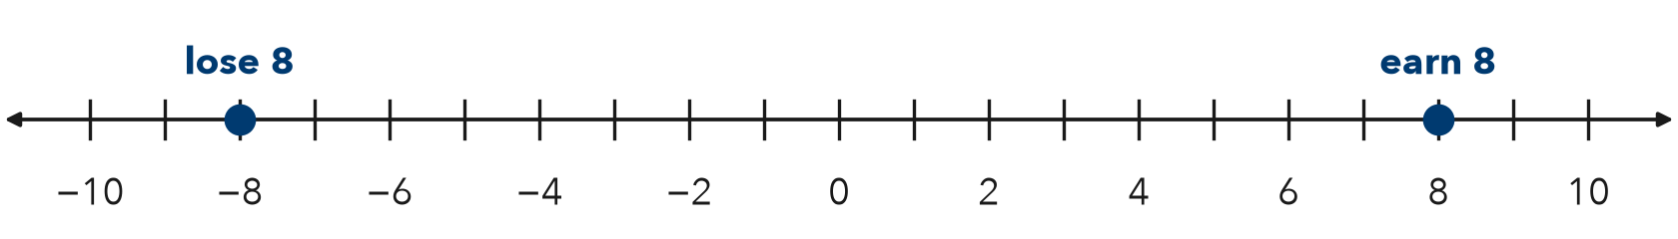
Step 1 Zero means the score.
Step 2 Earning 8 points is . Losing 8 points is .
Step 3 Each is 8 units from 0, on opposite sides.
Answer 8 and −8 are .
YOU TRY use the example as a model

1. Write an integer for each situation.
a. 14 feet below sea level | b. a gain of 6 pounds

2. Plot −4 and its opposite. Label each point.
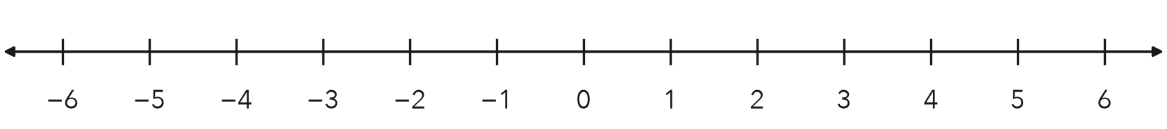

SUM IT UP in your own words
To write an integer for a situation, I first , then I .
Name Date Period
Lesson 7-1 · Session 2 · Guided Notes
Integers in Real Situations
Learning target — I can interpret integers in real situations and find the opposite of an opposite. · 6.NS.C.5
WORDS TO KNOW fill in the missing words
WORD | WHAT IT MEANS | EXAMPLE
opposite  opuesto | A number the same distance from 0, on the side of 0. | −6 and 6
opposite of the opposite  opuesto del opuesto | Flip across 0 and you are back where you started. | −(−6) = 6
integer  entero | A whole number or its . | −14, 0, 6
KEY IDEA complete each sentence
• The sign shows the of a change from a starting point.
• −(−9) means the opposite of −9, which is .
WORKED EXAMPLE fill in the blanks as we solve
A water tank gains 25 liters on Monday and loses 25 liters on Tuesday. Write an integer for each day.
Step 1 Zero means in the water.
Step 2 Monday’s gain is . Tuesday’s loss is .
Answer The two changes are : same size, opposite effects.
YOU TRY use the example as a model

1. Find each value.
a. −(−11) = | b. opposite of the opposite of 9

2. A diver is at −14 meters. She moves to the opposite of that reading, then to the opposite again. Where is she now?

Show your work.
Answer m

SUM IT UP in your own words
The opposite of the opposite of a number is because .

