Name Date Period
Lesson 7-1 · Homework Packet · Level 1 · Sheet 1 of 2
Integers and Opposites
Maryland Standard 6.NS.C.5 · Learning target — I can write an integer for a real situation and name its opposite.

REMEMBER  • Integers: … −3, −2, −1, 0, 1, 2, 3 …  • Positive = above 0 (gain, up). Negative = below 0 (loss, down).  • Opposites are the same distance from 0 on different sides: 6 and −6. | WORKED EXAMPLE  A diver swims 18 feet below sea level. Write an integer for her depth and its opposite.  Step 1 Below sea level is less than 0: −18.  Step 2 The opposite is 18 units from 0 on the other side: 18.  Answer −18 feet; opposite 18

WORD BANK  integer — …, −2, −1, 0, 1, 2, …  opposite — same distance from 0, other side | negative — less than 0: below, loss, owe  positive — more than 0: above, gain, earn
PRACTICE show your work · label units

1. Write an integer for each situation.
Step 1 Is it up, a gain, or money in? Use a positive number.
Step 2 Is it down, a loss, or money out? Use a negative number.
a. a loss of 12 yards | b. a deposit of $40
c. 9 floors below the street | d. 15 degrees above zero
e. a $25 withdrawal | f. a gain of 7 pounds

2. Plot −6 and its opposite on the number line. Label each point with its value.
Step 1 Find −6 on the number line and mark it.
Step 2 Its opposite is the same distance from 0, on the other side.
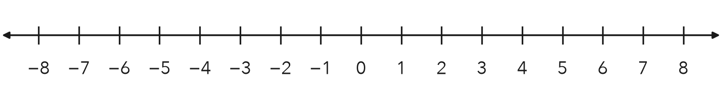
How far is each point from 0? units

3. Write the integer for each point. Then write its opposite.
Step 1 Read the number under each letter.
Step 2 For the opposite, keep the number and change the sign.
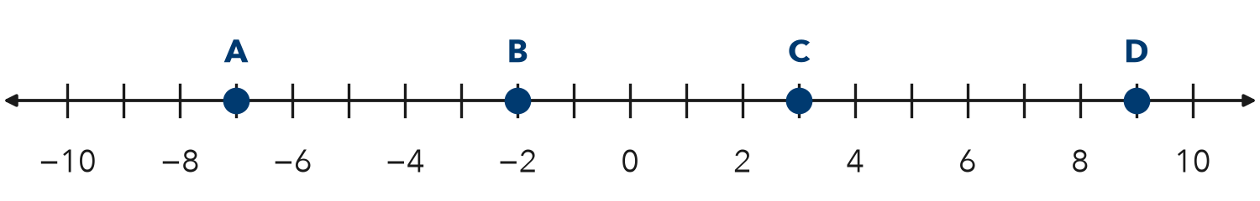
Point | A | B | C | D
Integer
Opposite

4. Find the Error. Keisha says the opposite of −15 is −15, because opposites keep the same number. Explain her mistake. Write the correct opposite.
Frame Keisha is wrong because opposites are on sides of 0. The opposite of −15 is .

CHECK YOURSELF | □ I can do this on my own | □ I need a little help | □ I have a question about #
AT HOME With someone at home, name a temperature on a weather report. Then name its opposite.
Name Date Period
Lesson 7-1 · Homework Packet · Level 1 · Sheet 2 of 2
Integers in Real Situations
Maryland Standard 6.NS.C.5 · Learning target — I can interpret integers in real situations and find the opposite of an opposite.

REMEMBER  • Positive: above, gain, deposit. Negative: below, loss, withdrawal.  • 0 is the start: sea level, a $0 balance.  • The opposite of the opposite is the number itself: −(−8) = 8. | WORKED EXAMPLE  Find the opposite of the opposite of 14.  Step 1 The opposite of 14 is −14.  Step 2 The opposite of −14 is 14.  Answer 14

WORD BANK  opposite — same distance from 0, other side  −(−9) — the opposite of −9, which is 9 | below zero — a negative number
PRACTICE show your work · label units

1. Write an integer for each situation.
a. a town 35 feet below sea level | b. earning $20 walking dogs
c. 4 degrees below zero | d. a loss of 8 yards

2. Find each value.
Step 1 Read −(−9) as “the opposite of −9.”
Step 2 Flip to the other side of 0.
a. −(−9) = | b. −(15) = | c. −(−(−4)) =

3. Start at −3. Plot point A at −3, point B at the opposite of A, and point C at the opposite of B.
Step 1 Mark A at −3.
Step 2 B is the same distance from 0 on the other side.
Step 3 C is the opposite of B.
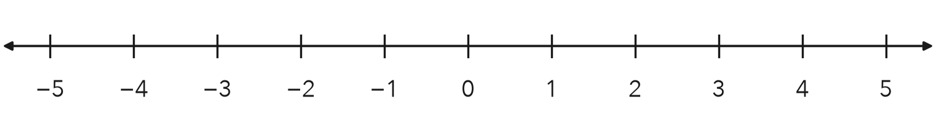
What do you notice about points A and C?

4. Weather. At noon it was 6 degrees above zero. At midnight it was 6 degrees below zero.
a. Write an integer for each temperature.
b. How are the two integers related?

5. Reasoning. Marcus says the opposite of a number is always negative. Is he right? Give an example.
Frame Marcus is . For example, the opposite of is , which is .

TEST PRACTICE choose the best answer

6. Which integer describes a loss of 18 points in a game?
A 18 | B −18 | C −(−18) | D 0

7. Which equation is true?
A −(−11) = −11 | B −(−11) = 11 | C −(11) = 11 | D −(0) = 1

CHECK YOURSELF | □ I can do this on my own | □ I need a little help | □ I have a question about #
AT HOME Tell someone at home a money story with a negative number. Ask what 0 means in it.

