Name Date Period
Lesson 7-1 · Session 1 · Prerequisite Practice B · Skill 1 of 2
Name Opposite Directions
Builds on Grade 4 · 4.MD.A.2
TODAY’S LESSON | You will write 31 feet above the ground and its opposite, 31 feet below.
YOU NEED TO | Flip a direction word, like above becomes below. You will use it in Practice Form A, problems 4 and 7.
STEPS TO FOLLOW use these same steps on every problem
1 | Find the direction word: above, gain, up, over, rise.
2 | Flip it: above becomes below, gain becomes loss, up becomes down.
3 | Keep the same amount. Write the new phrase.
WATCH ME the steps in action
Write the opposite of “6 floors above the lobby.”
Step 1 The direction word is above.
Step 2 Flip it: above becomes below.
Step 3 6 floors below the lobby
Answer 6 floors below the lobby
TRY IT WITH HELP fill in each step
1. Write the opposite of “a gain of 12 yards.”
Step 1 The direction word is .
Step 2 Flip it: gain becomes .
Step 3 Write:

2. Write the opposite of “4 strokes over par.”
Step 1 The direction word is .
Step 2 Flip it: over becomes .
Step 3 Write:

YOUR TURN use the steps on your own

3. Write the opposite of each situation.
a. a deposit of $45 | b. a rise of 8 degrees
c. 30 m above sea level | d. climb 340 ft
e. earn 15 points | f. 12 degrees below zero

Lesson 7-1 · Session 1 · Prerequisite Practice B · Skill 2 of 2
Same Distance From a Point
Builds on Grade 3 · 3.NBT.A.2
TODAY’S LESSON | You will find opposites like 35 and −35. Both are 35 units from 0.
YOU NEED TO | Find the two numbers the same distance from a point, like 8 units from 30. You will use it in Practice Form A, problems 2 and 3.
STEPS TO FOLLOW use these same steps on every problem
1 | Start at the middle point.
2 | Subtract the distance to go left.
3 | Add the distance to go right.
WATCH ME the steps in action
Which two numbers are 8 units from 30?  Step 1 Start at 30.  Step 2 30 − 8 = 22  Step 3 30 + 8 = 38  Answer 22 and 38 | 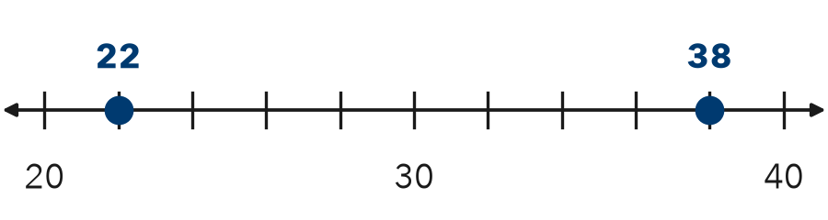

TRY IT WITH HELP fill in each step
4. Which two numbers are 9 units from 20?
Step 1 Start at .
Step 2 20 − 9 =
Step 3 20 + 9 =

5. Which two numbers are 25 units from 100?
Step 1 Start at .
Step 2 100 − 25 =
Step 3 100 + 25 =

YOUR TURN use the steps on your own

6. Find both numbers that are this far from the point.
a. 15 units from 50 | b. 12 units from 40
c. 5 units from 10 | d. 20 units from 20
e. 7 units from 30 | f. 10 units from 10

READY CHECK a problem like the one in today’s lesson

7. Which two numbers are both 35 units from 0?
A 0 and 35 | B 35 and 70 | C −35 and 35 | D −35 and 0

CHECK YOURSELF | □ I can do this on my own | □ I need a little help | □ I have a question about #

