Name Date Period
Lesson 7-1 · Session 2 · Prerequisite Practice B · Skill 1 of 2
Write Integers for Situations
Builds on Lesson 7-1 Session 1 · 6.NS.C.5
TODAY’S LESSON | You will write integers like −9 for a 9-yard loss and 200 for 200 feet above sea level.
YOU NEED TO | Write an integer for a situation, like 35 feet below sea level = −35. You will use it in Practice Form A, problems 1 and 5.
STEPS TO FOLLOW use these same steps on every problem
1 | Find the zero point: the ground, sea level, or $0.
2 | Choose the sign: above or gain is +. Below or loss is −.
3 | Write the number with its sign.
WATCH ME the steps in action
A diver is 35 feet below sea level. Write an integer.
Step 1 Zero is sea level.
Step 2 Below sea level, so the sign is −.
Step 3 Write −35.
Answer −35
TRY IT WITH HELP fill in each step
1. A team gains 15 yards. Write an integer.
Step 1 Zero is the starting .
Step 2 A gain, so the sign is .
Step 3 The integer is .

2. Ben withdraws $35 from the bank. Write an integer.
Step 1 Zero is .
Step 2 Taking money out is a loss, so the sign is .
Step 3 The integer is .

YOUR TURN use the steps on your own

3. Write an integer for each situation.
a. 20 feet below sea level | b. a deposit of $50
c. 6 floors below the lobby | d. a rise of 11 degrees
e. 3 strokes under par | f. a loss of 8 yards

Lesson 7-1 · Session 2 · Prerequisite Practice B · Skill 2 of 2
Find Opposites of Integers
Builds on Lesson 7-1 Session 1 · 6.NS.C.5
TODAY’S LESSON | You will find values like −(−16) and the opposite of the opposite of −7.
YOU NEED TO | Find the opposite of an integer: the opposite of −5 is 5. You will use it in Practice Form A, problems 2, 4, and 6.
STEPS TO FOLLOW use these same steps on every problem
1 | Find the number’s distance from 0.
2 | Switch sides of 0: left becomes right, right becomes left.
3 | Write the number on the new side. −( ) means the opposite of.
WATCH ME the steps in action
Find the opposite of −5.  Step 1 −5 is 5 units from 0.  Step 2 −5 is left of 0. Switch to the right.  Step 3 The opposite is 5.  Answer 5 | 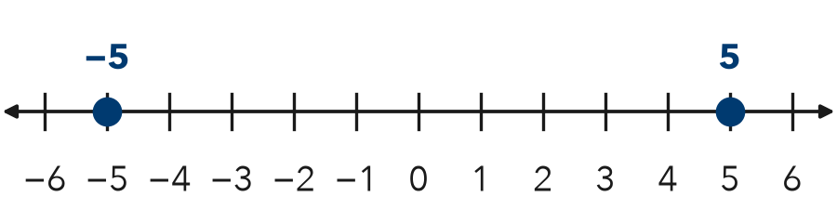

TRY IT WITH HELP fill in each step
4. Find the opposite of 7.
Step 1 7 is units from 0.
Step 2 7 is right of 0. Switch to the .
Step 3 The opposite is .

5. Find −(−12).
Step 1 −12 is units from 0.
Step 2 −12 is left of 0. Switch to the .
Step 3 −(−12) =

YOUR TURN use the steps on your own

6. Write the opposite of each number.
a. 12 | b. −25 | c. 0
d. −40 | e. 100 | f. −3

READY CHECK a problem like the one in today’s lesson

7. A freezer reads −24 degrees. Then it changes to the opposite reading. What does it read now?
A −24 degrees | B 24 degrees | C 0 degrees | D −48 degrees

CHECK YOURSELF | □ I can do this on my own | □ I need a little help | □ I have a question about #

