Name Date Period
Lesson 7-2 · Session 1 · Practice · Form B
Rational Numbers on a Number Line
Learning target — I can plot a rational number and its opposite on a number line. · 6.NS.C.6c

REMEMBER  • A rational number can be written as a fraction of two integers: 3/4, −2.5 = −5/2, 7 = 7/1.  • To plot one, mark the integers, then split each gap into equal parts (halves, fourths, tenths).  • Negative numbers sit left of 0, or below 0 on a vertical number line. | WORKED EXAMPLE  Plot 1.5 and −3.5 on a number line.  Step 1 Mark the integers from −4 to 4.  Step 2 Split each gap into halves.  Step 3 1.5 is halfway between 1 and 2. −3.5 is halfway between −4 and −3.  Answer 1.5 is right of 0; −3.5 is left of 0
WORDS rational number (número racional) · integer (número entero) · number line (recta numérica)
PRACTICE show your work · label units

1. Name the two integers each number is between.
a. −7/2 | b. 0.4
c. −9/4 | d. −3.7

2. Garden Log. Ms. Patel’s class measures from the soil surface (0): sunflower 2.5 m up, carrot root 0.5 m down, bean sprout 1.25 m up, tulip bulb 0.3 m down.
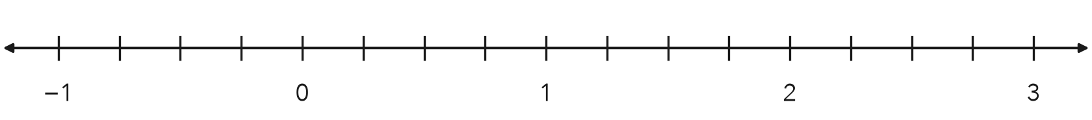
a. Write a rational number for each: sunflower carrot bean tulip
b. Plot and label all four on the number line.

3. Lab Thermometer. A lab thermometer read −3.5 degrees at 6 a.m. and 3.5 degrees at noon. Plot both readings. How far is each reading from 0?
Hint Count the halves from 0 to each point.
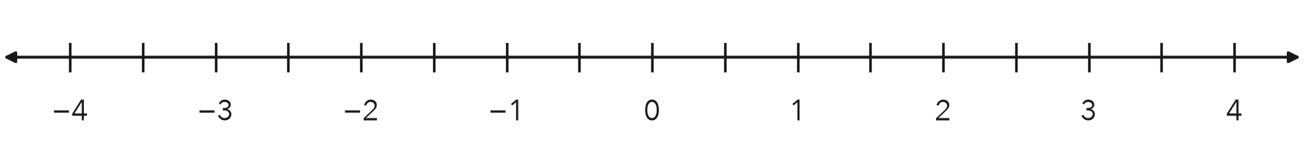
Answer degrees

4. Mixing Bowl. A cook added 7/4 cups of broth to a bowl, then removed 7/4 cups. Write the removal as a rational number in decimal form.  Hint Removing makes the number negative. 7/4 = 1 3/4.  Answer cups | 5. Rational Claim. Jalen says −4 is not a rational number because it is not written as a fraction. Write −4 as a fraction with a denominator of 1. Is Jalen right?  Hint Any integer can be divided by 1.  Fraction
  Show your work.
  Show your work.

6. Three Marks. A number strip shows the marks −9/4, 1.6 and −0.35. Plot all three. Which mark is closest to 0?
Hint Write −9/4 as a decimal first: −2.25.
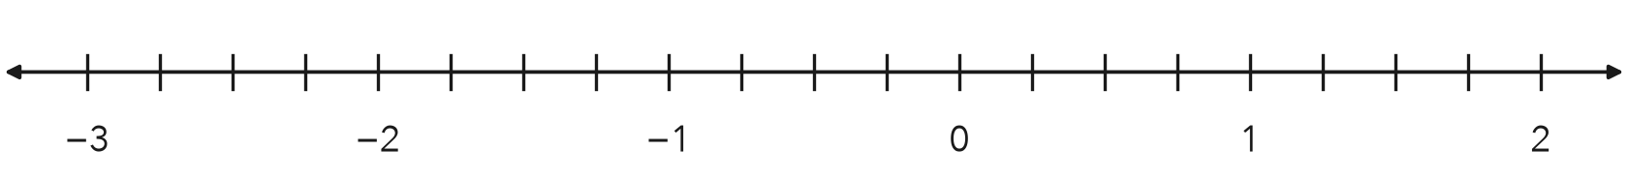
Closest to 0

7. Pool Depths. A pool’s surface is 0. A float sits 0.6 m above the surface and a drain sits at −2.1 m. How many meters farther from the surface is the drain than the float?  Hint Find each distance from 0, then subtract.  Answer m | 8. Ledge and Cave. A rock ledge is 8.5 meters above the sea surface. A cave floor sits at the opposite value.  a. Write the number for the cave floor. m  b. Between which two integers is the cave floor?
  Show your work.
  Show your work.

FIND THE ERROR explain the mistake, then fix it

9. Jalen’s Work. To plot −3.6, Jalen counted six tenths to the RIGHT of −3 and put his point between −3 and −2. Explain his mistake. Then name the two integers −3.6 is between.

TEST PRACTICE choose the best answer

10. On a number line, −1.5 sits between —
A −1 and 0 | B 1 and 2 | C −2 and −1 | D −1.5 and −1

11. Which number is farthest right on a number line?
A −0.5 | B −3 | C 0.25 | D −0.75

SELF-CHECK CODE find your answer · copy its letter into that problem’s box · spell a math word
0.35  J | 3.5  P | 1.75  Q | −1.75  O | 1.5  T | 8.5  X | −8.5  S | −4/1  I | −0.35  N | −3.5  Z

#3 | #4 | #5 | #6 | #7 | #8a

CHECK YOURSELF | □ I can do this on my own | □ I need a little help | □ I have a question about #

