Name Date Period
Lesson 7-2 · Session 1 · Prerequisite Practice A · Skill 1 of 2
Fractions on a Number Line
Builds on Grade 3 · 3.NF.A.2
TODAY’S LESSON | You will plot fractions and decimals, like −11/4, on a number line.
YOU NEED TO | Find where a fraction like 11/4 sits between two whole numbers. You will use it in Practice Form A, problems 1 and 6.
STEPS TO FOLLOW use these same steps on every problem
1 | Look at the bottom number. Split each whole into that many equal parts.
2 | Count the top number of parts, starting at 0.
3 | Mark the point. Name the whole numbers on each side.
WATCH ME the steps in action
Where is 7/4 on a number line?  Step 1 The bottom number is 4. Split each whole into 4 equal parts.  Step 2 Count 7 parts from 0. Four parts reach 1, then 3 more.  Step 3 Mark the point. It is between 1 and 2.  Answer 7/4 is between 1 and 2. | 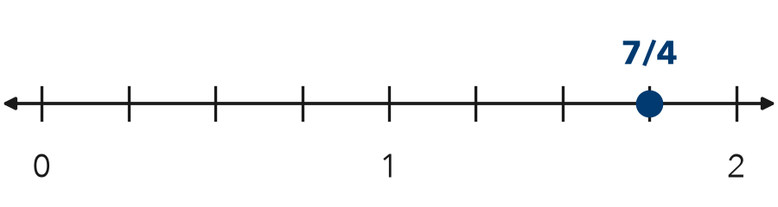

TRY IT WITH HELP fill in each step
1. Where is 5/2 on a number line?
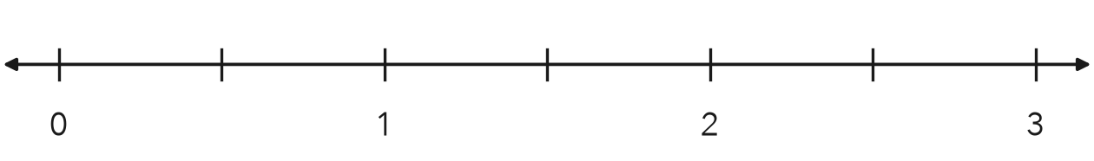
Step 1 Split each whole into equal parts.
Step 2 Count parts from 0. Mark the point.
Step 3 5/2 is between and .

2. Where is 10/3 on a number line?
Step 1 Split each whole into equal parts.
Step 2 Count parts from 0. Every 3 parts make 1 whole.
Step 3 10/3 is between and .

YOUR TURN use the steps on your own

3. Write the two whole numbers each fraction is between.
a. 9/4 | b. 7/2 | c. 5/3
d. 11/4 | e. 13/5 | f. 3/2

Lesson 7-2 · Session 1 · Prerequisite Practice A · Skill 2 of 2
Decimals Between Whole Numbers
Builds on Grade 4 · 4.NF.C.6
TODAY’S LESSON | You will plot measurements like 3.5 m and −12.5 m on a number line.
YOU NEED TO | Find the two whole numbers a decimal sits between. You will use it in Practice Form A, problems 2 and 8.
STEPS TO FOLLOW use these same steps on every problem
1 | The number before the point is the whole number.
2 | The next whole number is one more.
3 | The digit after the point tells how many tenths past the whole number.
WATCH ME the steps in action
Where is 4.6 on a number line?  Step 1 The whole number is 4.  Step 2 The next whole number is 5.  Step 3 6 tenths past 4. Mark it closer to 5.  Answer 4.6 is between 4 and 5. | 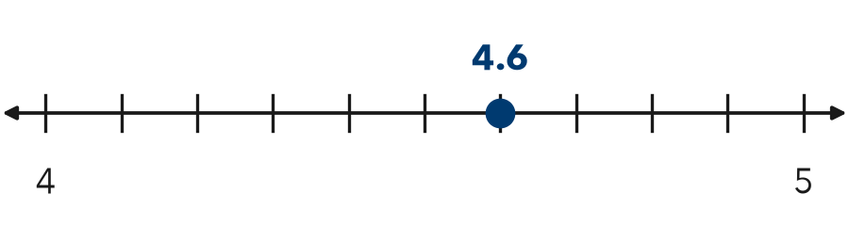

TRY IT WITH HELP fill in each step
4. Where is 2.3 on a number line?
Step 1 The whole number is .
Step 2 The next whole number is .
Step 3 2.3 is tenths past 2.

5. Where is 12.5 on a number line?
Step 1 The whole number is .
Step 2 The next whole number is .
Step 3 12.5 is 5 tenths past 12. That is halfway between and .

YOUR TURN use the steps on your own

6. Write the two whole numbers each decimal is between.
a. 5.4 | b. 0.8 | c. 9.9
d. 3.5 | e. 12.1 | f. 7.25

READY CHECK a problem like the one in today’s lesson

7. A float sits 2.5 m above the water. Between which two whole numbers is 2.5?
A 1 and 2 | B 2 and 3 | C 3 and 4 | D 2.5 and 3

CHECK YOURSELF | □ I can do this on my own | □ I need a little help | □ I have a question about #

