Name Date Period
Lesson 7-3 · Session 1 · Practice · Form B
Absolute Value as Distance
Learning target — I can use absolute value to describe how far a number is from zero. · 6.NS.C.7c

REMEMBER  • Absolute value is how far a number is from 0. Write it with bars: |−4| = 4 and |4| = 4.  • Distance is never negative, so absolute value is never negative.  • Greater means farther right. Farther from 0 means a bigger absolute value. −9 is farther from 0 than 4, but 4 is greater. | WORKED EXAMPLE  Find |−13| and |6|. Which number is farther from 0?  Step 1 −13 is 13 units left of 0, so |−13| = 13.  Step 2 6 is 6 units right of 0, so |6| = 6.  Step 3 Compare the distances: 13 > 6.  Answer −13 is farther from 0
WORDS absolute value (valor absoluto) · distance (distancia) · magnitude (magnitud)
PRACTICE show your work · label units

1. Find each absolute value.
a. |−19| = | b. |12| =
c. |0| = | d. |−3.8| =

2. Beaker Readings. Ms. Chen’s team records four beakers: A −4 degrees, B 1.5 degrees, C −7 degrees, D 0.5 degrees.
Hint Count the units from 0 to each point.
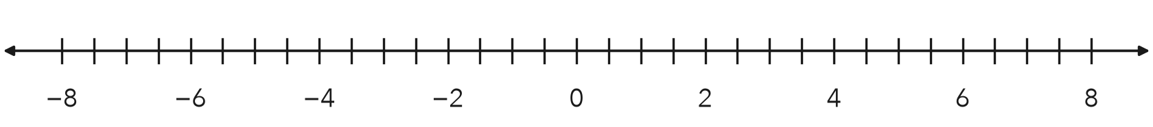
a. Absolute values: A B C D
b. Plot all four. Which beaker is closest to 0? Farthest?

3. Two Accounts. One account has a balance of −30 dollars. Another has a balance of 18 dollars.
a. Absolute value of each balance:
b. Which account is closer to a zero balance?

Show your work.

4. Survey Cards. One card reads −6.5 m and another reads 6.5 m. Find each absolute value. Do they mark the same place?  Hint Same distance does not mean same side.  Answer | 5. Cold Storage. A cooler logged −9 degrees at midnight. Find the absolute value. What does it tell you?  Answer
  Show your work.
  Show your work.

6. Greater Magnitude. Which number has the greater absolute value, −27 or 31? Justify your choice.
Hint Compare 27 and 31.

Show your work.
Number

7. Leah’s Claim. Leah says |−8.4| = −8.4 because the number inside the bars is negative. Is she right? Give the correct value.
Hint Can a distance be negative?

Show your work.
|−8.4|

8. Bank Balances. Three accounts read −95, 60, and −150 dollars.
a. Find the absolute value of each balance.
b. Which balance is farthest from 0?
c. Which balance is greatest? Why is this a different question?

Show your work.

FIND THE ERROR explain the mistake, then fix it

9. Tessa’s Work. Tessa said −6 is closer to 0 than 4: “The negative number is smaller, so it must be closer to zero.” Explain her mistake. Then say which number is closer to 0.

TEST PRACTICE choose the best answer

10. |8.5| equals —
A −8.5 | B 8.5 | C 0 | D 85

11. Which number is closest to 0?
A −8 | B 6 | C −2 | D 4

SELF-CHECK CODE find your answer · copy its letter into that problem’s box · spell a math word
−9  X | 31  R | −150  A | −95  Z | 19  N | 60  L | −27  Q | 18  U | 9  E | 6.5  M

#1a | #3b | #4 | #5 | #6 | #8b | #8c

CHECK YOURSELF | □ I can do this on my own | □ I need a little help | □ I have a question about #

