Name Date Period
Lesson 7-3 · Session 1 · Guided Notes
Absolute Value as Distance
Learning target — I can use absolute value to describe how far a number is from zero. · 6.NS.C.7c
WORDS TO KNOW fill in the missing words
WORD | WHAT IT MEANS | EXAMPLE
absolute value  valor absoluto | How many units a number is from . | |−3| = 3 and |3| = 3
distance  distancia | How many units apart two points are. It is never . | from 0 to −5 is 5 units
magnitude  magnitud | How big a number is, ignoring its . | −50 has magnitude 50
KEY IDEA complete each sentence
• Absolute value is never , because distance is never negative.
• Closer to 0 means a absolute value.
WORKED EXAMPLE fill in the blanks as we solve
Find |−13| and |6|. Which number is farther from 0?
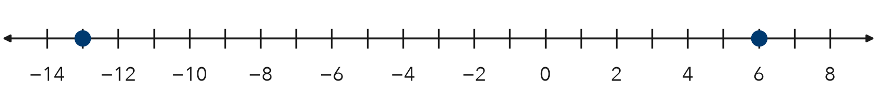
Step 1 −13 is units left of 0, so |−13| = 13.
Step 2 6 is 6 units right of 0, so |6| = .
Answer 13 > 6, so is farther from 0.
YOU TRY use the example as a model

1. Find each absolute value.
a. |−21| = | b. |4.5| =

2. Which number is closer to 0: −2.5 or 3? Explain with absolute value.

Show your work.
Closer to 0

SUM IT UP in your own words
Absolute value is never negative because .
Name Date Period
Lesson 7-3 · Session 2 · Guided Notes
Absolute Value as Total Distance
Learning target — I can use absolute value to find the total distance between a negative and a positive reading. · 6.NS.C.7c
WORDS TO KNOW fill in the missing words
WORD | WHAT IT MEANS | EXAMPLE
absolute value  valor absoluto | How many units a number is from . | |−50| = 50
distance  distancia | How many units two points are. | from −8 to 3 is 11 units
magnitude  magnitud | The of a number, ignoring its sign. | −50 and 50 have the same size
KEY IDEA complete each sentence
• If two numbers are on sides of 0, add their absolute values.
• If they are on the side of 0, subtract the smaller absolute value from the larger.
WORKED EXAMPLE fill in the blanks as we solve
Each unit is 1 block. How far is it from −8 to 3?
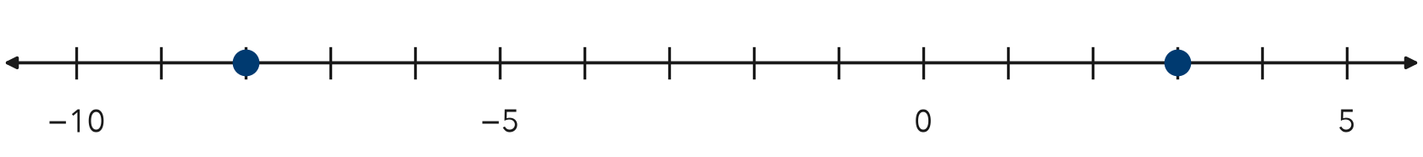
Step 1 0 is between them, so they are on sides.
Step 2 |−8| = 8 and |3| = .
Answer 8 + 3 = blocks
YOU TRY use the example as a model

1. Find the distance between each pair.
a. −5 and 9 | b. −12 and −4

2. A submarine rises from −30 m to −12 m. How far does it rise?

Show your work.
Answer m

SUM IT UP in your own words
To find the distance between a negative and a positive number, I because .

