Name Date Period
Lesson 7-4 · Session 1 · Practice · Form A
Comparing Numbers on a Number Line
Learning target — I can compare two rational numbers using their positions on a number line. · 6.NS.C.7a

REMEMBER  • On a number line, the number farther right is greater. Any positive number is greater than any negative number.  • For negatives, the one closer to 0 is greater. Bigger digits do not mean a bigger negative number: −13 > −40.  • For decimals, use the same number of digits: −0.06 > −0.60. | WORKED EXAMPLE  Compare −14 degrees and −5 degrees.  Step 1 Plot −14 and −5 on a number line.  Step 2 −5 is to the right of −14.  Step 3 Write the comparison: −14 < −5.  Answer −5 is greater; −14 is colder
WORDS greater than (mayor que) · less than (menor que) · inequality (desigualdad)
PRACTICE show your work · label units

1. Write < or > in each blank.
a. −4 −9 | b. −2.5 1.5
c. −6 −2 | d. 0 −4

2. Trivia Scores. Scores: Rosa −6, Tomas 3, Willa −11, Pia 0.
Hint The score farthest right is greatest.
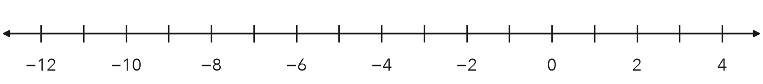
a. Plot and label all four scores.
b. Compare Rosa and Willa using >.
c. Greatest score Least score

3. Two Accounts. One account ended at −32 dollars. Another ended at −47 dollars. Which balance is greater?  Hint Which is closer to 0?  Greater | 4. Freezer Check. One freezer holds at −18 degrees. Another holds at 5 degrees. Which reading is colder?  Colder
  Show your work.
  Show your work.

5. Two Cave Floors. Cave A has a floor at −24 m. Cave B has a floor at −9 m. Write a comparison using < or >. Which cave is deeper?
Hint The deeper floor is farther left.
Deeper

6. Eighths. Plot −7/8 and −1/8. Which number is greater?
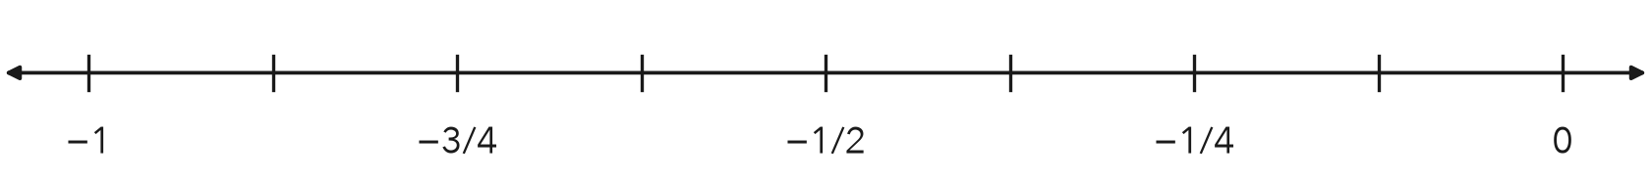
Greater

7. Amina’s Claim. Amina says −0.9 > −0.09 because nine tenths is more than nine hundredths. Is she right? Which number is greater?
Hint Write −0.9 as −0.90.

Show your work.
Greater

8. Three Accounts. Three accounts hold −45, 12, and −8 dollars.
a. Order the balances from least to greatest.
b. Which balance has the largest absolute value?
c. Why is that balance not the greatest?

Show your work.

FIND THE ERROR explain the mistake, then fix it

9. Camila’s Work. Camila wrote −15 > −4. She said 15 comes after 4 when you count, so −15 must be greater. Explain her mistake. Then write the correct comparison.

TEST PRACTICE choose the best answer

10. Which symbol makes −6 −2 true?
A < | B > | C = | D none of these

11. On a number line, the greater number is always —
A farther left | B farther right | C farther from 0 | D negative

SELF-CHECK CODE find your answer · copy its letter into that problem’s box · spell a math word
−6 > −11  C | −0.9  X | −0.09  R | −47  Q | −32  O | −1/8  A | −45  E | −7/8  Z | −18  M | Cave A  P

#2b | #3 | #4 | #5 | #6 | #7 | #8b

CHECK YOURSELF | □ I can do this on my own | □ I need a little help | □ I have a question about #

