Name Date Period
Lesson 7-4 · Session 2 · Practice · Form B
Ordering Integers and Rational Numbers
Learning target — I can order integers and rational numbers from least to greatest. · 6.NS.C.7b

REMEMBER  • Least to greatest means left to right on a number line. Greatest to least means right to left.  • The number farthest from 0 may be the least. Deepest or coldest means least.  • Change every number to a decimal first: −2 1/2 = −2.5 and 3/4 = 0.75. | WORKED EXAMPLE  Order −6, 1.5, −0.5, and 3/4 from least to greatest.  Step 1 3/4 = 0.75.  Step 2 Negatives first: −6 < −0.5.  Step 3 Then positives: 0.75 < 1.5.  Answer −6, −0.5, 3/4, 1.5
WORDS order (orden) · least (mínimo) · greatest (máximo)
PRACTICE show your work · label units

1. Order each set from least to greatest.
a. −5, −18, −11 | b. −4, 1.5, −0.5, 0

2. Golf Leaderboard. Scores: Maya −2, Eli 3, Nora −6, Caleb 0, Priya 4. In golf, the least score leads.
Hint |−6| = 6 and |4| = 4.
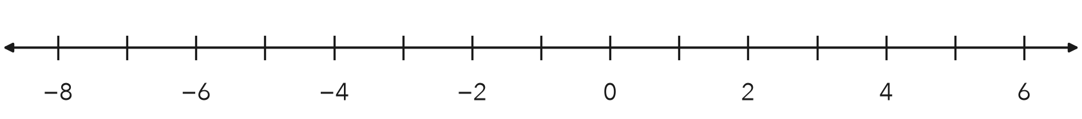
a. Plot the scores. Order them from least to greatest.
b. Which score is farther from 0, −6 or 4?
c. Who is leading?

3. Lake Floors. Three lake floors sit at −245 ft, −812 ft, and −1,320 ft. Which floor is deepest?  Hint The deepest floor is the least number.  Deepest | 4. Mixed Forms. Order −3/4, −0.5, and −1.5 from least to greatest. Which is greatest?  Hint −3/4 = −0.75.  Greatest
  Show your work.
  Show your work.

5. Week of Lows. Low temperatures: −8, 6, −15, 0, and −3 degrees. Plot and order them from least to greatest. Name the coldest reading.
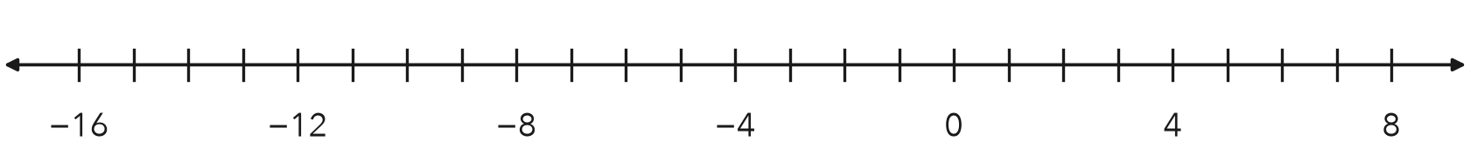
Coldest

6. Number Strip. A strip shows −1.5, −1.05, 3/4, and −2.6. Order them from greatest to least. Which has the greatest absolute value?
Hint Write 3/4 as 0.75 first.

Show your work.
Greatest |n|

7. Harbor Depths. A harbor chart lists −12 ft, −7 1/2 ft, 0 ft, and −12.5 ft. Order them from least to greatest. Name the deepest spot.
Hint −7 1/2 = −7.5.

Show your work.
Deepest

8. Five Readings. Sensors read 2.5, −1, −3/4, 0.5, and −1.5 degrees.
a. Write every reading as a decimal.
b. Order the readings from least to greatest.
c. Which reading is closest to 0? How do you know?

Show your work.

FIND THE ERROR explain the mistake, then fix it

9. Malik’s Work. Malik ordered −3, −12, and −7 from least to greatest as −3, −7, −12, because 3 is smaller than 7 and 12. Explain his mistake. Then write the correct order.

TEST PRACTICE choose the best answer

10. The least of −6, −13, and −1 is —
A −6 | B −13 | C −1 | D 0

11. The greatest of −3.6, −3.06, and −3.66 is —
A −3.6 | B −3.06 | C −3.66 | D They are equal.

SELF-CHECK CODE find your answer · copy its letter into that problem’s box · spell a math word
−1,320  R | −1.05  Z | −6  O | −0.5  D | −12.5  E | 0.5  D | −2.6  R | −15  E | −12  X | −245  Q

#2b | #3 | #4 | #5 | #6 | #7 | #8c

CHECK YOURSELF | □ I can do this on my own | □ I need a little help | □ I have a question about #

