Name Date Period
Lesson 7-5 · Session 1 · Practice · Form B
Plotting Points on the Coordinate Plane
Learning target — I can plot a point with rational coordinates and name the quadrant it lies in. · 6.NS.C.6c

REMEMBER  • An ordered pair (x, y) names a point. Start at the origin (0, 0): x says right or left, then y says up or down.  • Signs name the quadrant: (+, +) I, (−, +) II, (−, −) III, (+, −) IV.  • A point with a 0 coordinate is on an axis, not in a quadrant. | WORKED EXAMPLE  Plot (−5, −4). Name its quadrant.  Step 1 Start at the origin, (0, 0).  Step 2 Move 5 units left, because x = −5.  Step 3 Move 4 units down, because y = −4.  Answer (−, −) is Quadrant III
WORDS coordinate plane (plano de coordenadas) · ordered pair (par ordenado) · origin (origen) · quadrant (cuadrante)
PRACTICE show your work · label units

1. Name the quadrant or axis for each point.
a. (−3, 8) | b. (5, 2) | c. (−6, −1)
d. (7, −4) | e. (0, 3) | f. (−6, 0)

2. Park Map. Ms. Rivera’s class map puts the fountain at the origin. Gate (3, 6), Pond (−8, 4), Bench (−2, −7), Swing Set (6, −5).  Hint Move along the x-axis first.  a. Plot and label all four spots.  b. Quadrant: Gate Pond Bench Swing Set  c. Ordered pair for the fountain: | 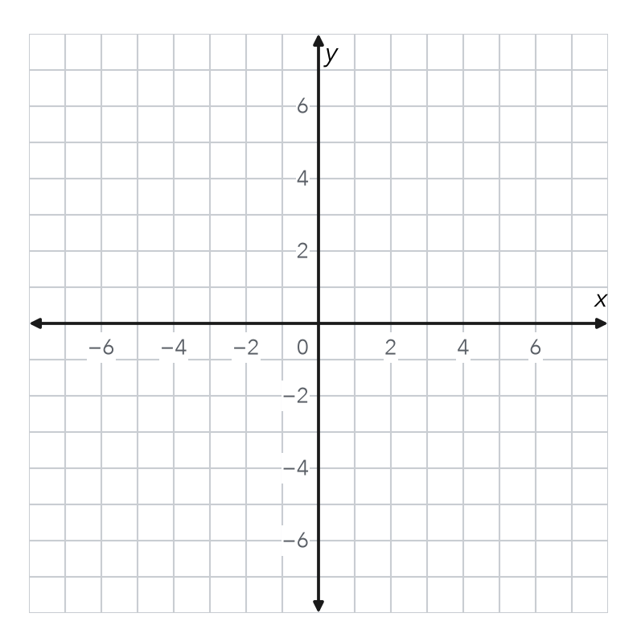

3. Build the Pair. A point is 9 units left of the y-axis and 5 units below the x-axis. Write its ordered pair and quadrant.  Hint Below means y is negative.  Point | 4. Order Matters. Name the quadrant of (−4, 2) and of (2, −4). Are they the same point?  Hint Check the sign of x, then the sign of y.  Quadrants

5. Same Digits. Theo says (3, −7) and (−7, 3) name the same point because they use the same two numbers. Explain why he is wrong.

6. Rational Coordinates. Plot (−2.5, −4.5) and (3.5, 1.5). Name each quadrant.  Hint Count 2 whole units, then half of the next.  Quadrants | 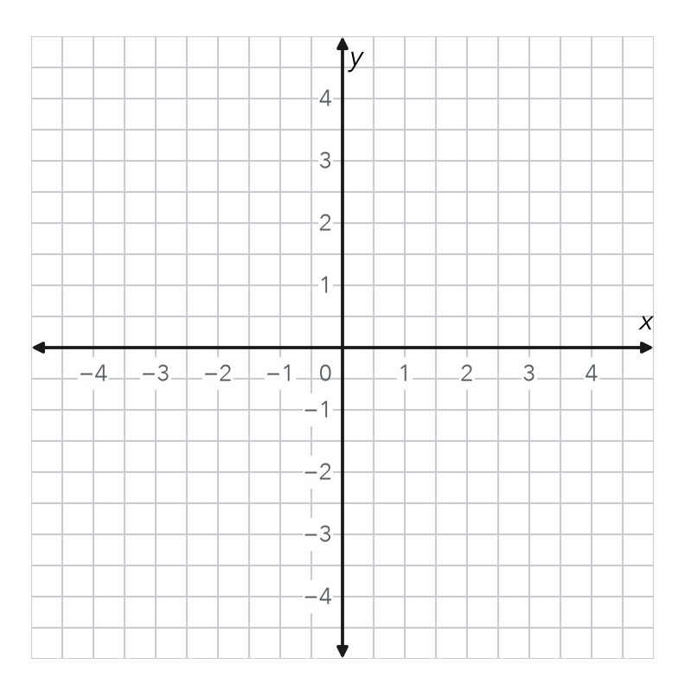

7. City Map. The library is at the origin. The museum is at (6, −3). The stadium is at (−8, 2).
a. Quadrant: museum stadium
b. Ordered pair for the library:

8. Map Points. A map shows a school at (3.5, −2), a park at (−3.5, −2), and a pool at (−3.5, 4).
a. Name the quadrant of each place.
b. Which y-coordinate do two places share?
c. How many units straight up is the pool from the park?

FIND THE ERROR explain the mistake, then fix it

9. Jalen’s Work. Jalen plotted (−3, 6) by moving down 3 units and then right 6 units. His point landed in Quadrant IV. Explain his mistake. Then describe the correct moves and quadrant.

TEST PRACTICE choose the best answer

10. The point (5, −2) lies in —
A Quadrant I | B Quadrant II | C Quadrant III | D Quadrant IV

11. A point with both coordinates negative lies in —
A Quadrant I | B Quadrant II | C Quadrant III | D Quadrant IV

SELF-CHECK CODE find your answer · copy its letter into that problem’s box · spell a math word
(9, 5)  Z | (−9, −5)  I | II  P | (−5, −9)  Q | (0, 0)  N | y-axis  O | 2  X | −2  T | 6  S

#1a | #1e | #3 | #7b | #8b | #8c

CHECK YOURSELF | □ I can do this on my own | □ I need a little help | □ I have a question about #

