Name Date Period
Lesson 7-5 · Session 1 · Guided Notes
Plotting Points on the Coordinate Plane
Learning target — I can plot a point with rational coordinates and name the quadrant it lies in. · 6.NS.C.6c
WORDS TO KNOW fill in the missing words
WORD | WHAT IT MEANS | EXAMPLE
coordinate plane  plano de coordenadas | A grid made by a horizontal and a vertical . | x-axis across, y-axis up and down
ordered pair  par ordenado | Two numbers (x, y) that name one . | (−3, 4)
origin  origen | The point where the two axes cross. | start every plot here
quadrant  cuadrante | One of the sections of the plane. | Quadrant II is upper left
KEY IDEA complete each sentence
• The x-coordinate tells you to move . The y-coordinate tells you to move up or down.
• Signs name the quadrant: (−, +) is Quadrant and (−, −) is Quadrant III.
WORKED EXAMPLE fill in the blanks as we solve
Plot the point (−5, −4). Name its quadrant.
Step 1 Start at the origin, (0, 0).
Step 2 Move 5 units , because x = −5.
Step 3 Move 4 units , because y = −4.
Answer (−, −) means Quadrant , the lower left.
YOU TRY use the example as a model

1. Name the quadrant of each point.
a. (6, −2) | b. (−1.5, 3)

2. Plot and label A(−4, 2) and B(3, −5). | 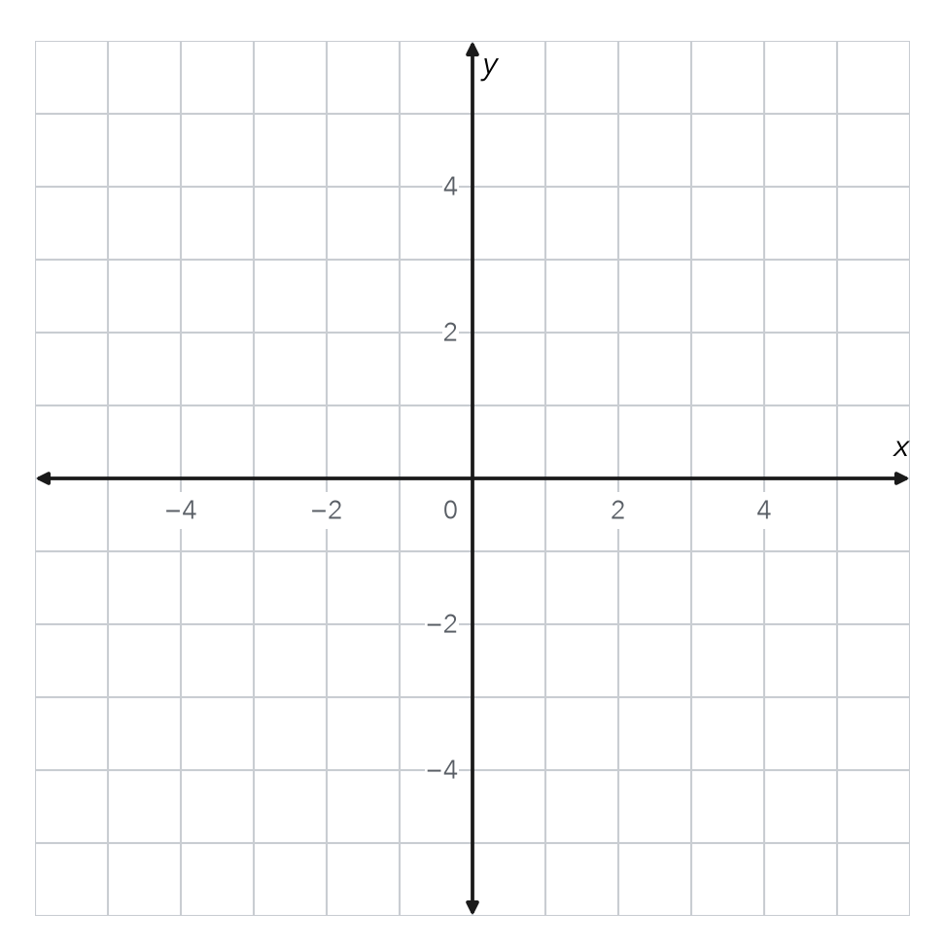

SUM IT UP in your own words
To plot (x, y), I start at , then I .
Name Date Period
Lesson 7-5 · Session 2 · Guided Notes
Reflecting Points Across Axes
Learning target — I can reflect a point across the x-axis or the y-axis and name the new coordinates. · 6.NS.C.6b
WORDS TO KNOW fill in the missing words
WORD | WHAT IT MEANS | EXAMPLE
reflection  reflexión | A that makes a mirror image across a line. | (4, 1) becomes (4, −1) across the x-axis
x-axis  eje x | The number line through the origin. | runs left and right
y-axis  eje y | The number line through the origin. | runs up and down
KEY IDEA complete each sentence
• Across the x-axis, the -coordinate changes sign.
• Across the y-axis, the -coordinate changes sign.
WORKED EXAMPLE fill in the blanks as we solve
Reflect (7, −2) across the x-axis. Then reflect (7, −2) across the y-axis.
Step 1 Across the x-axis: keep x = 7 and change −2 to . Image: (7, 2).
Step 2 Across the y-axis: keep y = −2 and change 7 to .
Answer The images are (7, 2) and .
YOU TRY use the example as a model

1. Write each image.
a. (3, −5) across the x-axis | b. (−6, 1) across the y-axis

2. Point A is at (−2, 4). Plot A and its reflection B across the x-axis.  B = | 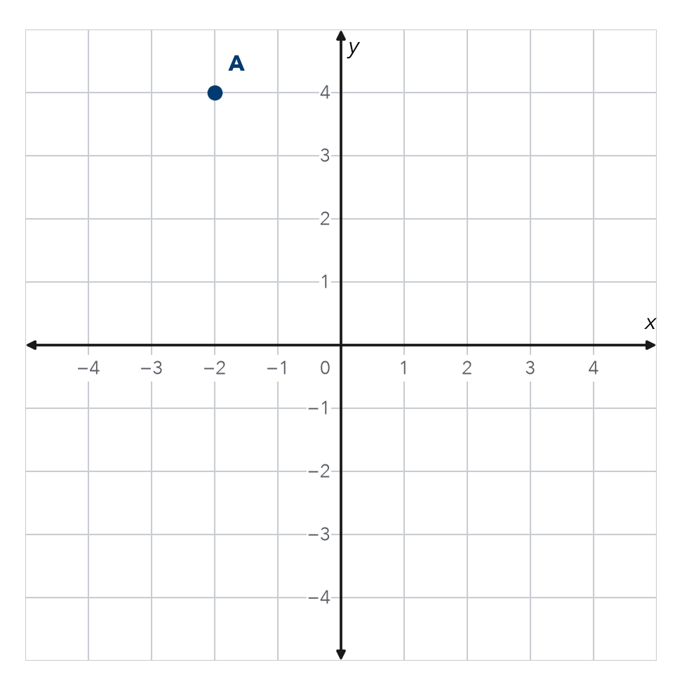

SUM IT UP in your own words
When I reflect across the y-axis, changes because .

