Name Date Period
Lesson 7-5 · Homework Packet · Level 1 · Sheet 1 of 2
Plotting Points on the Coordinate Plane
Maryland Standard 6.NS.C.6c · Learning target — I can plot a point with rational coordinates and name the quadrant it lies in.

REMEMBER  • Start at the origin (0, 0). Move x units right or left, then y units up or down.  • Quadrant signs: I (+, +), II (−, +), III (−, −), IV (+, −).  • A point with a 0 coordinate is on an axis, not in a quadrant. | WORKED EXAMPLE  Plot (−3.5, 2) and name its quadrant.  Step 1 Start at the origin. Move left 3.5 units.  Step 2 Move up 2 units. Left and up is Quadrant II.  Answer Quadrant II

WORD BANK  ordered pair — (x, y): first move right or left, then up or down  origin — (0, 0), where the axes cross | quadrant — one of the four parts of the grid  on an axis — a point with a 0 in it
PRACTICE show your work · label units

1. Write the ordered pair for each point. Name its quadrant.  Step 1 Start at the origin. Count left or right to the point: that is x.  Step 2 Count up or down: that is y.  Step 3 Use the signs to name the quadrant. | 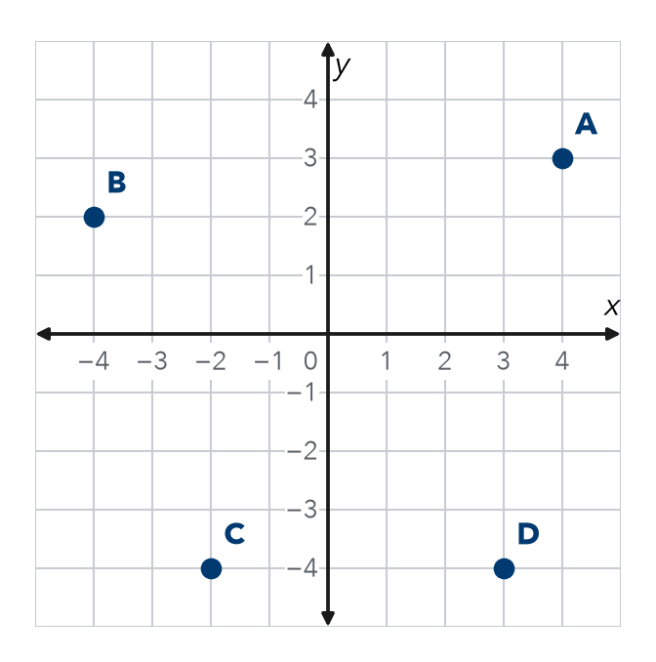
  Point | Ordered pair | Quadrant
  A
  B
  C
  D

2. Town Map. The library is at the origin. Plot and label each place: Park P(2, 4), Pool Q(−4, −1), School S(−3.5, 3), Garden G(4, −2.5).  Step 1 Move right or left first (the first number).  Step 2 Then move up or down (the second number).  Which place is in Quadrant III? Quadrant IV? | 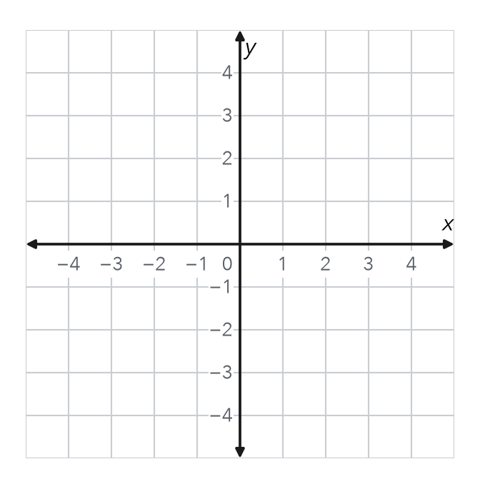

3. Name the quadrant or axis for each point.
Step 1 Look at the sign of each number.
Step 2 If a number is 0, the point is on an axis.
a. (−7, −2) | b. (8, −1) | c. (0, 6)
d. (−1.5, 4) | e. (−9, 0) | f. (2.5, −6)

4. Reasoning. Malia says (−3, 5) and (5, −3) name the same point. Is she right? Explain.
Frame Malia is because . (−3, 5) is in Quadrant and (5, −3) is in Quadrant .

CHECK YOURSELF | □ I can do this on my own | □ I need a little help | □ I have a question about #
AT HOME With someone at home, name a quadrant. Take turns saying an ordered pair that lands in it.
Name Date Period
Lesson 7-5 · Homework Packet · Level 1 · Sheet 2 of 2
Reflecting Points Across Axes
Maryland Standard 6.NS.C.6b · Learning target — I can reflect a point across the x-axis or the y-axis and name the new coordinates.

REMEMBER  • x-axis reflection: flip the sign of y. (3, 4) becomes (3, −4).  • y-axis reflection: flip the sign of x. (3, 4) becomes (−3, 4).  • Across both axes, both signs flip. | WORKED EXAMPLE  Reflect (−2, 5) across the x-axis.  Step 1 Keep x = −2.  Step 2 Change the sign of y: 5 becomes −5.  Answer (−2, −5)

WORD BANK  reflection — a mirror flip  across the x-axis — change the sign of y | across the y-axis — change the sign of x
PRACTICE show your work · label units

1. Point A is at (−4, 3). Plot point B, the reflection of A across the x-axis. Plot point C, the reflection of A across the y-axis.  Step 1 For B, keep x. Change the sign of y.  Step 2 For C, keep y. Change the sign of x.  a. B =  b. C = | 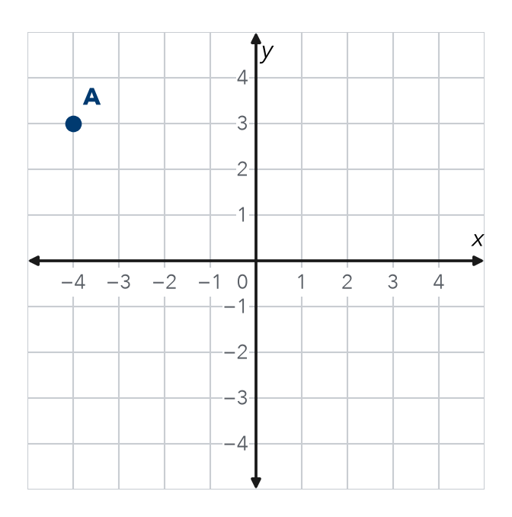

2. Write the new point after each reflection.
Step 1 Find the mirror: the x-axis or the y-axis.
Step 2 Change the sign of only one number. For both axes, do one flip, then the other.
a. (−6, −2) across the y-axis | b. (−4, 7) across both axes

3. Park Map. A bench is the mirror image of a bus stop at (7, −2.5). The mirror is the x-axis. Where is the bench?
Answer

4. Stretch. Point K was reflected across the x-axis. The new point is (−6, −5). Where was point K?
K

5. Find the Error. Sam reflected (−3, −8) across the y-axis and got (−3, 8). Explain his mistake. Fix it.
Frame Sam changed the -coordinate. Across the y-axis, the -coordinate changes sign. The correct point is .

TEST PRACTICE choose the best answer

6. Point M(−5, 2) is reflected across the y-axis. What is the new point?
A (−5, −2) | B (5, 2) | C (5, −2) | D (2, −5)

7. The points (6, −1) and (6, 1) are reflections of each other across —
A the x-axis | B the y-axis | C both axes | D neither axis

CHECK YOURSELF | □ I can do this on my own | □ I need a little help | □ I have a question about #

